

SOFTWARE DESIGN SPECIFICATION
Gym Center Management System
GCMS

– Hanoi, June 2026 –

Table of Contents
I. Record of Changes 5
II. Software Design Document 6
1. High Level Design 6
1.1 Software Architecture 6
1.2 Package Diagram 7
1.3 Database Design 8
2. State Transition Diagrams 21
2.1 Account Status 21
2.2 Package State Diagram 22
2.3 Invoice State Diagram 23
2.4 Member Package State Diagram 24
2.5 Register Package State Diagram 25
2.6 Manage Equipment State 26
2.7 Manage Equipment Issues 27
2.8 Equipment Reports 28
2.9 PT Schedule Training 29
2.10 Reschedule Request 29
2.11 Make-up Request 30
2.12 PT Registration 31
2.13 PT Attendance Result 32
2.14 Manage Maintenance Schedules 33
2.15 Manage Blog & Policies 34
3. Detailed Design 34
3.1 System & Account Management 34
3.2 Package Management & Payment Management 48
3.4 Manage Equipment 70
3.5 Manage Equipment Issues 74
3.6 Equipment Reports 77
3.7 Create Personal Trainer Module 80
3.8 View Personal Trainer Information Module 82
3.9 Manage Personal Trainer Profile Module 86
3.10 PT Service Registration Module 91
3.11 Generate PT Schedule Module 96
3.12 PT Work Dashboard Module 98
3.13 Schedule Change Request Module 102
3.14 Manage Member 109
3.15 View Member Portal 121
3.16 View Member Notifications 124
3.17 Make-up Request Module 127
3.18 Staff/Admin PT Schedule Operations Module 131
3.19 Manage Maintenance Schedules 139
3.20 Manage PT Package 142
3.20 Manage Blog & Policies 146
3.21 View Membership Growth Report 150
3.22 Chat Bot 153

I. Record of Changes
Date | A*  M, D | In charge | Change Description
23/6/2026 | A | PhuND | Initial Document Creation
30/6/2026 | M | PhuND | Add Swimlane Activity Diagram
10/7/2026 | M | PhuND | Change all PT part diagram
16/7/2026 | M | PhuND | Add new use case management PT package types
*A - Added M - Modified D - Deleted

II. Software Design Document

1. High Level Design

1.1 Software Architecture
[The content of this section includes the overall architectural diagram which includes the sub-systems and/or components, the external systems (if any), and the relationships (communication messages) among them. You need also provide the explanation for each of the diagram components (modules, sub-systems, external systems, etc.)].
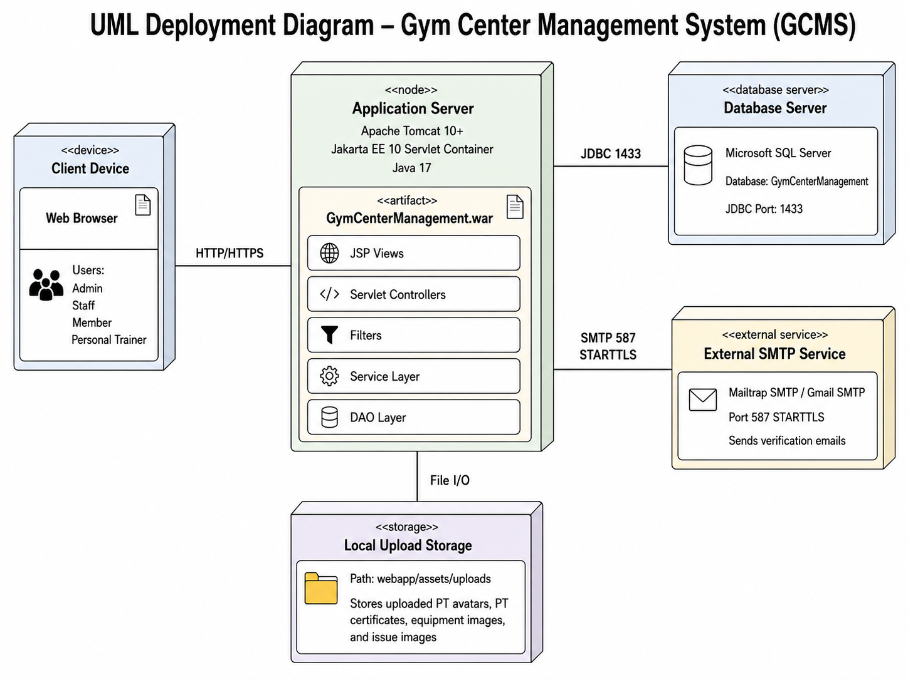

1.2 Package Diagram
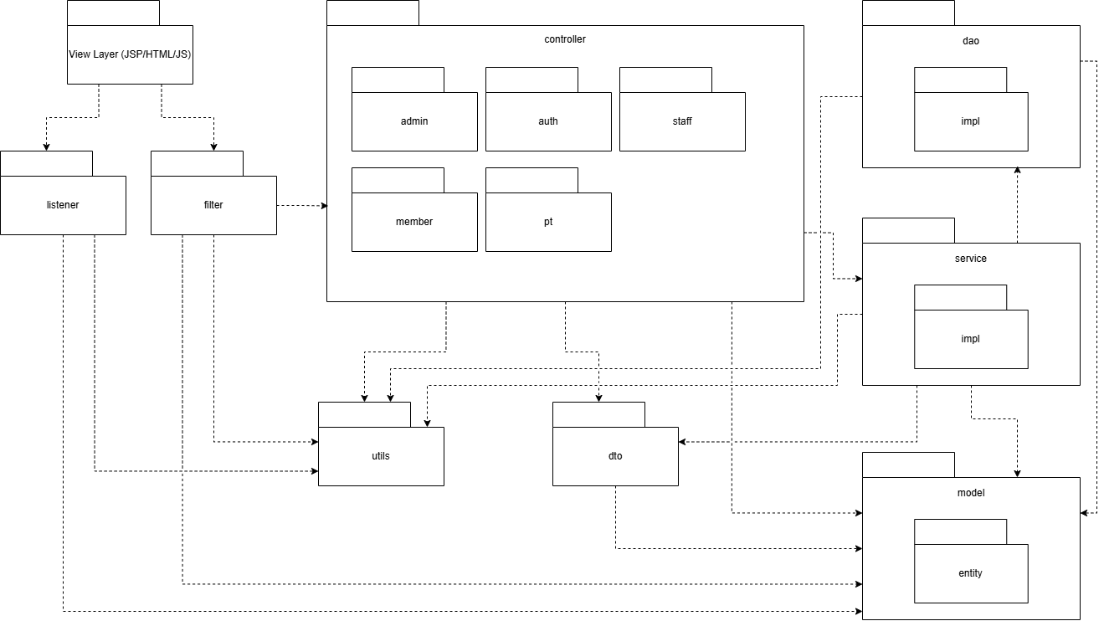
https://drive.google.com/file/d/1V-LreXOQjfaJRE7ECLUxZtQAiaYZLp4D/view?usp=sharing
Package descriptions
No | Package | Naming Conventions | Description
01 | controller | Suffix Controller (e.g., UserController) | Contains Servlets acting as controllers. Handles HTTP Requests from users, invokes service, and forwards/redirects to View. Phân chia thành các sub-package (admin, auth, member, pt, staff) theo quyền hạn và nhóm chức năng.
02 | service | Interface prefix I, Class suffix Service or ServiceImpl | Contains interfaces and classes that handle Business Logic. service.impl chứa các class triển khai (implementation) chi tiết.
03 | dao | Suffix DAO or Repository (e.g., UserDAO) | Data Access Object. Giao tiếp trực tiếp với database. dao.impl chứa các class triển khai truy vấn SQL chi tiết.
04 | model | PascalCase, singular nouns (e.g., User, GymPackage) | Chứa các đối tượng hệ thống. Sub-package model.entity chứa các class ánh xạ (mapping) trực tiếp với các bảng trong CSDL.
05 | dto | Suffix DTO (e.g., MemberProfileDTO) | Data Transfer Object. Chứa các class dùng để đóng gói và luân chuyển dữ liệu giữa các layer, đặc biệt khi cấu trúc dữ liệu gửi/nhận phức tạp hơn 1 Entity đơn thuần.
06 | filter | Suffix Filter (e.g., AuthFilter, EncodingFilter) | Contains Servlet Filters to intercept and process Requests before they reach the controller (e.g., Authentication, Authorization, UTF-8 Encoding).
07 | listener | Suffix Listener | Chứa các Servlet Listener để lắng nghe và xử lý các sự kiện vòng đời của ứng dụng web (ví dụ: Session tạo/hủy, Application khởi động).
08 | utils | Nouns describing functionality, suffix Util (e.g., DBContext, PasswordUtil) | Contains static utility classes shared across the entire system (e.g., Database connection, password hashing, string formatting).

1.3 Database Design
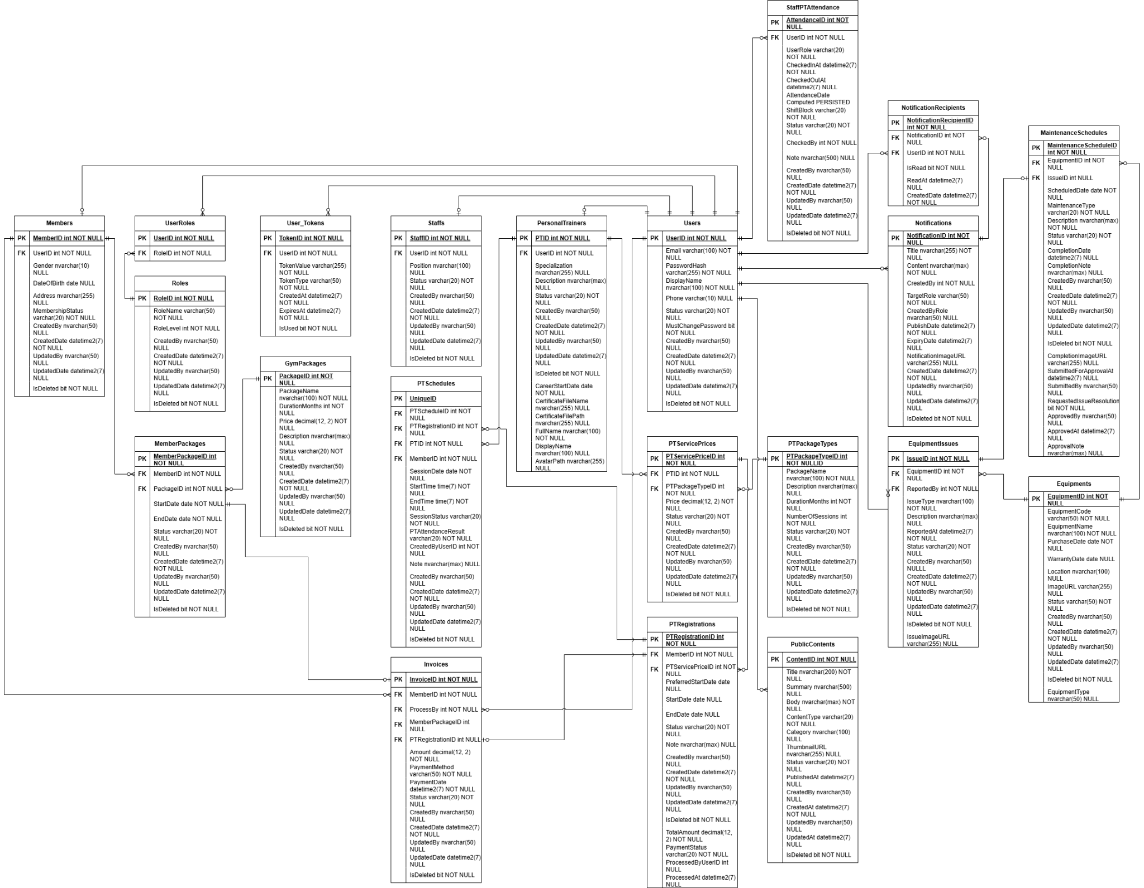
https://drive.google.com/file/d/1d7bupepcVnf2KC8oUO2393T6_lo-Mxu6/view?usp=sharing

1.3.1 Personal Trainer
[Provide brief description of the table here]
[Provide the detailed table fields description using below table format
* PK~Primary Key; FK~Foreign Key; UN~Unique; NN ~ not null
No | Field | PK | FK | UN | NN | Description
01 | PTID | X |  |  | X | Unique identifier of the personal trainer
02 | UserID |  | X |  | X | References the associated user account
03 | Specialization |  |  |  |  | Trainer specialization area
04 | Description |  |  |  |  | Trainer profile description
05 | Status |  |  |  | X | Current trainer status (Active, Inactive)
06 | CareerStartDate |  |  |  | X | Date when trainer started professional career
07 | CertificateFileName |  |  |  |  | Uploaded certificate file name
08 | CertificateFilePath |  |  |  |  | Certificate storage path
09 | FullName |  |  |  | X | Official full name of trainer
10 | DisplayName |  |  |  |  | Public display name shown to members
11 | AvatarPath |  |  |  |  | Trainer profile image path
12 | CreatedBy |  |  |  |  | User who created the record
13 | CreatedDate |  |  |  | X | Record creation date
14 | UpdatedBy |  |  |  |  | User who last updated the record
15 | UpdatedDate |  |  |  |  | Last update date
16 | IsDeleted |  |  |  | X | Soft delete flag

1.3.2 PTPackageTypes
No | Field | PK | FK | UN | NN | Description
01 | PTPackageTypeID | X |  |  | X | Unique package type identifier
02 | PackageName |  |  |  | X | Package type name
03 | Description |  |  |  |  | Package description
04 | DurationMonths |  |  |  | X | Package duration in months
05 | NumberOfSessions |  |  |  | X | Number of training sessions included
06 | Status |  |  |  | X | Package availability status
07 | CreatedBy |  |  |  |  | User who created the record
08 | CreatedDate |  |  |  | X | Record creation date
09 | UpdatedBy |  |  |  |  | User who updated the record
10 | UpdatedDate |  |  |  |  | Last update date
11 | IsDeleted |  |  |  | X | Soft delete flag

1.3.3 PTServicePrices
No | Field | PK | FK | UN | NN | Description
01 | PTServicePriceID | X |  |  | X | Unique PT service price identifier
02 | PTID |  | X |  | X | References personal trainer
03 | PTPackageTypeID |  | X |  | X | References PT package type
04 | Price |  |  |  | X | Package price
05 | Status |  |  |  | X | Package status
06 | CreatedBy |  |  |  |  | User who created the record
07 | CreatedDate |  |  |  | X | Record creation date
08 | UpdatedBy |  |  |  |  | User who updated the record
09 | UpdatedDate |  |  |  |  | Last update date
10 | IsDeleted |  |  |  | X | Soft delete flag

1.3.4 PTRegistrations
No | Field | PK | FK | UN | NN | Description
01 | PTRegistrationID | X |  |  | X | Unique PT registration identifier
02 | MemberID |  | X |  | X | References member
03 | PTServicePriceID |  | X |  | X | Selected PT package
04 | PreferredStartDate |  |  |  |  | Member preferred start date
05 | StartDate |  |  |  |  | Actual training start date
06 | EndDate |  |  |  |  | Training end date
07 | Status |  |  |  | X | Registration status
08 | Note |  |  |  |  | Member note/request
09 | TotalAmount |  |  |  | X | Total registration amount
10 | PaymentStatus |  |  |  | X | Payment status
11 | ProcessedByUserID |  | X |  |  | Staff/Admin who processed registration
12 | ProcessedAt |  |  |  |  | Processing timestamp
13 | PurchasedSessions |  |  |  | X | Number of training sessions purchased at registration time.
13 | CreatedBy |  |  |  |  | User who created the record
14 | CreatedDate |  |  |  | X | Record creation date
15 | UpdatedBy |  |  |  |  | User who updated the record
16 | UpdatedDate |  |  |  |  | Last update date
17 | IsDeleted |  |  |  | X | Soft delete flag

1.3.5 PTSchedules
No | Field | PK | FK | UN | NN | Description
01 | PTScheduleID | X |  |  | X | Unique schedule identifier
02 | PTRegistrationID |  | X |  | X | References PT registration
03 | PTID |  | X |  | X | References trainer
04 | MemberID |  | X |  | X | References member
05 | SessionDate |  |  |  | X | Training session date
06 | StartTime |  |  |  | X | Session start time
07 | EndTime |  |  |  | X | Session end time
08 | SessionStatus |  |  |  | X | Session status
09 | PTAttendanceResult |  |  |  | X | Attendance result recorded by PT
10 | CreatedByUserID |  | X |  | X | User who created the schedule
11 | Note |  |  |  |  | Session notes
12 | CreatedBy |  |  |  |  | User who created the record
13 | CreatedDate |  |  |  | X | Record creation date
14 | UpdatedBy |  |  |  |  | User who updated the record
15 | UpdatedDate |  |  |  |  | Last update date
16 | IsDeleted |  |  |  | X | Soft delete flag
17 | OriginalPTID |  | X |  |  | References the original trainer before substitute assignment.
18 | SubstituteReason |  |  |  |  | Reason for assigning a substitute trainer.
19 | SubstituteByUserID |  | X |  |  | Staff/Admin user who assigned the substitute trainer.
20 | SubstituteAt |  |  |  |  | Timestamp when the substitute trainer was assigned.
21 | CancelledByUserID |  | X |  |  | Admin user who cancelled the PT session.
22 | CancelledAt |  |  |  |  | Timestamp when the PT session was cancelled.
23 | CancellationReason |  |  |  |  | Reason for cancelling the PT session.

1.3.6 Users
No | Field | PK | FK | UN | NN | Description
01 | UserID | X |  |  | X | Unique user identifier
02 | Email |  |  | X | X | User email address
03 | PasswordHash |  |  |  | X | Hashed password
04 | DisplayName |  |  |  | X | User display name
05 | Phone |  |  |  |  | User phone number
06 | Status |  |  |  | X | Account status
07 | MustChangePassword |  |  |  | X | Indicates whether password change is required
08 | CreatedBy |  |  |  |  | User who created the record
09 | CreatedDate |  |  |  | X | Record creation date
10 | UpdatedBy |  |  |  |  | User who updated the record
11 | UpdatedDate |  |  |  |  | Last update date
12 | IsDeleted |  |  |  | X | Soft delete flag

1.3.7 Roles
No | Field | PK | FK | UN | NN | Description
01 | RoleID | X |  |  | X | Unique role identifier
02 | RoleName |  |  | X | X | Role name
03 | RoleLevel |  |  |  | X | Role hierarchy level
04 | CreatedBy |  |  |  |  | User who created the record
05 | CreatedDate |  |  |  | X | Record creation date
06 | UpdatedBy |  |  |  |  | User who updated the record
07 | UpdatedDate |  |  |  |  | Last update date
08 | IsDeleted |  |  |  | X | Soft delete flag

1.3.8 UserRoles
No | Field | PK | FK | UN | NN | Description
01 | UserID | X | X |  | X | References user
02 | RoleID | X | X |  | X | References role

1.3.9 Members
No | Field | PK | FK | UN | NN | Description
01 | MemberID | X |  |  | X | Unique member identifier.
02 | UserID |  | X |  | X | References the associated user account.
03 | Gender |  |  |  |  | Member gender.
04 | DateOfBirth |  |  |  |  | Member date of birth.
05 | Address |  |  |  |  | Member address.
06 | MembershipStatus |  |  |  | X | Current membership status.
07 | CreatedBy |  |  |  |  | User who created the record.
08 | CreatedDate |  |  |  | X | Record creation date.
09 | UpdatedBy |  |  |  |  | User who updated the record.
10 | UpdatedDate |  |  |  |  | Last update date.
11 | IsDeleted |  |  |  | X | Soft delete flag.

1.3.10 GymPackages
No | Field | PK | FK | UN | NN | Description
01 | PackageID | X |  |  | X | Unique package identifier
02 | PackageName |  |  |  | X | Package name
03 | DurationMonths |  |  |  | X | Package duration in months
04 | Price |  |  |  | X | Package price
05 | Description |  |  |  |  | Package description
06 | Status |  |  |  | X | Package status
07 | CreatedBy |  |  |  |  | User who created the record
08 | CreatedDate |  |  |  | X | Record creation date
09 | UpdatedBy |  |  |  |  | User who updated the record
10 | UpdatedDate |  |  |  |  | Last update date
11 | IsDeleted |  |  |  | X | Soft delete flag

1.3.11 MemberPackages
No | Field | PK | FK | UN | NN | Description
01 | MemberPackageID | X |  |  | X | Unique member package identifier
02 | MemberID |  | X |  | X | References member
03 | PackageID |  | X |  | X | References gym package
04 | StartDate |  |  |  | X | Package start date
05 | EndDate |  |  |  | X | Package end date
06 | Status |  |  |  | X | Package status
07 | CreatedBy |  |  |  |  | User who created the record
08 | CreatedDate |  |  |  | X | Record creation date
09 | UpdatedBy |  |  |  |  | User who updated the record
10 | UpdatedDate |  |  |  |  | Last update date
11 | IsDeleted |  |  |  | X | Soft delete flag

1.3.12 Invoices
No | Field | PK | FK | UN | NN | Description
01 | InvoiceID | X |  |  | X | Unique invoice identifier
02 | MemberID |  | X |  | X | References member
03 | ProcessBy |  | X |  | X | Staff who processed the payment
04 | MemberPackageID |  | X |  |  | Related member package
05 | PTRegistrationID |  | X |  |  | Related PT registration
06 | Amount |  |  |  | X | Invoice amount
07 | PaymentMethod |  |  |  | X | Payment method
08 | PaymentDate |  |  |  | X | Payment date
09 | Status |  |  |  | X | Invoice status
10 | CreatedBy |  |  |  |  | User who created the record
11 | CreatedDate |  |  |  | X | Record creation date
12 | UpdatedBy |  |  |  |  | User who updated the record
13 | UpdatedDate |  |  |  |  | Last update date
14 | IsDeleted |  |  |  | X | Soft delete flag

1.3.13 Notifications
No | Field | PK | FK | UN | NN | Description
01 | NotificationID | X |  |  | X | Unique notification identifier
02 | Title |  |  |  | X | Notification title
03 | Content |  |  |  | X | Notification content
04 | CreatedBy |  | X |  | X | User who created the notification
05 | TargetRole |  |  |  | X | Target recipient role
06 | CreatedByRole |  |  |  |  | Creator role
07 | CreatedDate |  |  |  | X | Creation date
08 | UpdatedBy |  |  |  |  | User who updated the record
09 | UpdatedDate |  |  |  |  | Last update date
10 | IsDeleted |  |  |  | X | Soft delete flag

1.3.14 Equipments
No | Field | PK | FK | UN | NN | Description
01 | EquipmentID | X |  |  | X | Unique equipment identifier
02 | EquipmentCode |  |  | X | X | Equipment code
03 | EquipmentName |  |  |  | X | Equipment name
04 | PurchaseDate |  |  |  | X | Equipment purchase date
05 | WarrantyDate |  |  |  |  | Warranty expiration date
06 | Location |  |  |  |  | Equipment location
07 | ImageURL |  |  |  |  | Equipment image path
08 | Status |  |  |  | X | Equipment status
09 | EquipmentType |  |  |  |  | Equipment category
10 | CreatedBy |  |  |  |  | User who created the record
11 | CreatedDate |  |  |  | X | Record creation date
12 | UpdatedBy |  |  |  |  | User who updated the record
13 | UpdatedDate |  |  |  |  | Last update date
14 | IsDeleted |  |  |  | X | Soft delete flag

1.3.15 EquipmentIssues
No | Field | PK | FK | UN | NN | Description
01 | IssueID | X |  |  | X | Unique issue identifier
02 | EquipmentID |  | X |  | X | References equipment
03 | ReportedBy |  | X |  | X | User who reported the issue
04 | IssueType |  |  |  | X | Issue category
05 | Description |  |  |  |  | Issue description
06 | ReportedAt |  |  |  | X | Report submission date
07 | Status |  |  |  | X | Issue status
08 | IssueImageURL |  |  |  |  | Image evidence path
09 | CreatedBy |  |  |  |  | User who created the record
10 | CreatedDate |  |  |  | X | Record creation date
11 | UpdatedBy |  |  |  |  | User who updated the record
12 | UpdatedDate |  |  |  |  | Last update date
13 | IsDeleted |  |  |  | X | Soft delete flag

1.3.16 Staffs
No | Field | PK | FK | UN | NN | Description
01 | StaffID | X |  |  | X | Unique staff identifier
02 | UserID |  | X |  | X | References user account
03 | Position |  |  |  |  | Staff position
04 | Status |  |  |  | X | Staff status
05 | CreatedBy |  |  |  |  | User who created the record
06 | CreatedDate |  |  |  | X | Record creation date
07 | UpdatedBy |  |  |  |  | User who updated the record
08 | UpdatedDate |  |  |  |  | Last update date
09 | IsDeleted |  |  |  | X | Soft delete flag

1.3.17 User_Tokens
No | Field | PK | FK | UN | NN | Description
01 | TokenID | X |  |  | X | Unique token identifier
02 | UserID |  | X |  | X | References user account
03 | TokenValue |  |  | X | X | Token value
04 | TokenType |  |  |  | X | Token type (Verification, Reset Password, etc.)
05 | CreatedAt |  |  |  | X | Token creation time
06 | ExpiresAt |  |  |  | X | Token expiration time
07 | IsUsed |  |  |  | X | Indicates whether token has been used

1.3.18 RescheduleRequests
No | Field | PK | FK | UN | NN | Description
01 | RequestID | X |  |  | X | Unique reschedule or make-up request identifier.
02 | PTScheduleID |  | X |  | X | References the original PT schedule session.
03 | SenderUserID |  | X |  | X | User who creates the request.
04 | ReceiverUserID |  | X |  | X | User who receives or reviews the request.
05 | OriginalDate |  |  |  | X | Original session date before change request.
06 | OriginalStartTime |  |  |  | X | Original session start time before change request.
07 | OriginalEndTime |  |  |  | X | Original session end time before change request.
08 | ProposedDate |  |  |  | X | Proposed new session date.
09 | ProposedStartTime |  |  |  | X | Proposed new session start time.
10 | ProposedEndTime |  |  |  | X | Proposed new session end time.
11 | Status |  |  |  | X | Request status, such as Pending, Approved, Rejected, or Escalated.
12 | Reason |  |  |  |  | Reason entered by the requester.
13 | ResponseReason |  |  |  |  | Reason entered when the request is rejected or processed.
14 | RespondedByUserID |  | X |  |  | User who approved or rejected the request.
15 | RespondedAt |  |  |  |  | Timestamp when the request was approved or rejected.
16 | EscalatedByUserID |  | X |  |  | User who escalated the request to Staff/Admin.
17 | EscalatedAt |  |  |  |  | Timestamp when the request was escalated.
18 | EscalationReason |  |  |  |  | Reason for requesting Staff/Admin support.
19 | CreatedDate |  |  |  | X | Request creation timestamp.
20 | UpdatedDate |  |  |  |  | Last update timestamp.

1.3.19 StaffPTAttendance
No | Field | PK | FK | UN | NN | Description
01 | AttendanceID | X |  |  | X | Unique attendance record identifier.
02 | UserID |  | X |  | X | References the staff or personal trainer user account.
03 | UserRole |  |  |  | X | Role of the attendance user, such as Staff or PT.
04 | CheckedInAt |  |  |  | X | Check-in timestamp.
05 | CheckedOutAt |  |  |  |  | Check-out timestamp.
06 | AttendanceDate |  |  |  | X | Attendance date calculated from check-in time.
07 | ShiftBlock |  |  |  | X | Working shift block, such as Morning, Afternoon, or Evening.
08 | Status |  |  |  | X | Attendance record status.
09 | CheckedBy |  | X |  | X | User who recorded or confirmed the attendance.
10 | Note |  |  |  |  | Additional attendance note.
11 | CreatedBy |  |  |  |  | User who created the record.
12 | CreatedDate |  |  |  | X | Record creation date.
13 | UpdatedBy |  |  |  |  | User who updated the record.
14 | UpdatedDate |  |  |  |  | Last update date.
15 | IsDeleted |  |  |  | X | Soft delete flag.

1.3.20 NotificationRecipients
No | Field | PK | FK | UN | NN | Description
01 | NotificationRecipientID | X |  |  | X | Unique notification recipient identifier.
02 | NotificationID |  | X |  | X | References the notification.
03 | UserID |  | X |  | X | References the recipient user.
04 | IsRead |  |  |  | X | Indicates whether the notification has been read.
05 | ReadAt |  |  |  |  | Timestamp when the notification was read.
06 | CreatedDate |  |  |  | X | Record creation date.

2. State Transition Diagrams

2.1 Account Status
[The state diagram describes the lifecycle of a user account in the system. A publicly registered member account starts as Inactive until the email verification token is successfully validated. After verification, the account becomes Active and can log in normally. Staff actions may change the account between Active, Inactive, and Locked. Deleted accounts are represented by the IsDeleted flag rather than by an enum value. ]
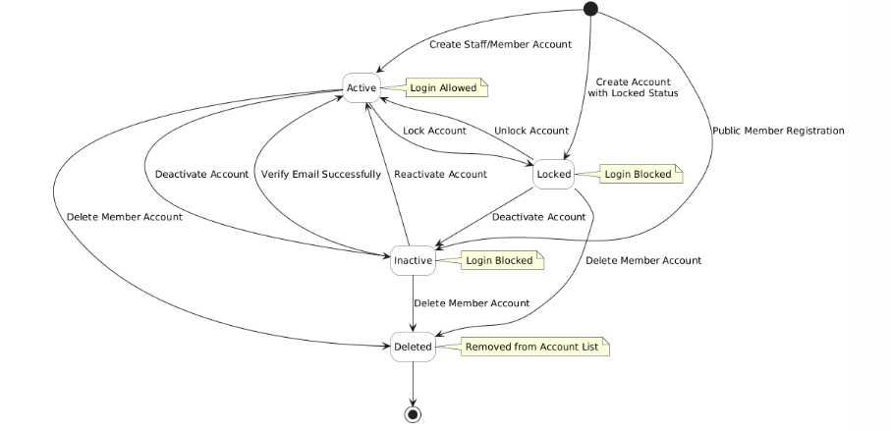

2.2 Package State Diagram
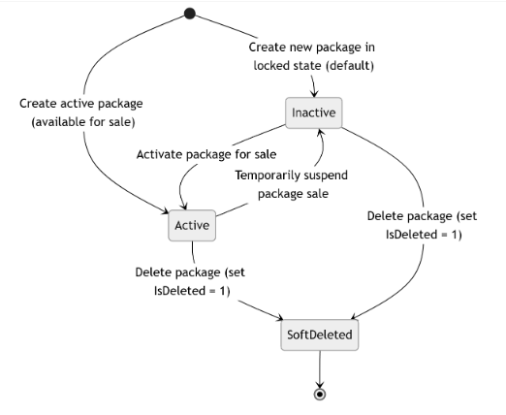

2.3 Invoice State Diagram
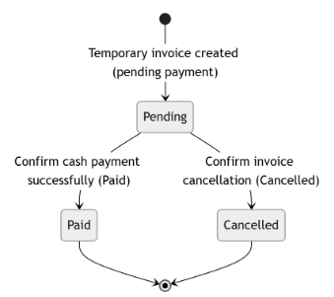

2.4 Member Package State Diagram
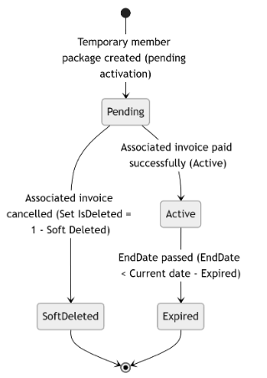

2.5 Register Package State Diagram
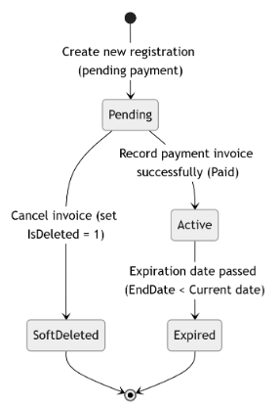

2.6 Manage Equipment State
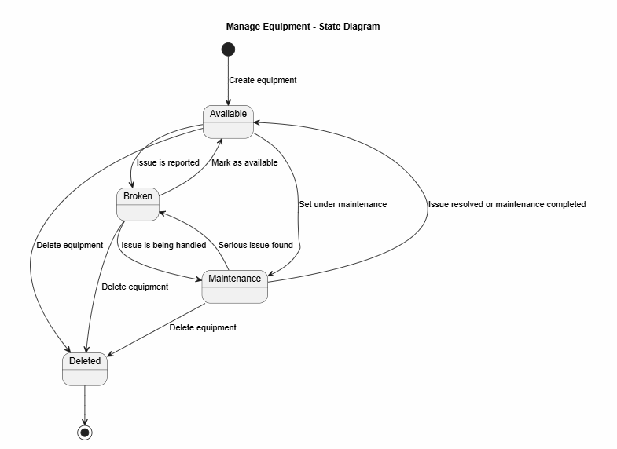
Description:This state diagram describes the main status changes of equipment. When equipment is created, it starts as Available. If an issue is reported, the equipment can become Broken. When the issue is being handled, the equipment changes to Maintenance. After the issue is resolved or maintenance is completed, the equipment returns to Available. Equipment can also be deleted from any main status.

2.7 Manage Equipment Issues
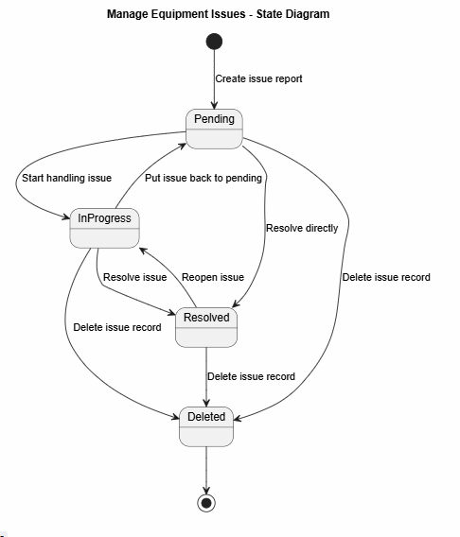
Description:This state diagram describes the lifecycle of an equipment issue. When an issue is reported, it starts as Pending. When staff begins handling the issue, it moves to InProgress. After the issue is fixed, it becomes Resolved. An issue can also be reopened or moved back to Pending if needed. Deleted is the final state when the issue record is removed from normal use.

2.8 Equipment Reports
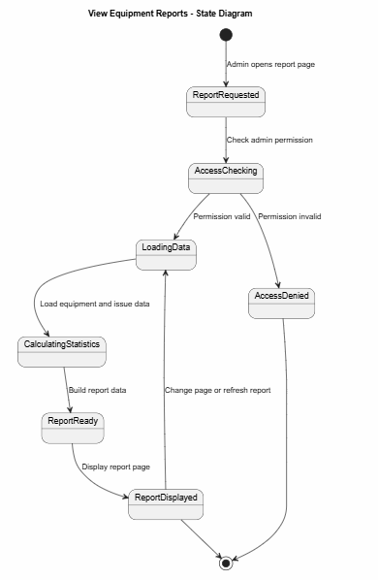
Description:This state diagram describes the states of the equipment report viewing process. When Admin opens the report page, the system checks access permission. If the permission is valid, the system loads equipment and issue data, calculates statistics, builds the report, and displays it. If the permission is invalid, access is denied. The displayed report can be refreshed or changed by pagination.

2.9 PT Schedule Training
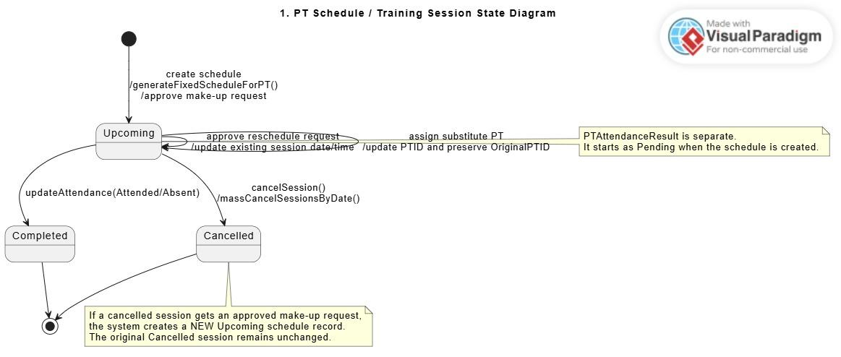
Description: This state diagram describes the lifecycle of a PT training session. A session is first created with Upcoming status when the PT schedule is generated or when a make-up request is approved. An Upcoming session can become Completed after attendance is updated, or Cancelled when Admin cancels the session individually or through mass cancellation. If a Cancelled session needs compensation, the system creates a new Upcoming make-up session instead of changing the original Cancelled session.

2.10 Reschedule Request 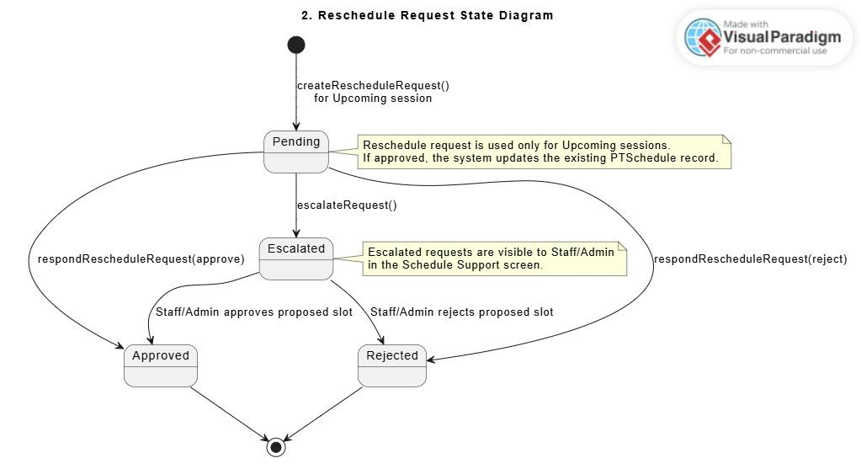
Description: This state diagram describes the lifecycle of a reschedule request for an Upcoming PT session. A request starts as Pending after a Member or Personal Trainer proposes a new date and fixed slot. The receiver can approve, reject, or escalate the request to Staff/Admin support. If approved, the existing PT session is updated to the proposed schedule. If rejected, the original session remains unchanged.

2.11 Make-up Request
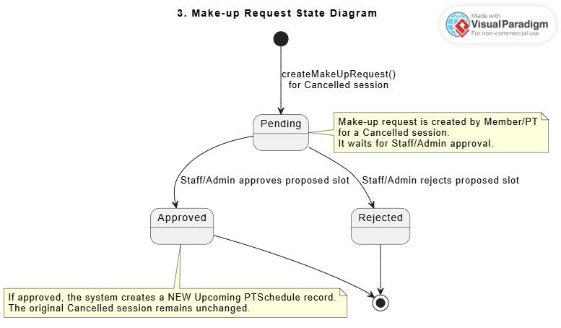
Description: This state diagram describes the lifecycle of a make-up request for a Cancelled PT session. A make-up request starts as Pending after a Member or Personal Trainer proposes a replacement date and fixed slot. Staff/Admin reviews the request and either approves or rejects it. If approved, the system creates a new Upcoming PT session while keeping the original Cancelled session unchanged for audit.

2.12 PT Registration
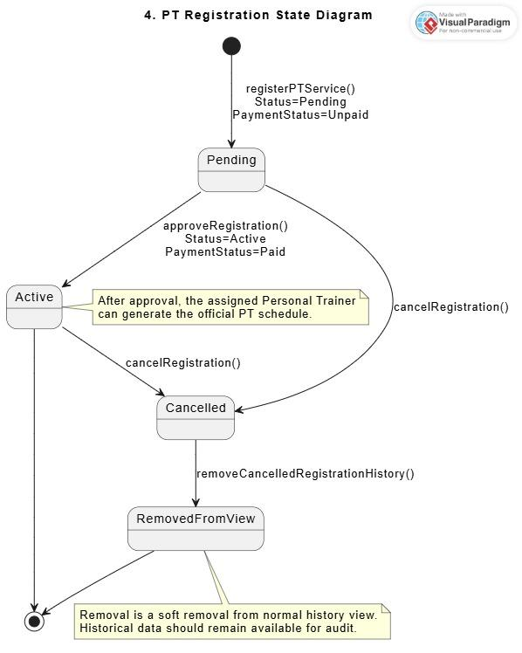
Description: This state diagram describes the lifecycle of a PT service registration. A registration starts as Pending with Unpaid payment status after the Member submits a PT service request. Staff/Admin approves the registration after payment confirmation, changing it to Active and Paid. A registration may be cancelled when the service should no longer continue. Cancelled registration history may be removed from the normal view by Admin while still being preserved for audit purposes.

2.13 PT Attendance Result

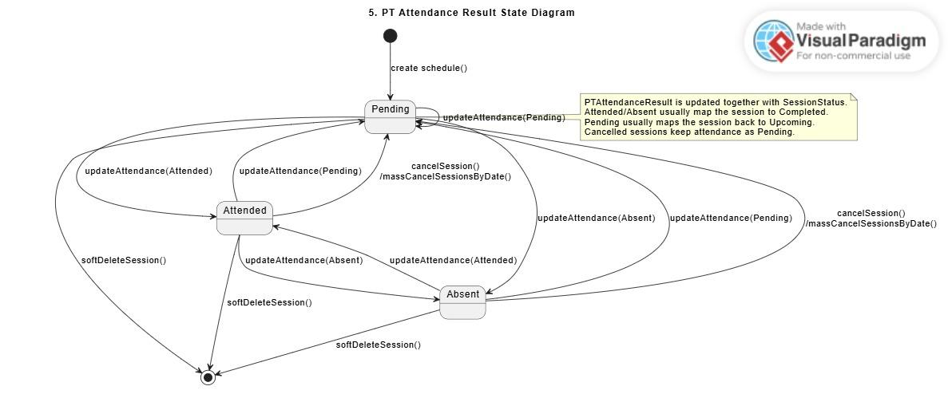
Description: This state diagram describes the possible attendance result values of a PT training session. A newly created schedule starts with Pending attendance. Staff/Admin can update the result to Attended or Absent after the session becomes eligible for attendance update. The attendance result may also be reset to Pending when needed. When a session is cancelled, the attendance result remains or returns to Pending, and the session is not counted as completed progress.

2.14 Manage Maintenance Schedules
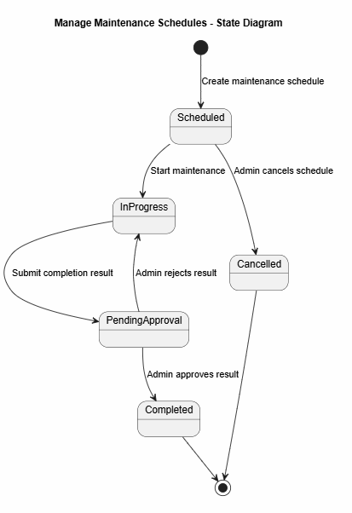
Description:This state diagram describes the lifecycle of a maintenance schedule. When a schedule is created, it starts as Scheduled. When maintenance begins, it changes to InProgress. After staff submits the completion result, it moves to PendingApproval. Admin can approve the result and change it to Completed, or reject it and return it to InProgress. A scheduled maintenance can also be cancelled by Admin.

2.15 Manage Blog & Policies
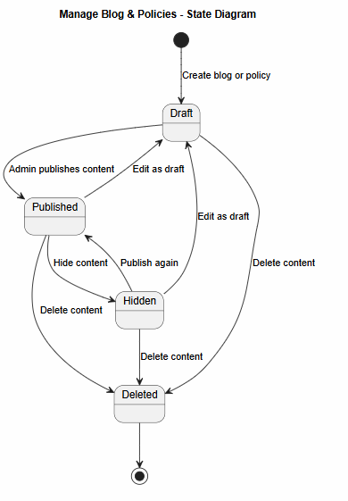
Description:This state diagram describes the status changes of a blog or policy. When content is created, it starts as Draft. Admin can publish it to make it visible to users. Published content can be hidden, and hidden content can be published again. Content can also be edited back as Draft. When content is deleted, it moves to Deleted and is no longer shown in normal management or public views.

2.16 Manage Members - Member Account State
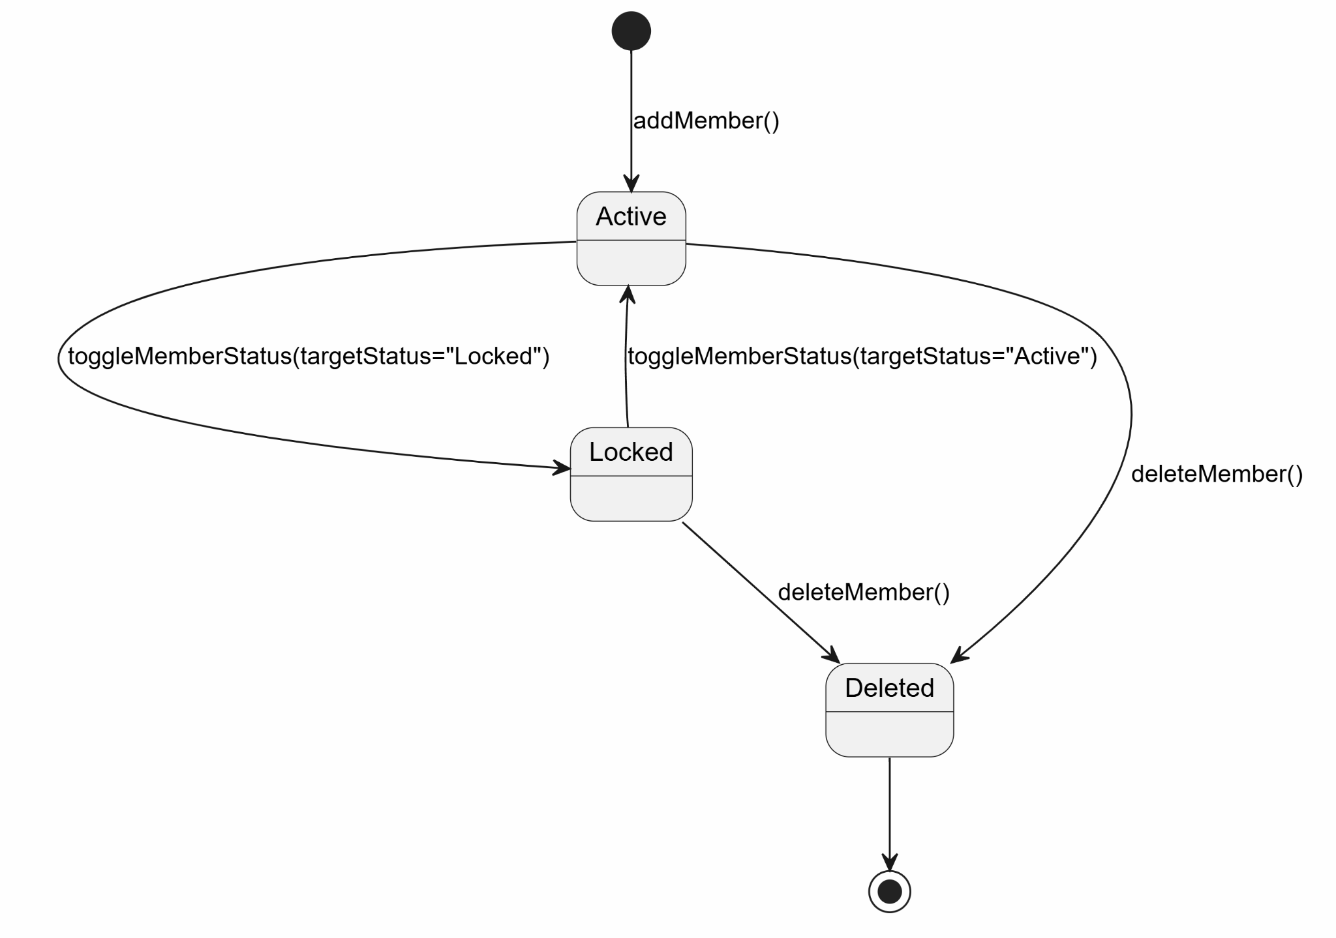

2.17 Staff & PTAttendance State
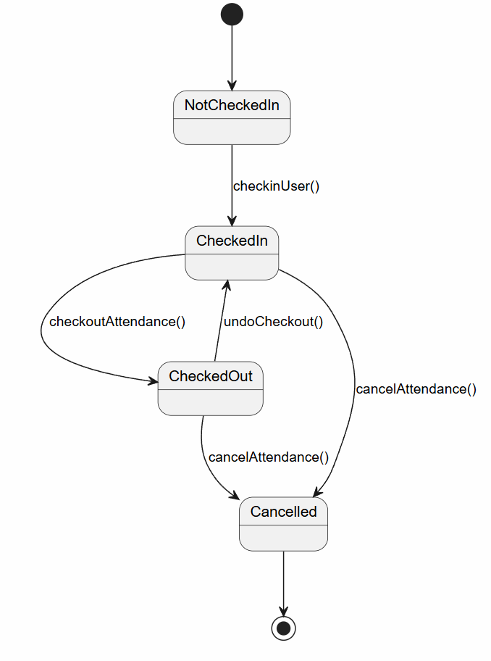

2.18 Session Chat History State
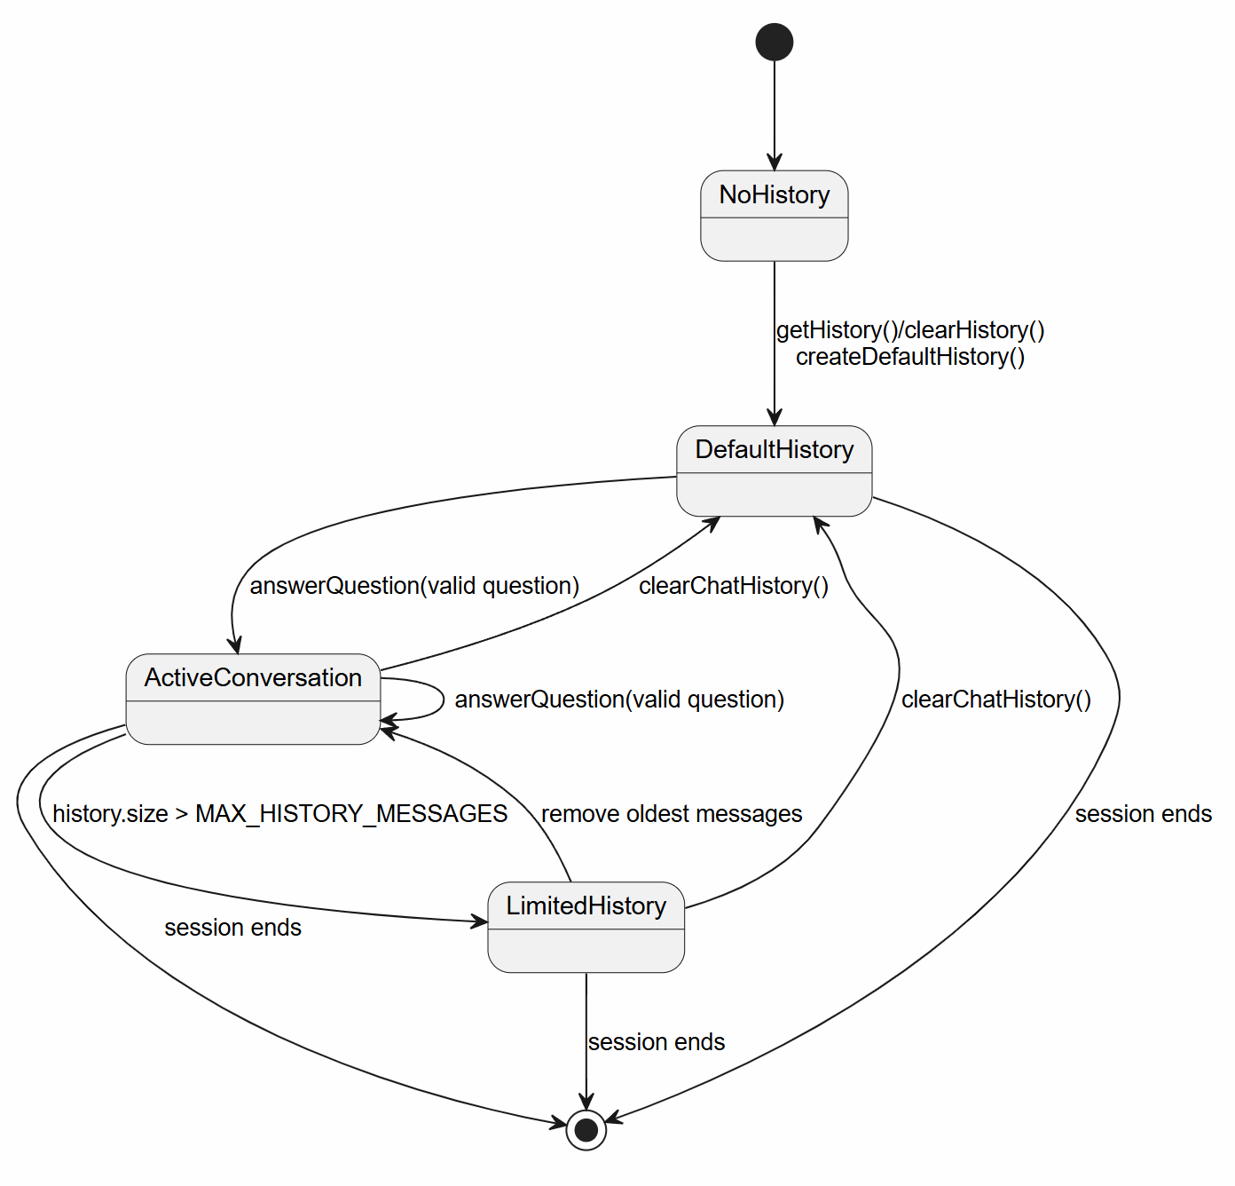

3. Detailed Design

3.1 System & Account Management

3.1.1 Class Diagram
[The implementation diagram provides a simplified class-level view of the authentication and profile module. It shows the main controllers, filter, DAO interface and implementation, base DAO, model classes, DTO classes, and utility classes used by the three use cases. The diagram highlights dependencies such as controllers using UserDAO, UserDAOImpl extending BaseDAO and implementing UserDAO, DTO inheritance from UserProfileBaseDTO, and utility usage such as PasswordUtils, EmailUtils, and DBContext ]
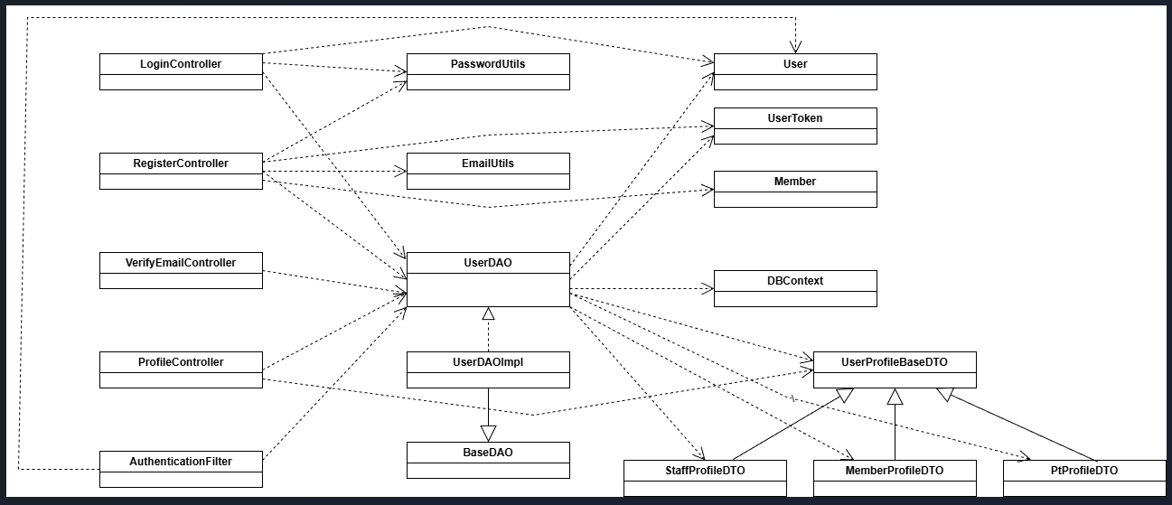

3.1.2 <Sequence Diagram Login>
[This sequence diagram describes the login process for a registered user. The user submits email and password through login.jsp, and LoginController validates the credentials against data retrieved by UserDAO and UserDAOImpl. The password is hashed using PasswordUtils before comparison. If authentication succeeds, the system checks the account status, optional remember-me token, and password-change requirement, then redirects the user to the proper role-based dashboard. Exception flows include missing input, invalid credentials, inactive account, locked account, and invalid remember-me token]
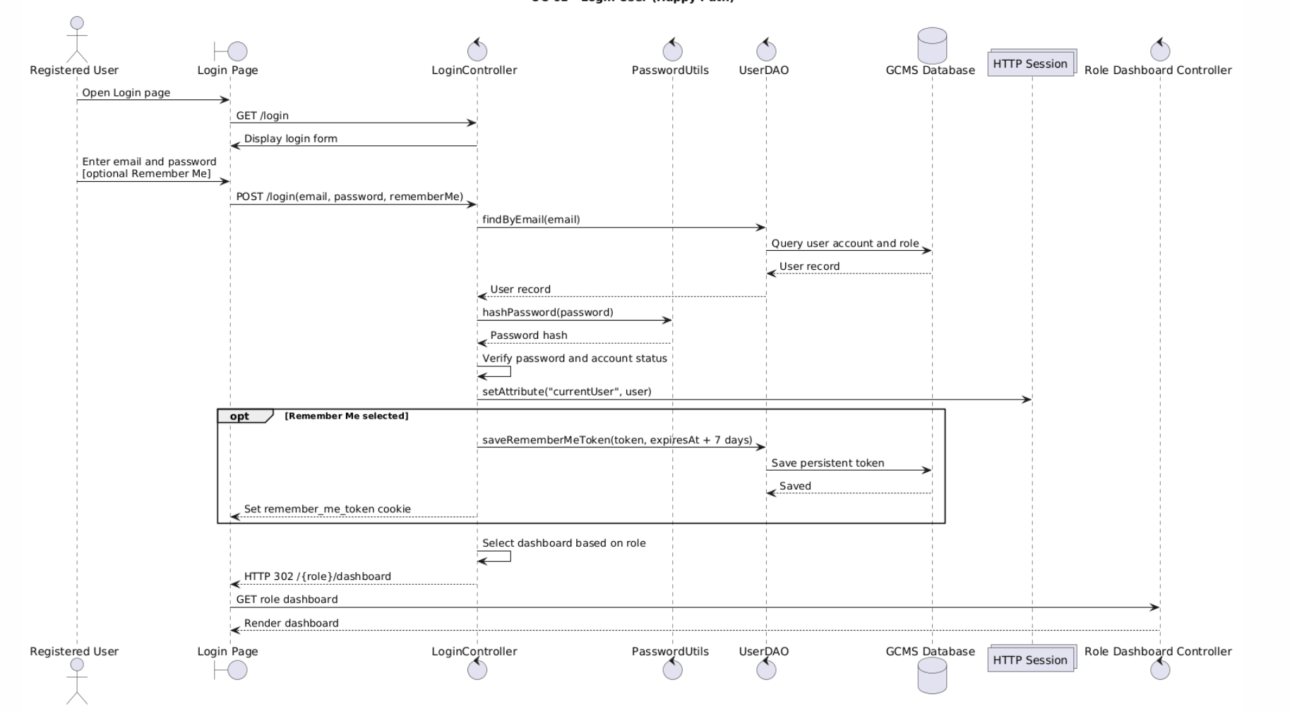

3.1.2.1 <Activity Diagram Login>
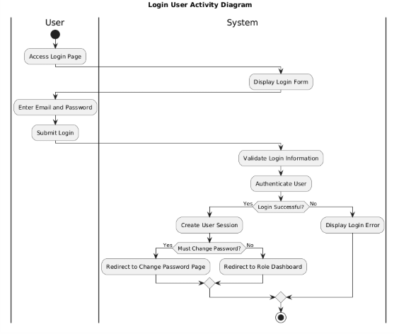

3.1.3 <Sequence Diagram Register Membership>
[This sequence diagram shows how a guest registers for a member account. The guest submits registration information through register.jsp, and RegisterController validates the input, checks for duplicate email, hashes the password, creates User, Member, and UserToken objects, and stores them through UserDAO and UserDAOImpl. The new account is initially created as inactive, and a verification email is sent using EmailUtils. After the user clicks the verification link, VerifyEmailController validates the token and activates the account. ]

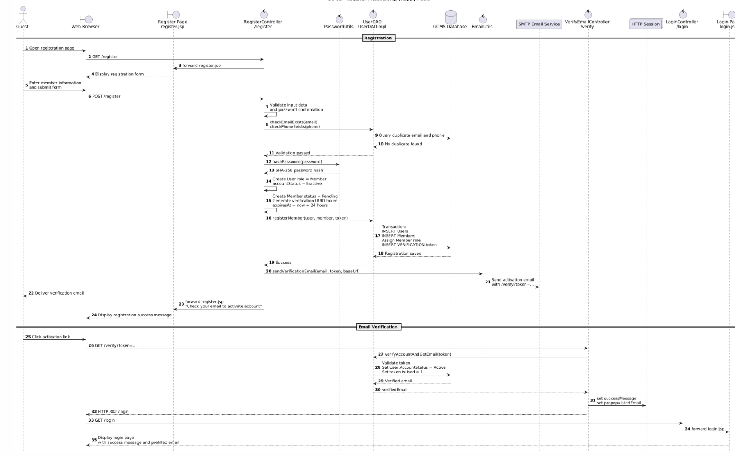

3.1.3.2 <Activity Diagram Register Membership>
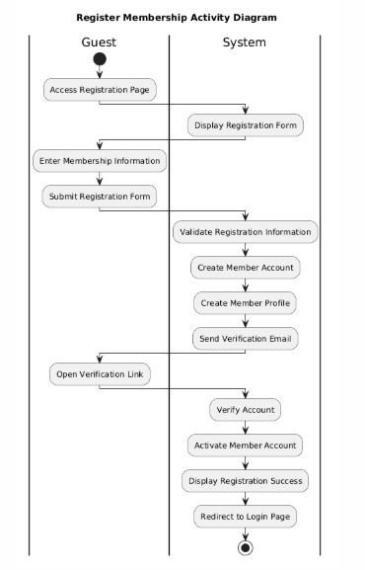

3.1.4 <Sequence Diagram Manage User Profile>
[This sequence diagram represents the profile viewing and updating process for authenticated users. ProfileController retrieves the current user profile through UserDAO and UserDAOImpl, then displays role-specific fields in profile.jsp. When the user submits changes, the controller validates common fields and role-specific data, such as member information or personal trainer uploads. If validation succeeds, the updated profile is saved to the database and the profile page is reloaded with a success message.. ]
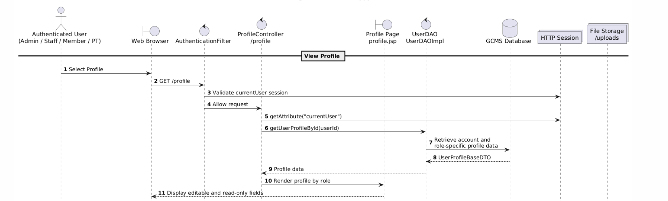
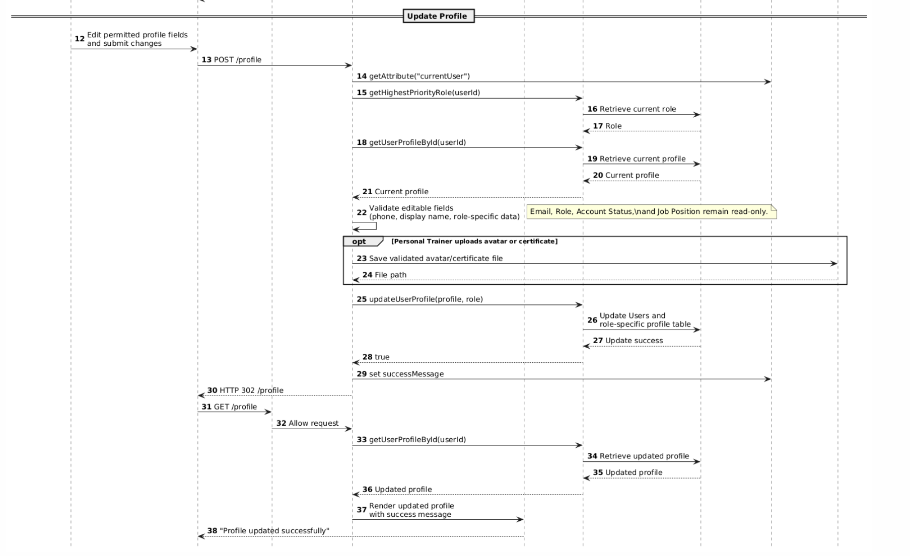

3.1.4.1 <Activity Diagram Manage User Profile>
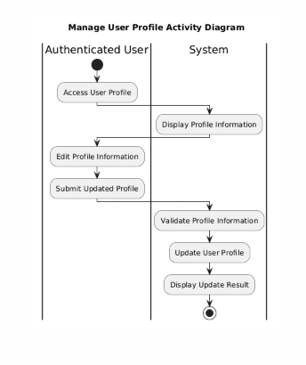

3.1.5 <Sequence Diagram Change Password>
[ This sequence diagram represents the password-change process for authenticated users. ChangePasswordController retrieves the current account through UserDAO and UserDAOImpl, validates the current password, new-password complexity, and confirmation password, then hashes and saves the new password. On success, the system revokes old Remember Me tokens, clears the browser cookie, invalidates other active sessions through SessionRegistry, and redirects the user to the correct role dashboard with a success message. ]
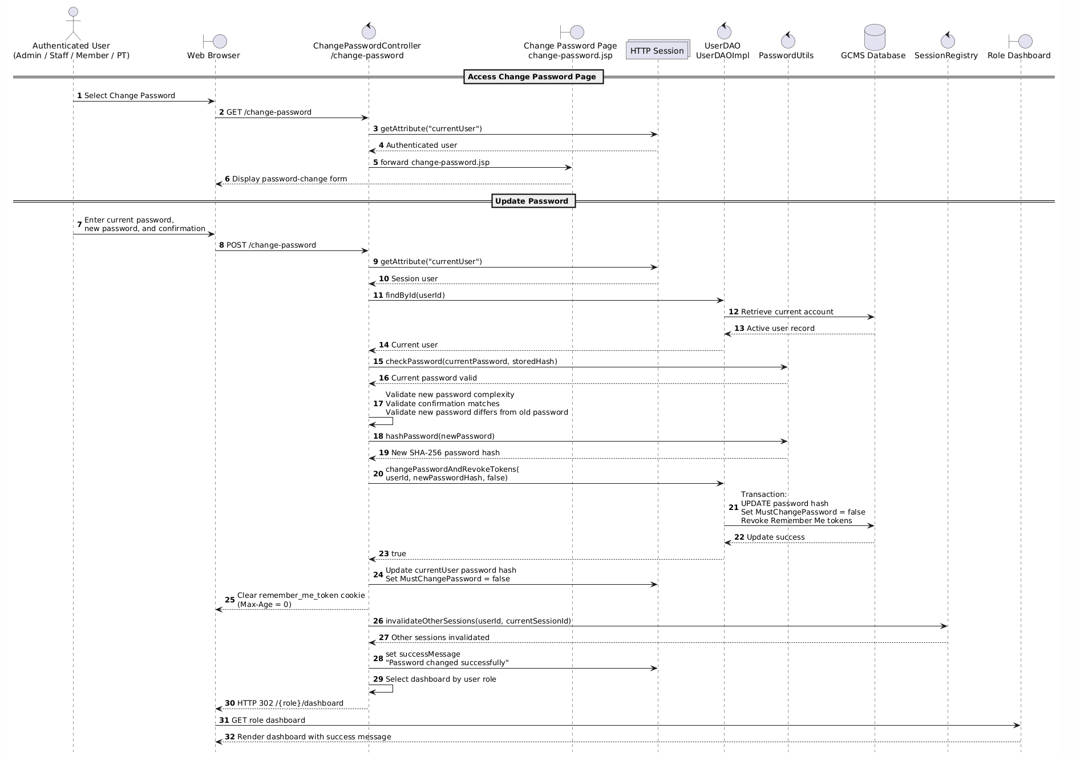

3.1.5.1 <SActivity Diagram Change Password>
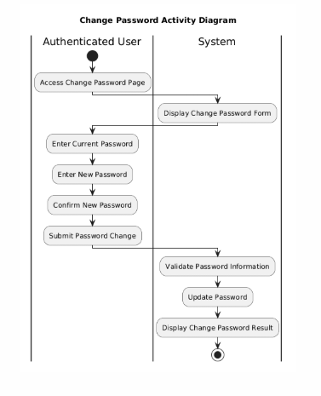

3.1.6 <Sequence Diagram Manage Accounts>
[ This sequence diagram represents the account-management process for an administrator. ManageAccountController retrieves the paginated account list through UserService and UserDAO, then allows the Admin to create a managed account. UserServiceImpl validates account data, generates and hashes a temporary password, marks the new account as requiring a password change, and saves the account with its role through UserDAOImpl. Finally, the controller redirects to the account list and displays the success message and temporary credentials. ]
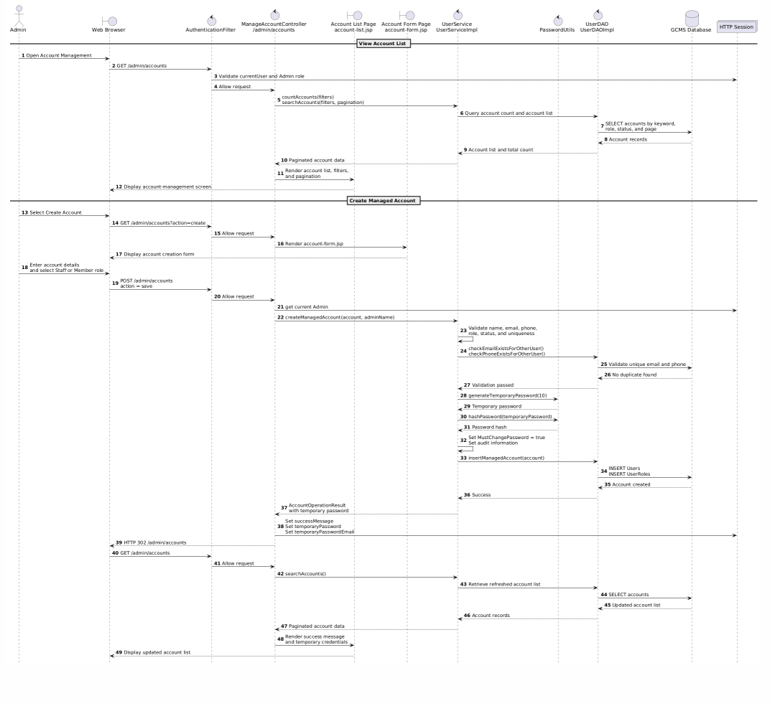

3.1.6.1 <Activity Diagram Manage Accounts>
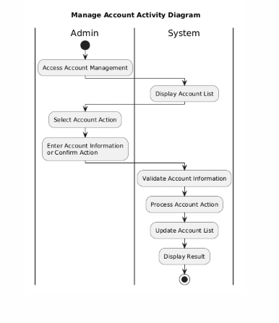

3.1.7 <Sequence Diagram View Dashboard>
[ This sequence diagram represents the process of viewing the Admin Dashboard. AdminDashboardController receives the authorized Admin request, creates a revenue filter, and calls DashboardService to aggregate dashboard metrics, revenue trends, recent invoices, and operational alerts through DashboardDAO. The service prepares chart labels and values, then dashboard.jsp renders the summary cards, revenue chart, alerts, and recent-invoice table without modifying system data. ]

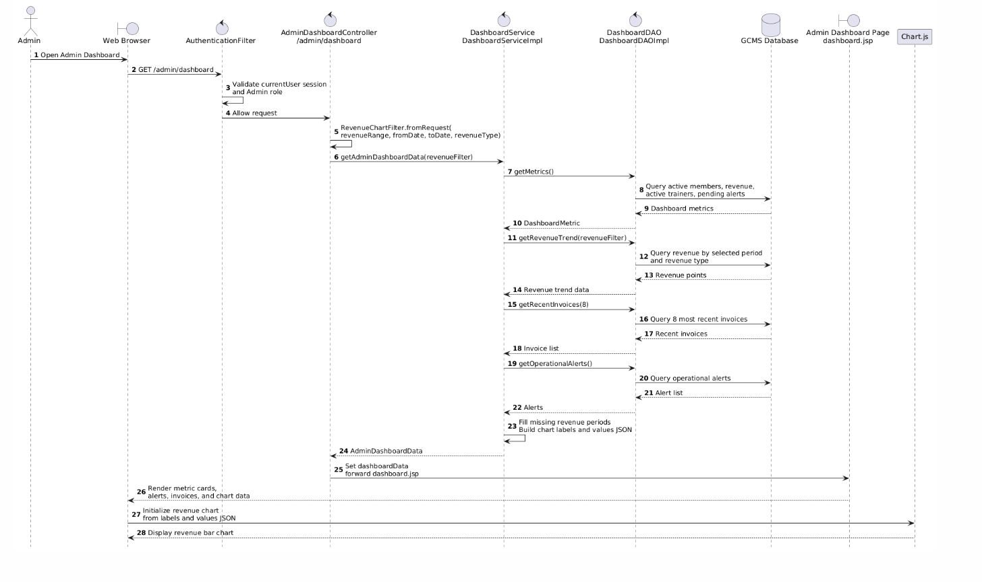

3.1.7.1 <Activity Diagram View Dashboard>
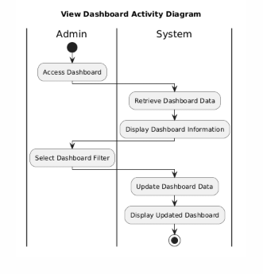

3.1.8 <Sequence Diagram Manage Notification>
[This sequence diagram represents the notification creation and publication process for an administrator. ManageNotificationController loads the notification list and creation form, validates the notification details and optional image, then calls NotificationService and NotificationDAO to save the notification. After successful persistence, the system redirects to the notification list and displays a confirmation message; the notification becomes available to its configured target role or account.]
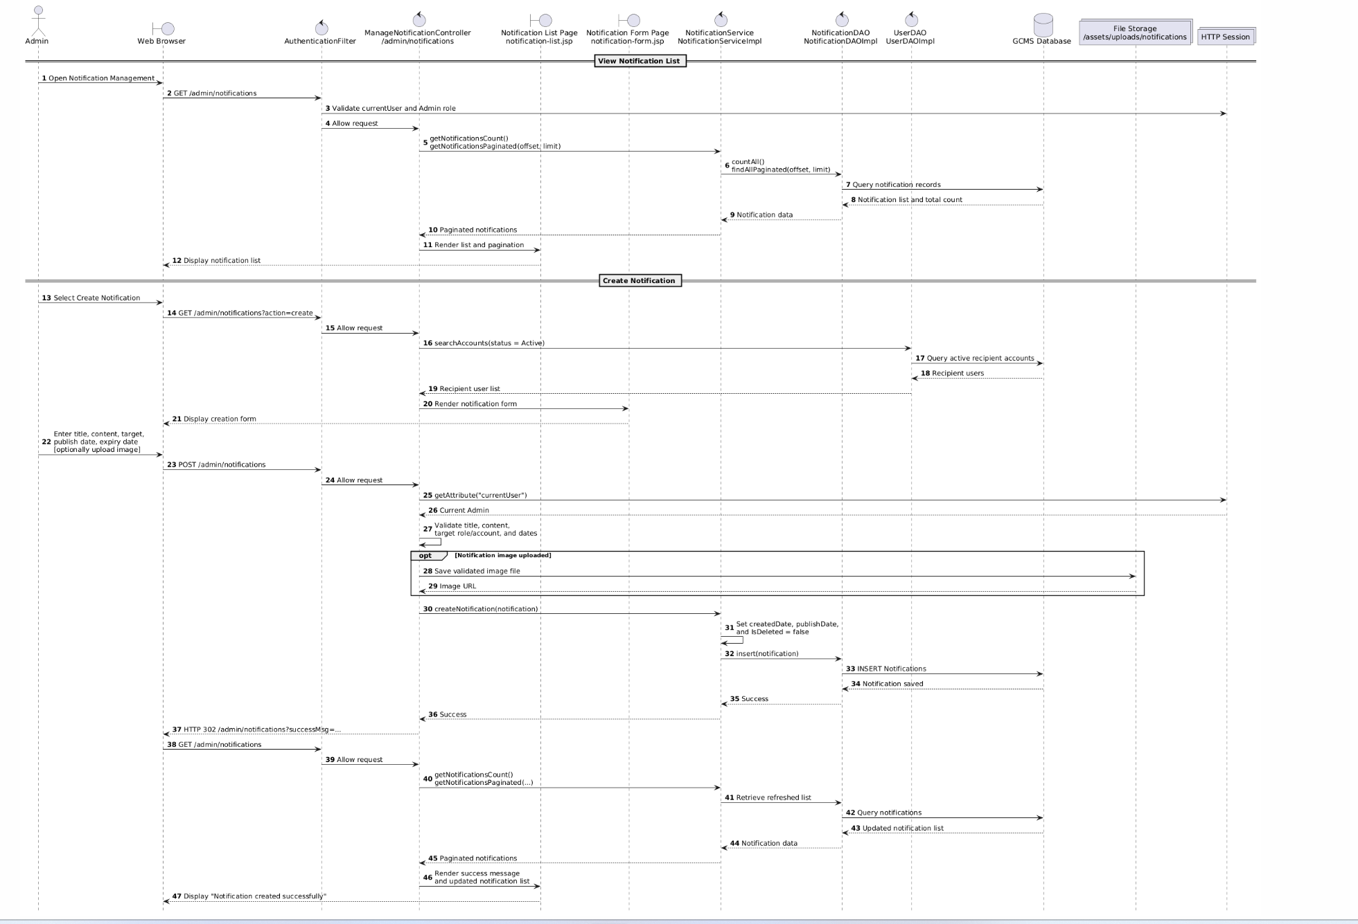

3.1.8.1 <Sequence Diagram Manage Notification>
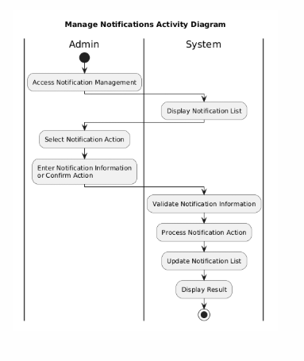

3.2 Package Management & Payment Management

3.2.1 Class Diagram

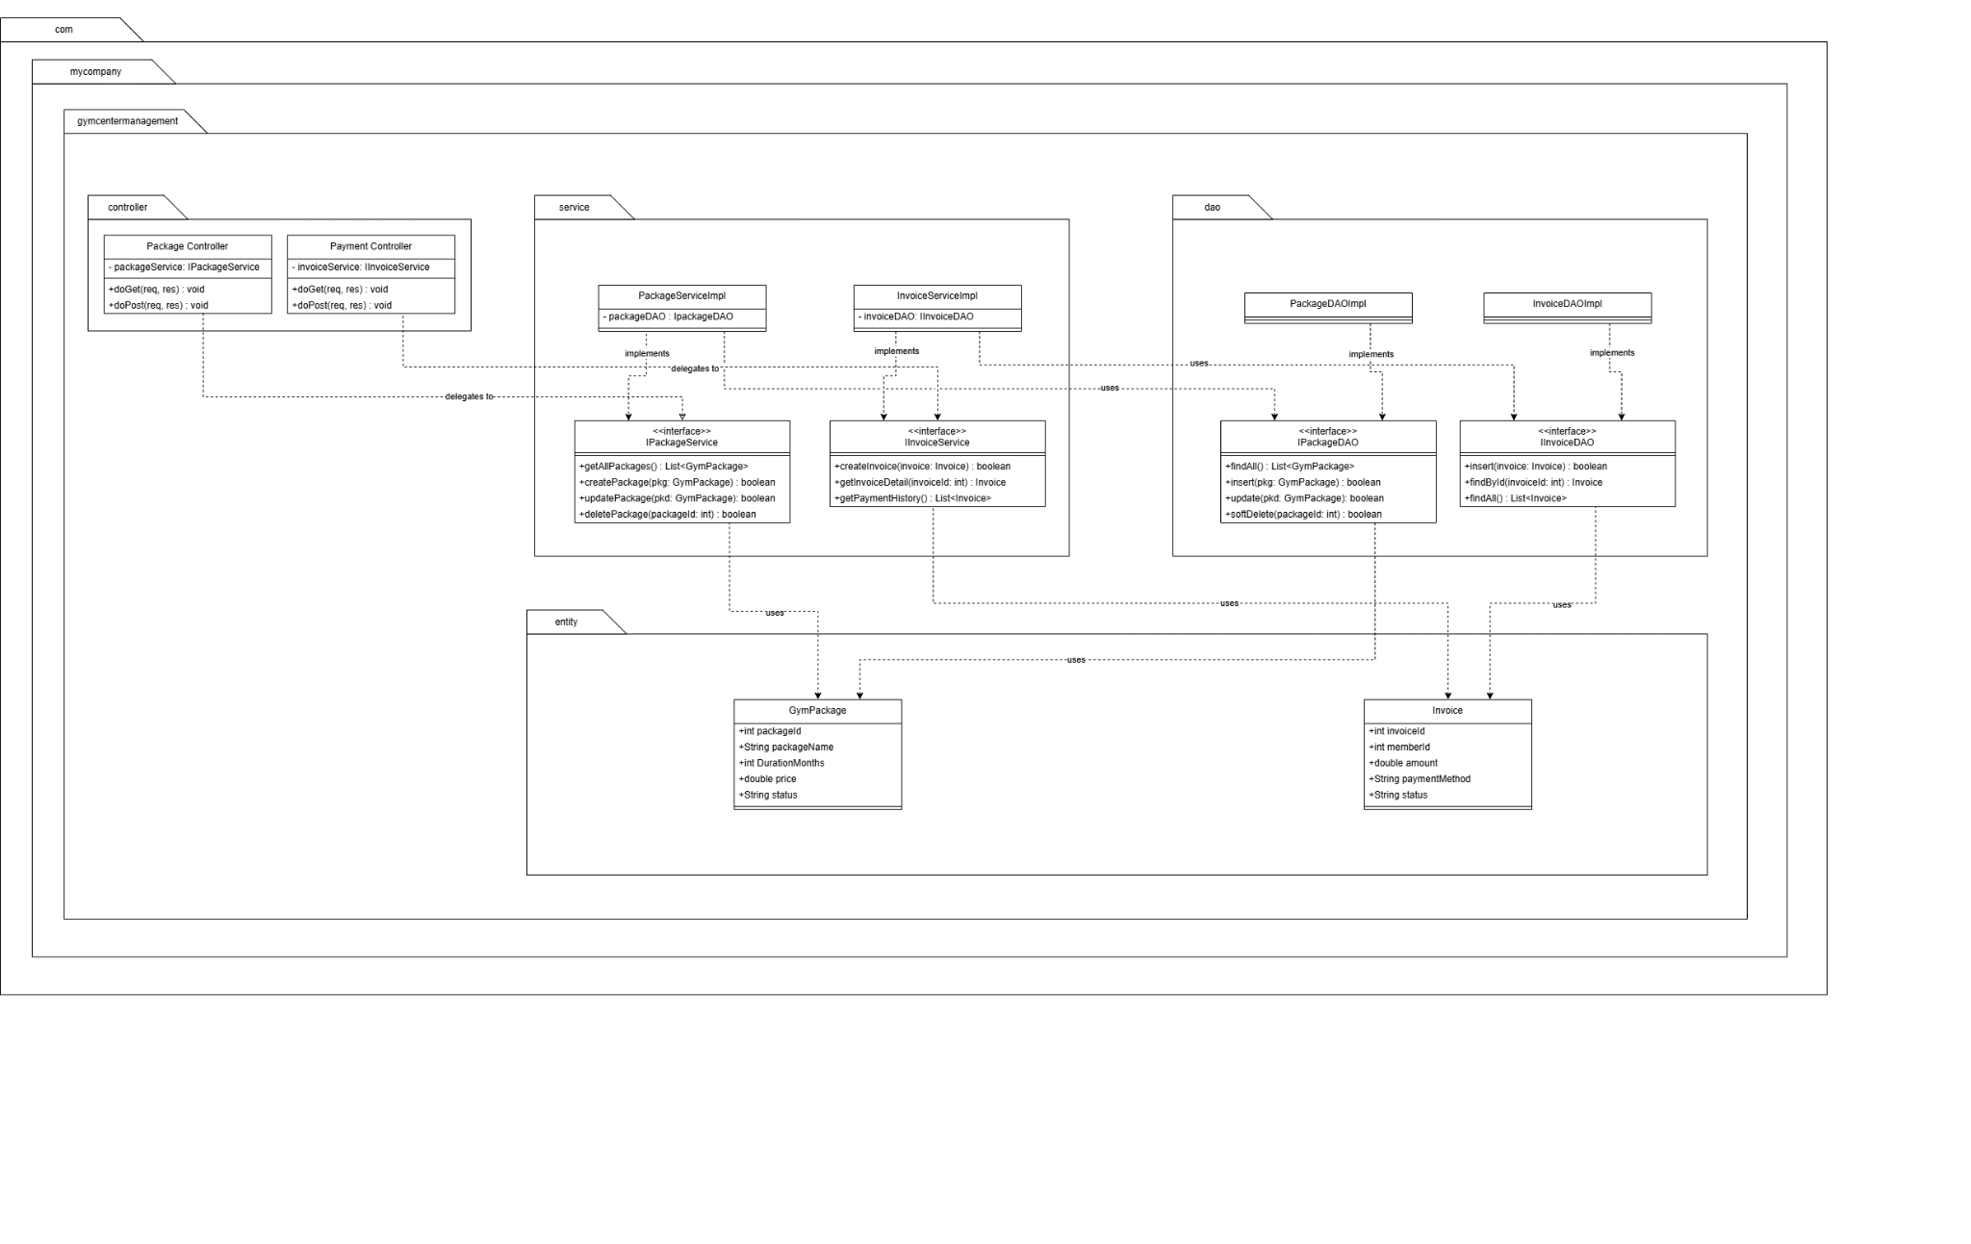https://drive.google.com/file/d/1jIbXUrocWRloffUqKaz0H79ItzQmz4m8/view?usp=sharing
Description: This class diagram presents the static structure of the Package and Payment Management module, strictly adhering to the N-tier architectural pattern. The Controllers (PackageController, PaymentController) are completely decoupled from direct database operations, interacting solely with the Service layer interfaces (IPackageService, IInvoiceService) to enforce core business rules such as package pricing validation and invoice generation. The service layer subsequently delegates data persistence tasks to the DAO layer (IPackageDAO, IInvoiceDAO), ensuring high cohesion and loose coupling across the system. This modular design guarantees secure data encapsulation and seamless transfer of GymPackage and Invoice entities between the presentation and data access layers.

3.2.2 Manage Package

3.2.2.1 Read Package Sequence
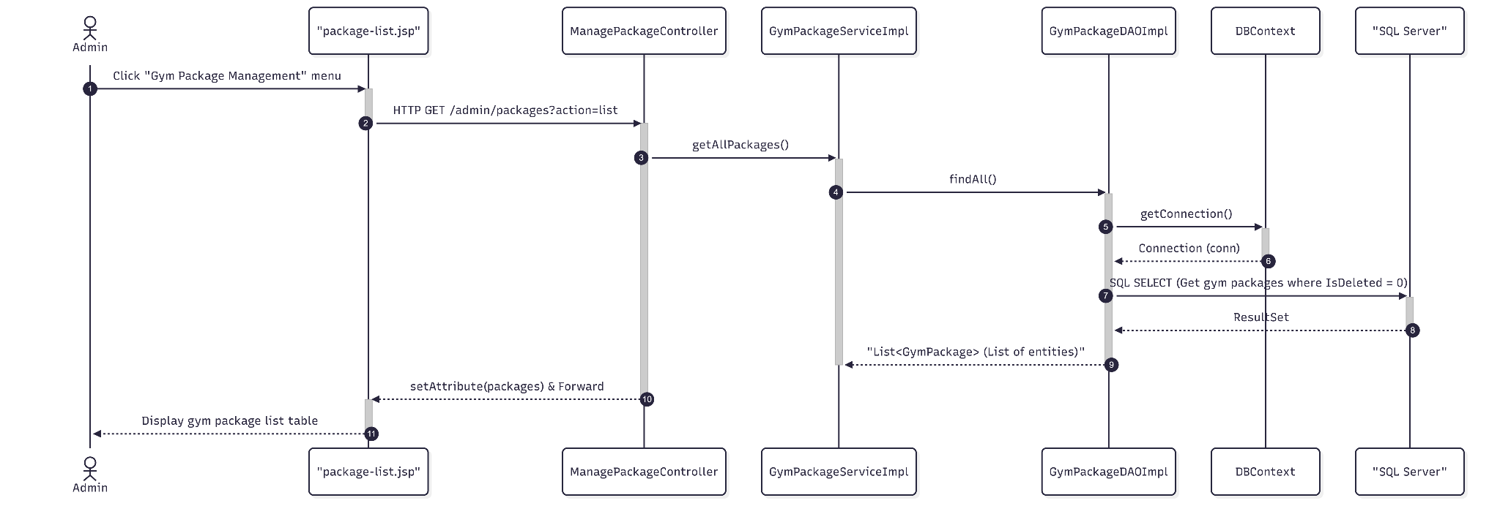

3.2.2.2 Read Package Swimlane Activity Diagram
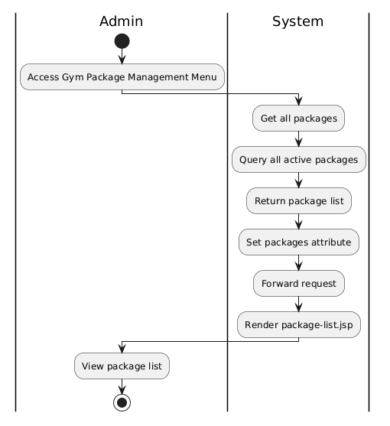

3.2.2.3 Create Package Sequence Diagram
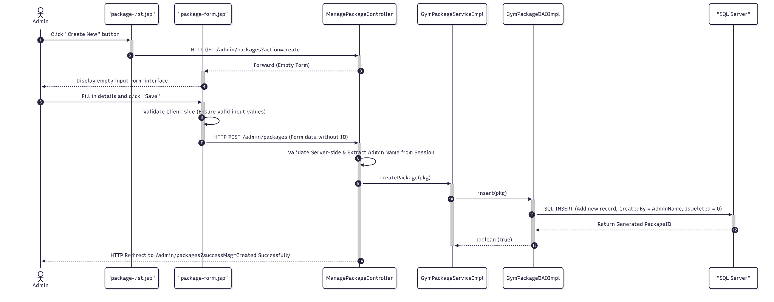

3.2.2.4 Create Package Swimlane Activity Diagram
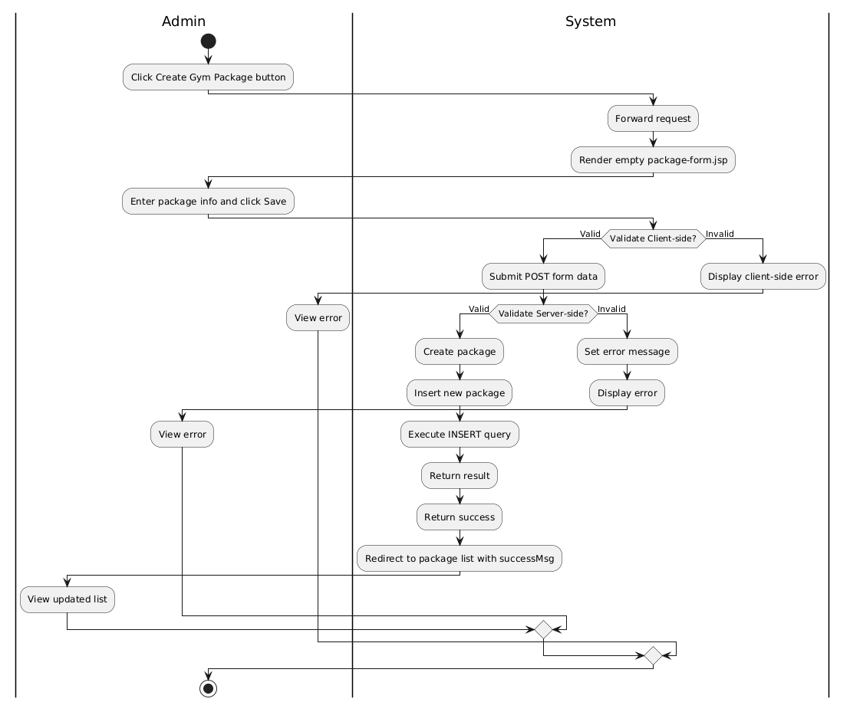

3.2.2.5 Update Package Sequence Diagram
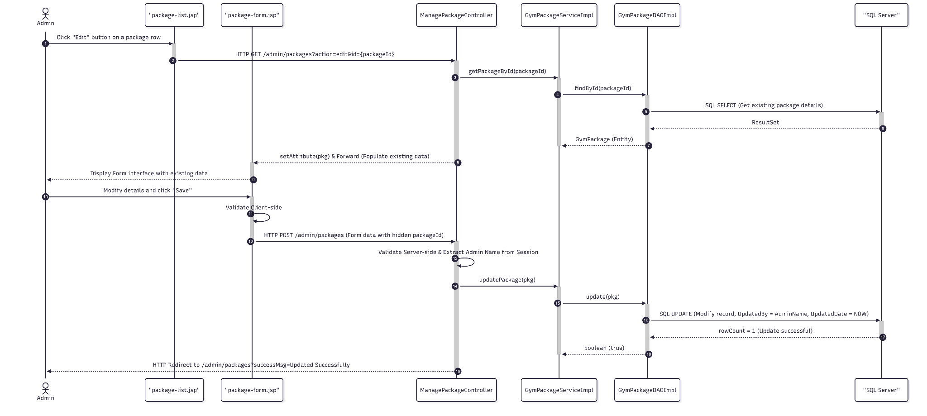

3.2.2.6 Update Package Swimlane Activity Diagram
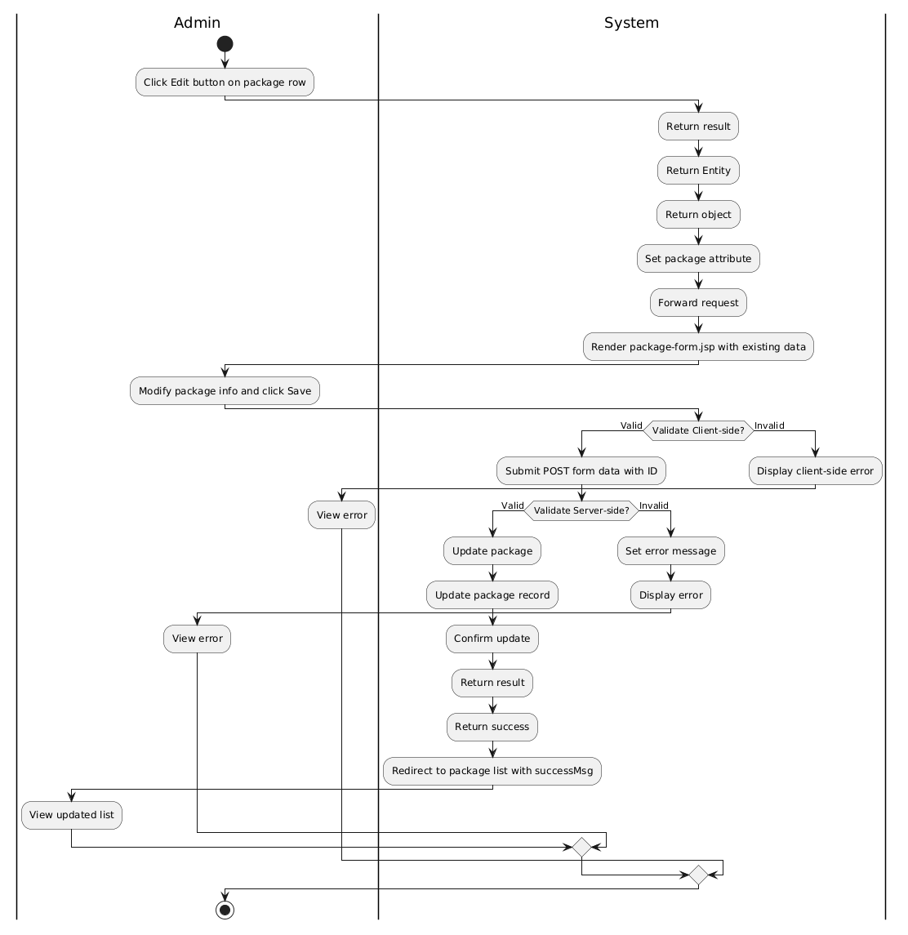

3.2.2.7 Deactivate/Disable Package Sequence Diagram
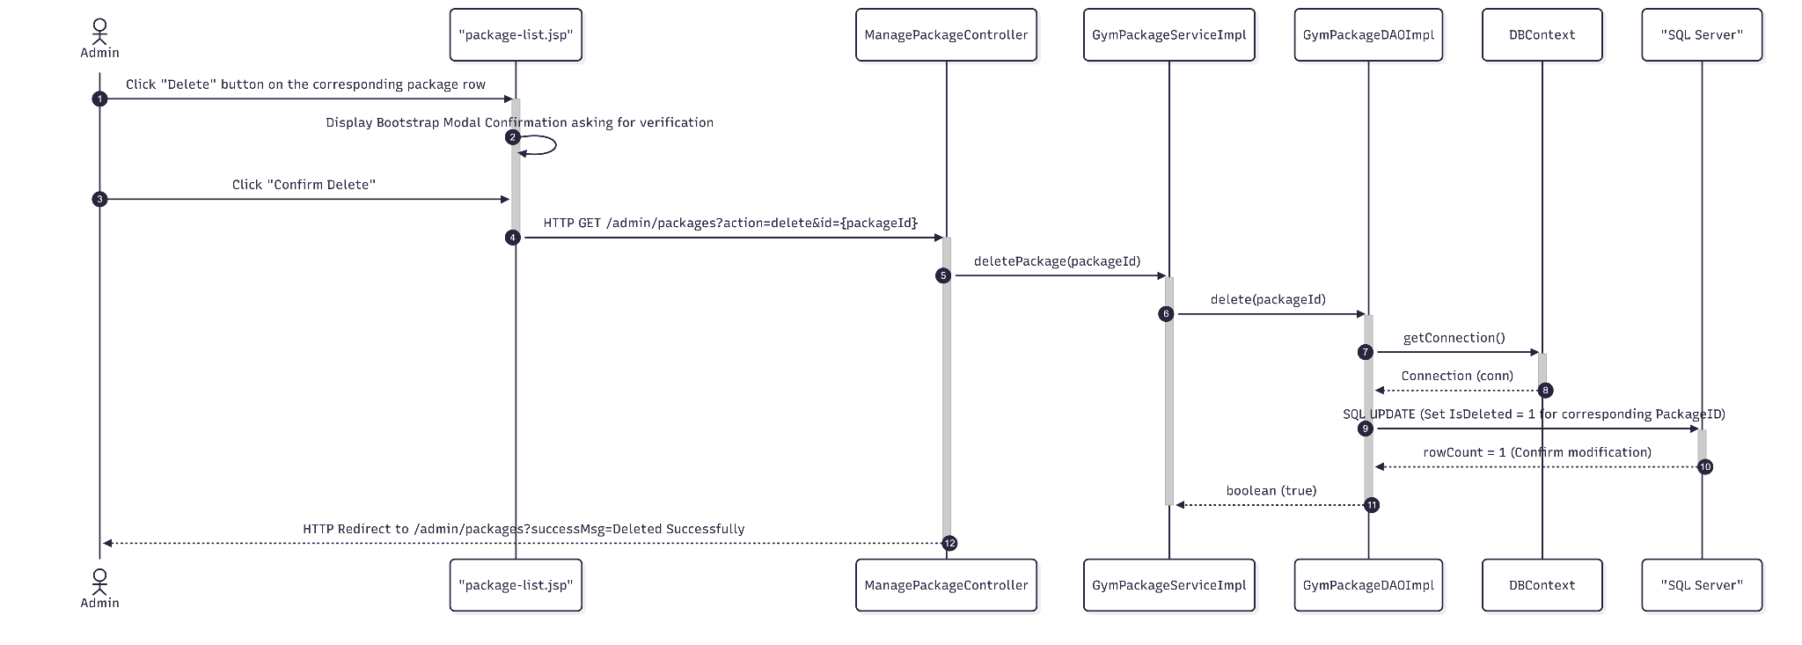

3.2.2.8 Deactivate/Disable Package Swimlane Activity Diagram
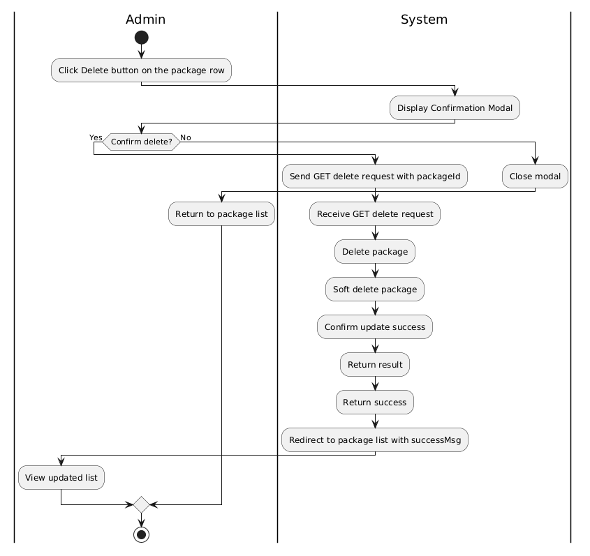

3.2.3 Register Package Sequence Diagram & Swimlane Activity Diagram

3.2.3.1 Register Package Sequence Diagram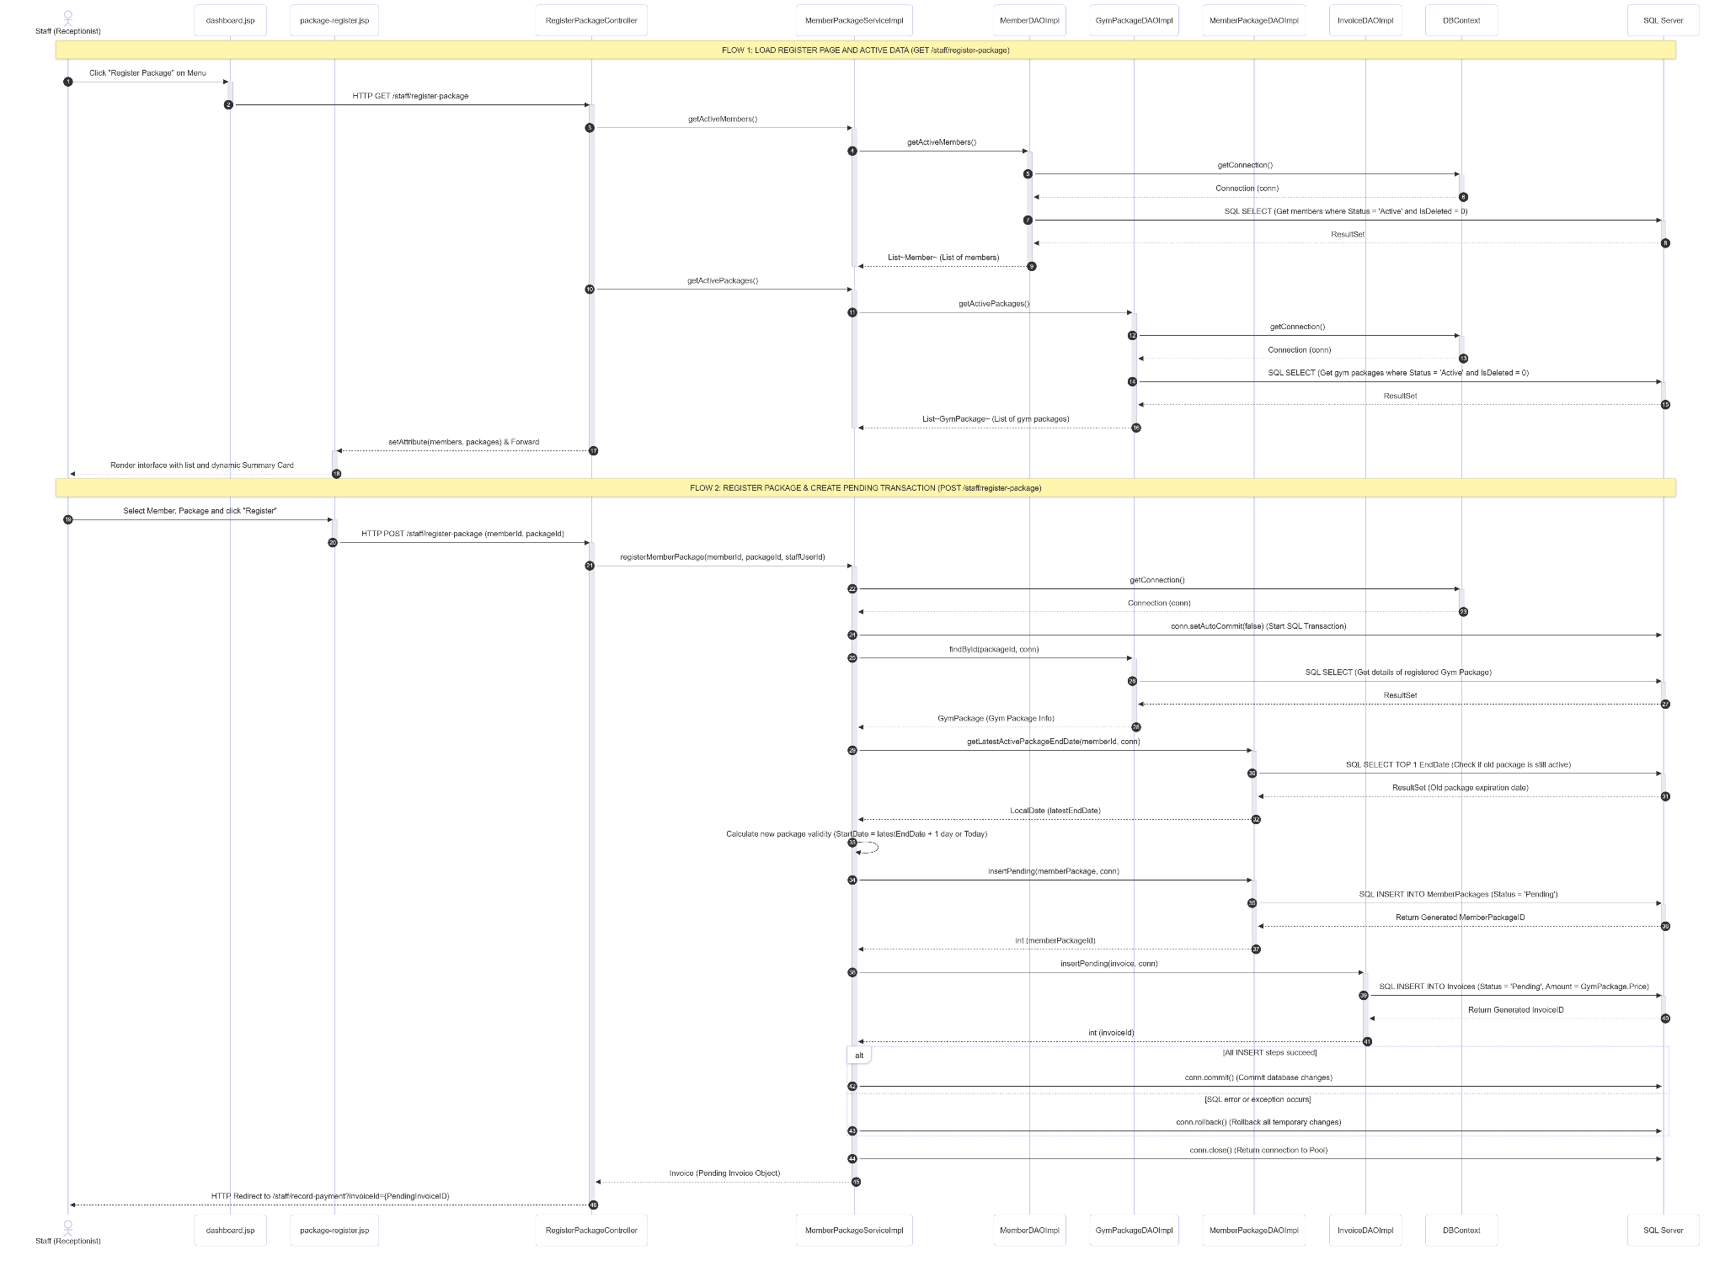

3.2.3.2 Register Package Swimlane Activity Diagram
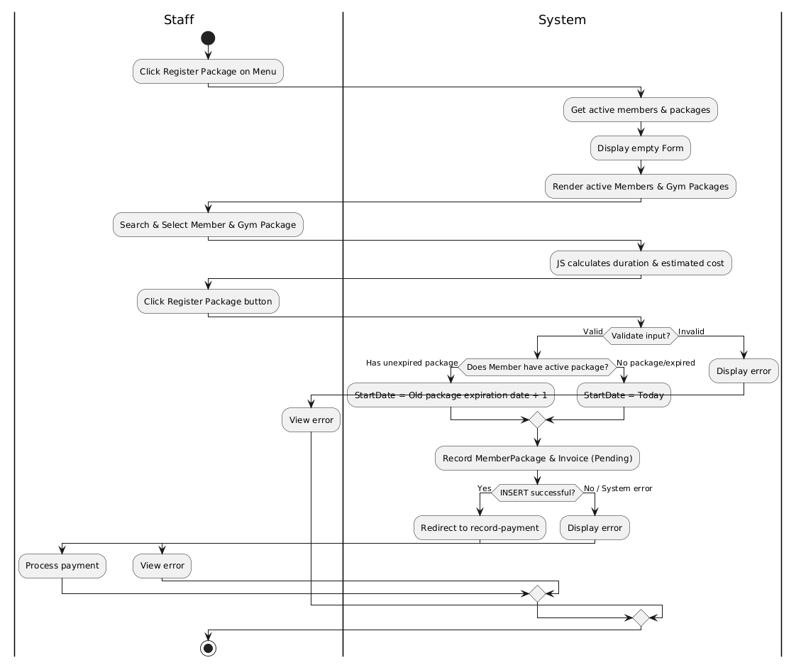

3.2.4 Record Payment

3.2.4.1 Invoice Display Sequence
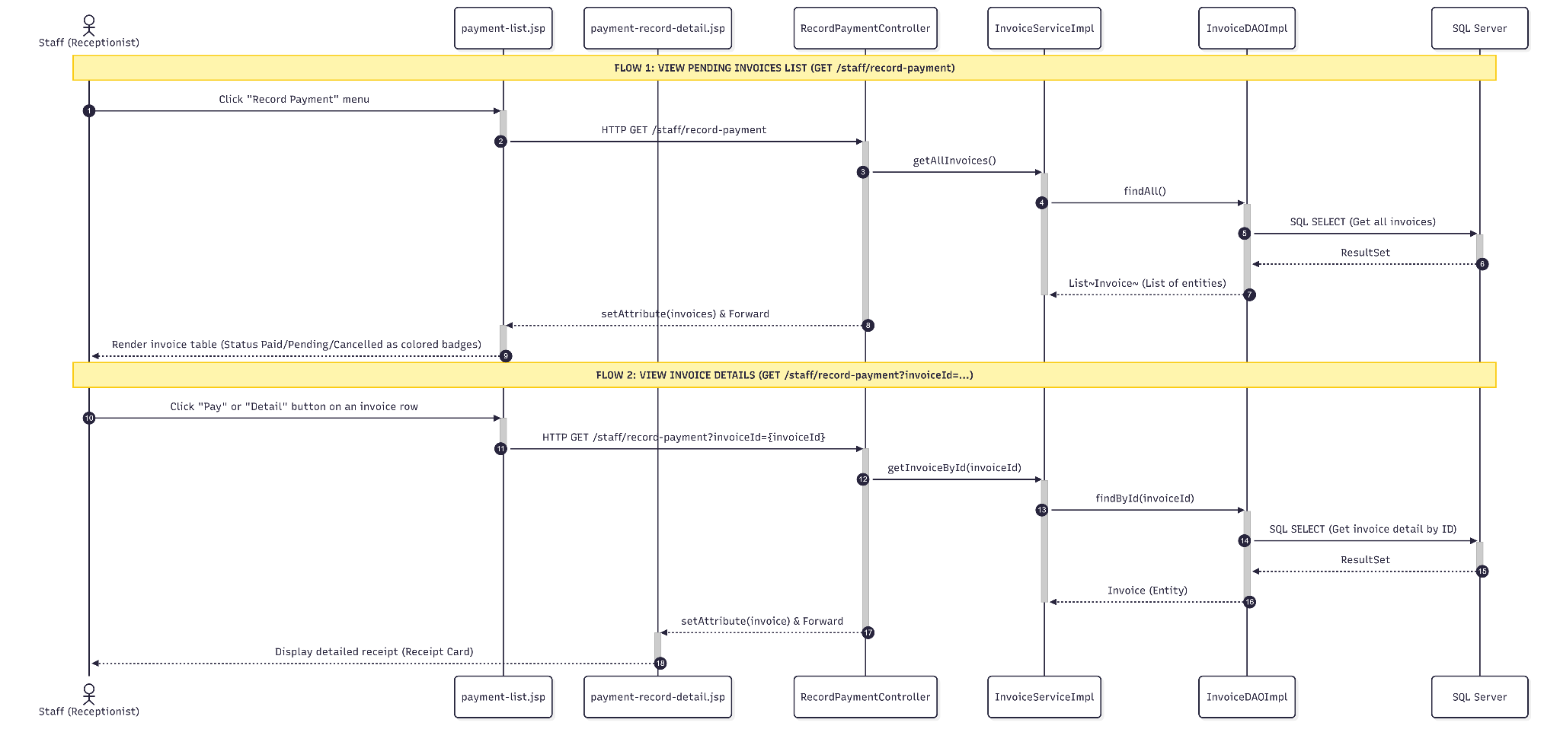

3.2.4.2 Confirm/Cancel Invoice Sequence
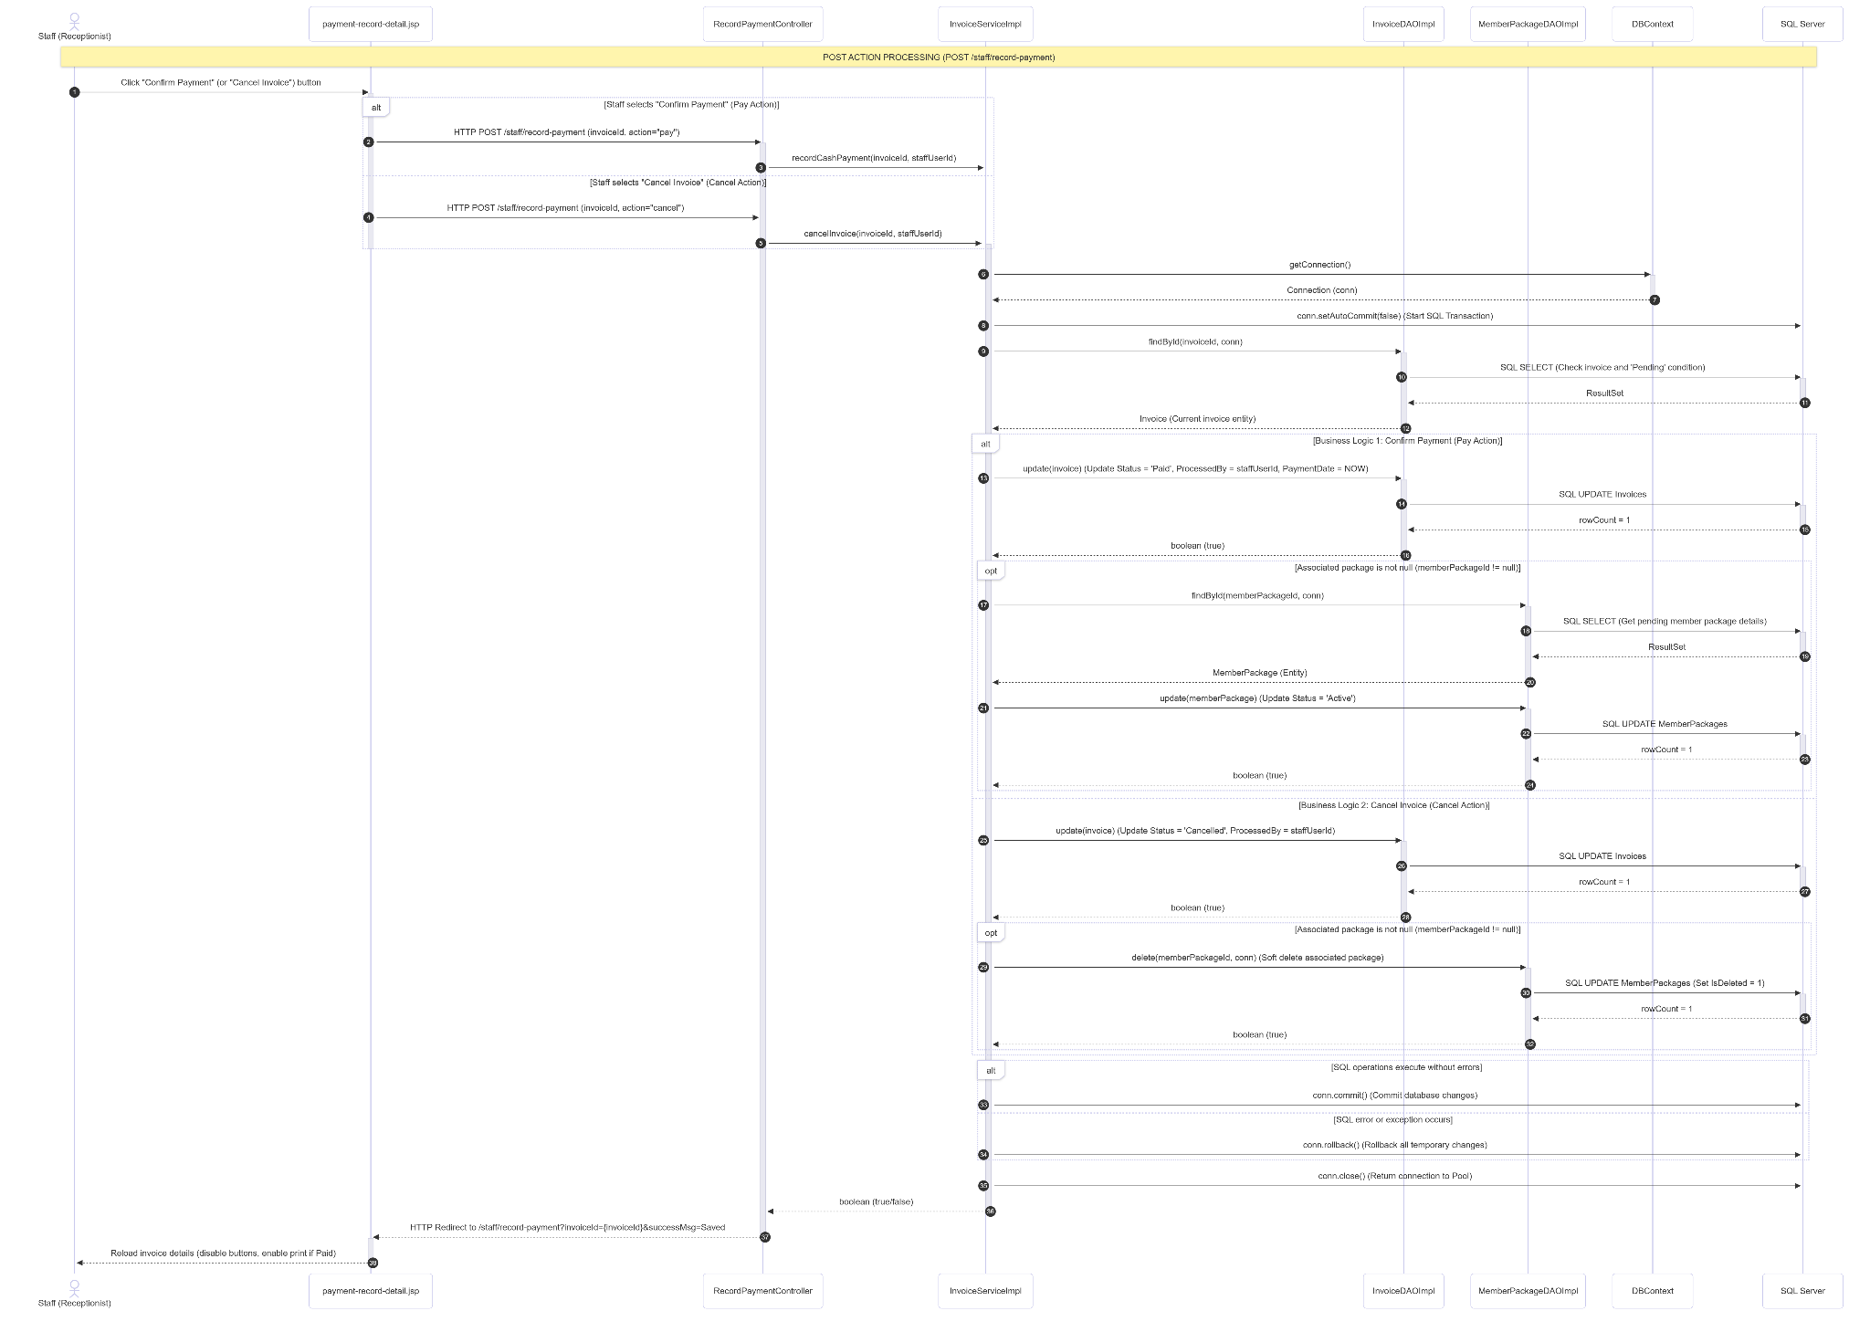

3.2.4.3 Record Payment Swimlane Activity Diagram
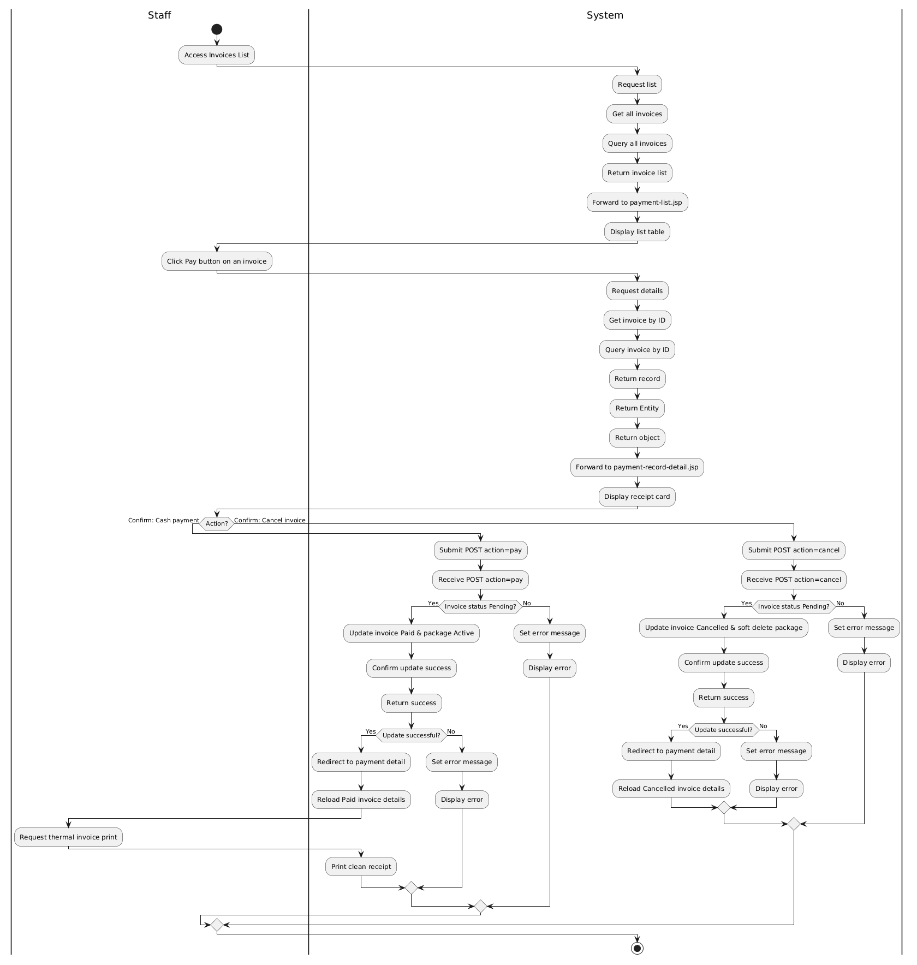

3.2.5 Renew & Transfer Package

3.2.5.1 Renew Package Sequence
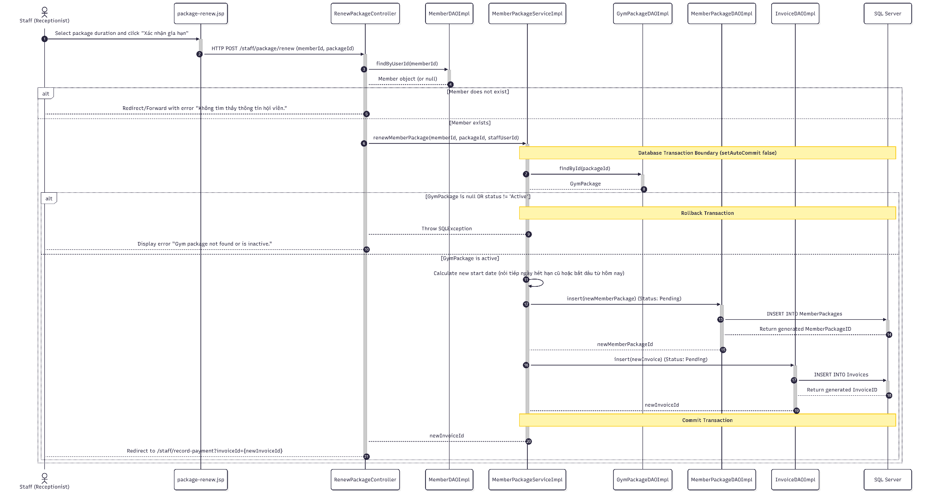

3.2.5.2 Renew Package Swimlane Activity Diagram
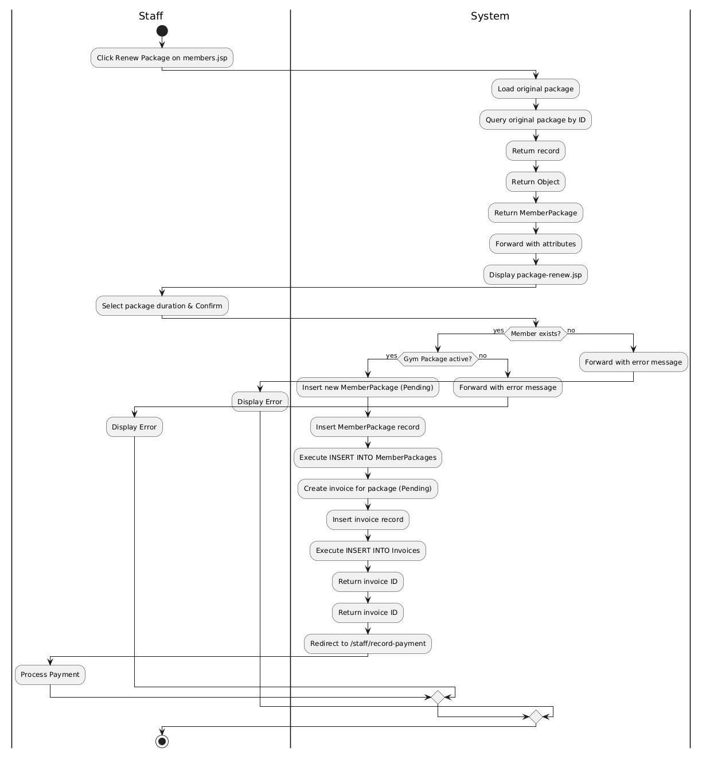

3.2.5.3 Transfer Package Sequence & Swimlane Activity Diagram
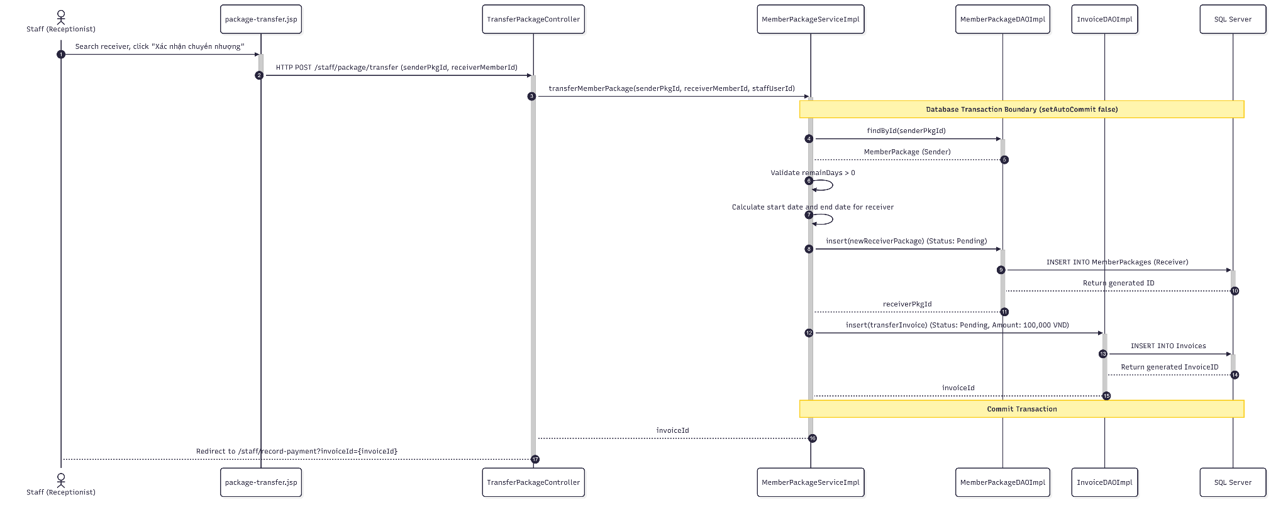

3.2.5.4 Transfer Package Swimlane Activity Diagram
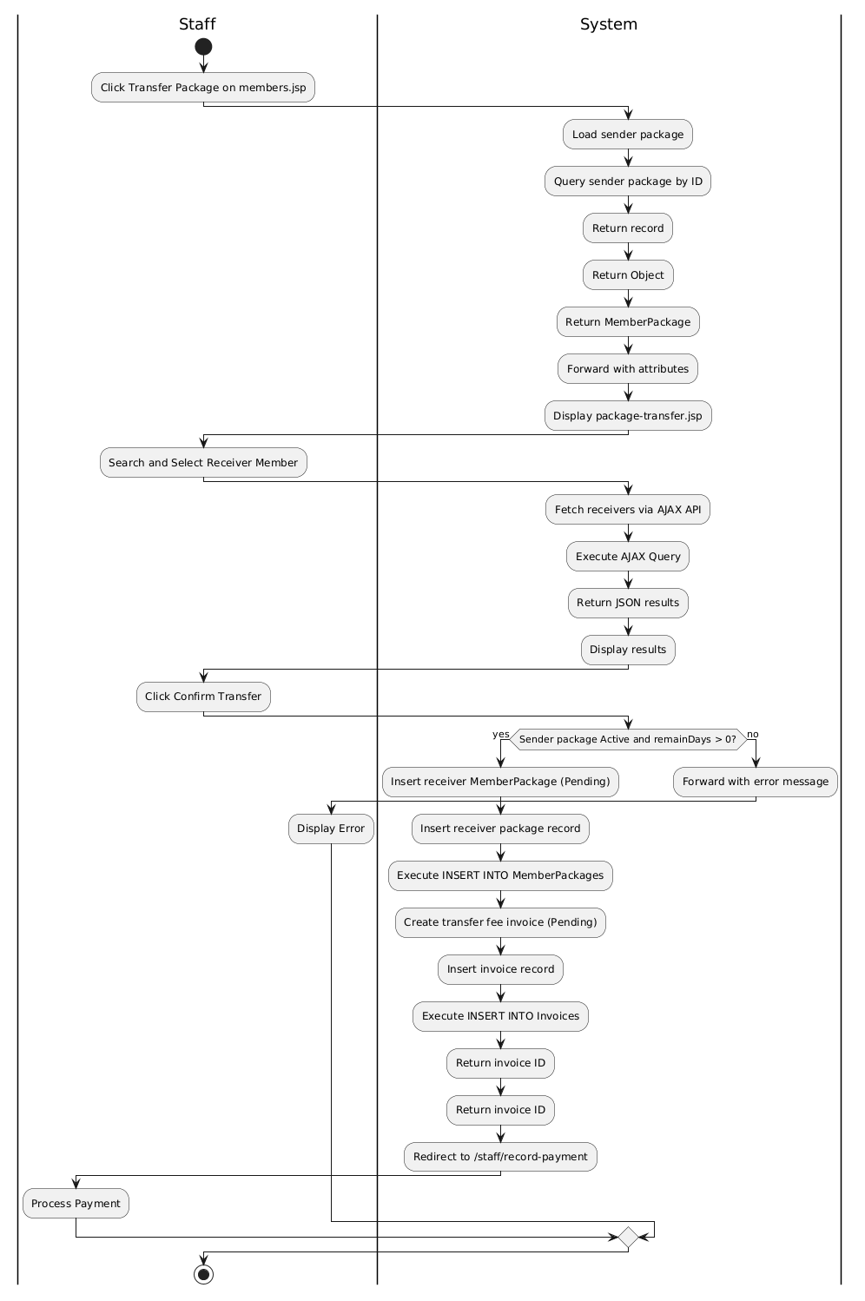

3.2.6 View Financial & Revenue Reports

3.2.6.1 View Financial & Revenue Reports Sequence

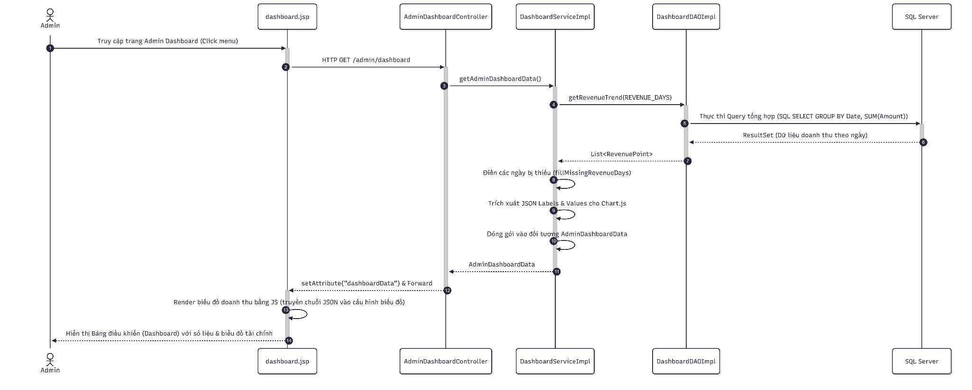

3.2.6.2 View Financial & Revenue Reports Swimlane Activity Diagram
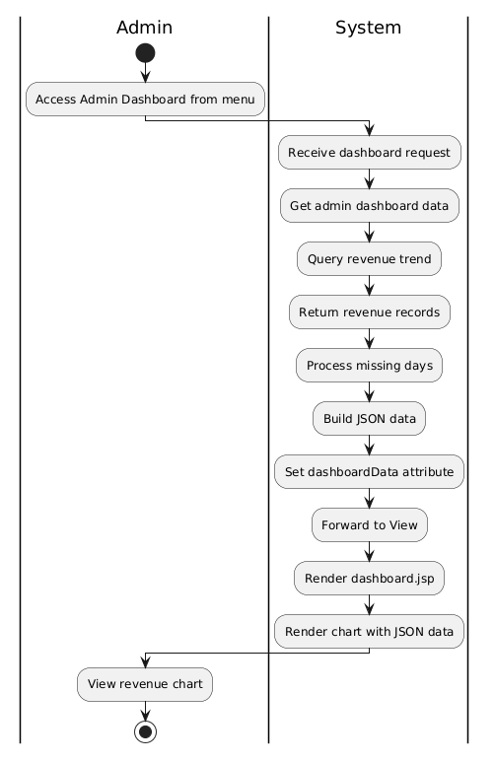

3.2.7. View Payment History

3.2.7.1 Get List Sequence
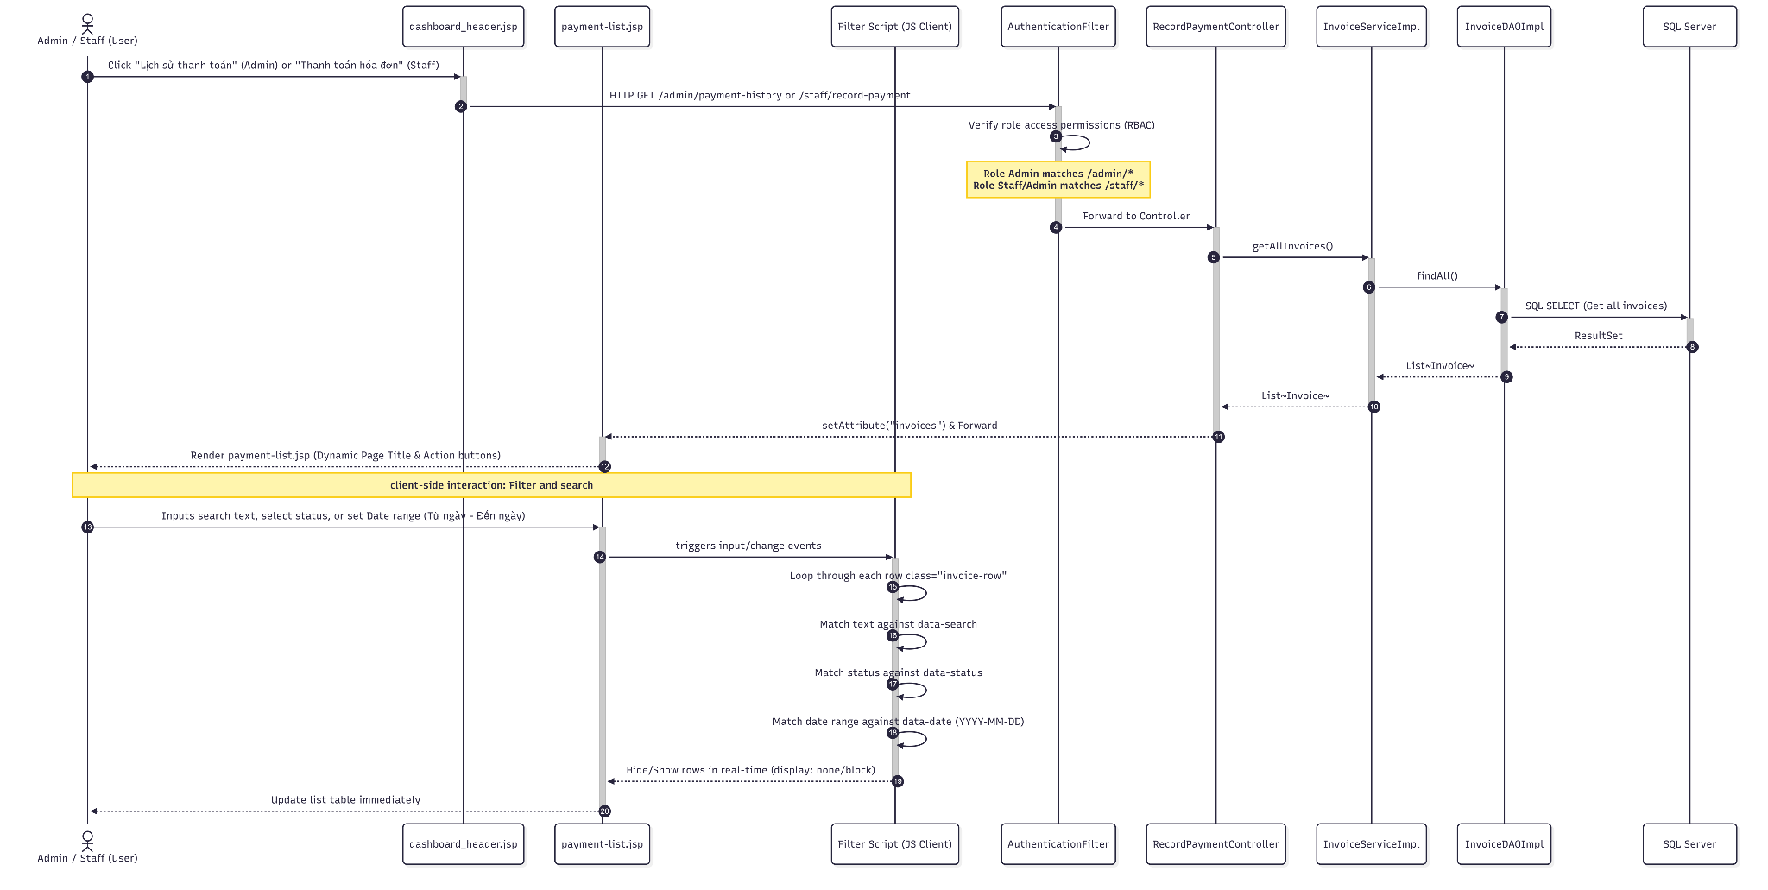

3.2.7.2 Get Detail Sequence
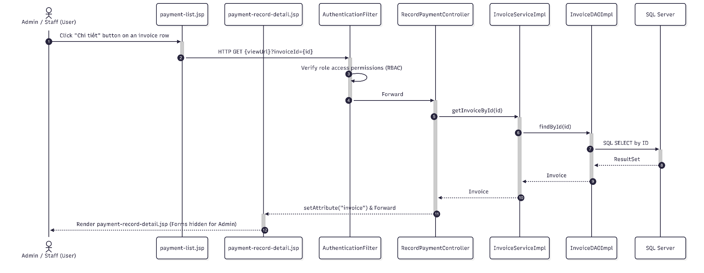

3.2.7.3 View Payment History Swimlane Activity Diagram
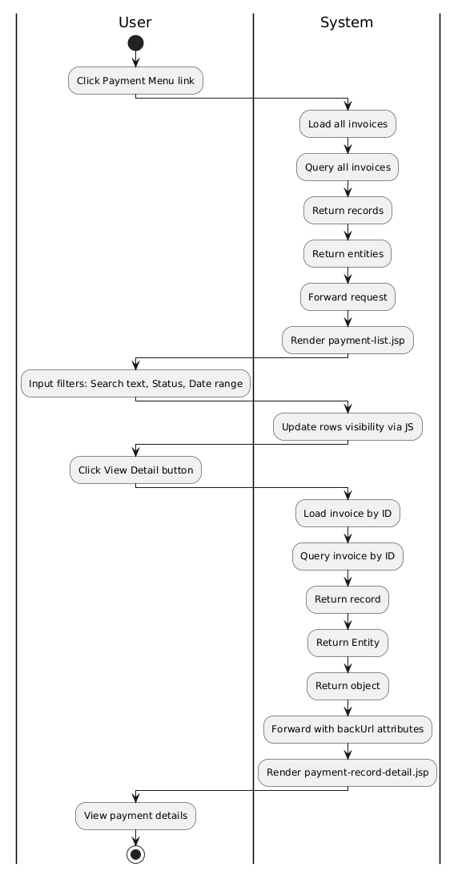

3.4 Manage Equipment

3.4.1 Class Diagram
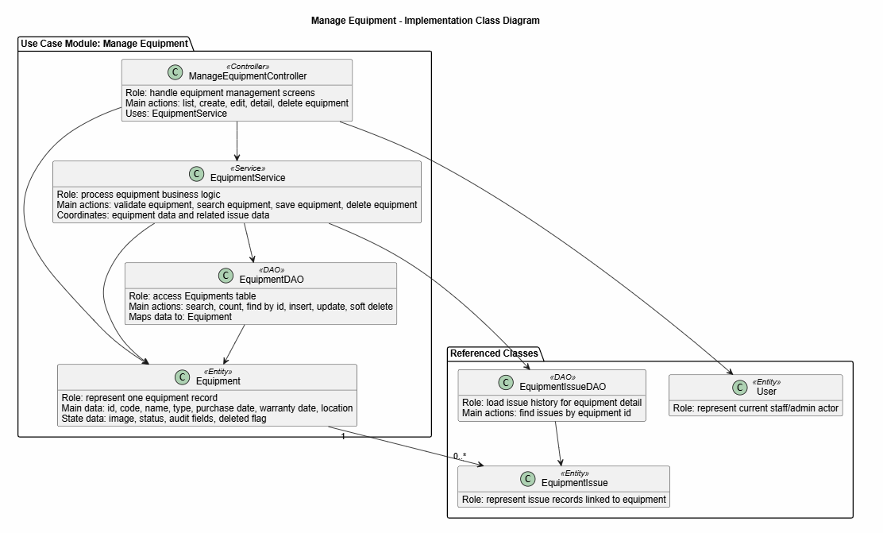
Description:This class diagram describes the main classes used in the Manage Equipment module. ManageEquipmentController handles equipment management screens such as listing, creating, editing, viewing detail, and deleting equipment. EquipmentService processes the main business logic, including validating equipment data, saving equipment, searching equipment, and deleting equipment. EquipmentDAO is responsible for working with the Equipments table in the database. The Equipment class represents one equipment record and stores information such as code, name, type, dates, location, image, status, and audit data.

3.4.2 Activity diagram
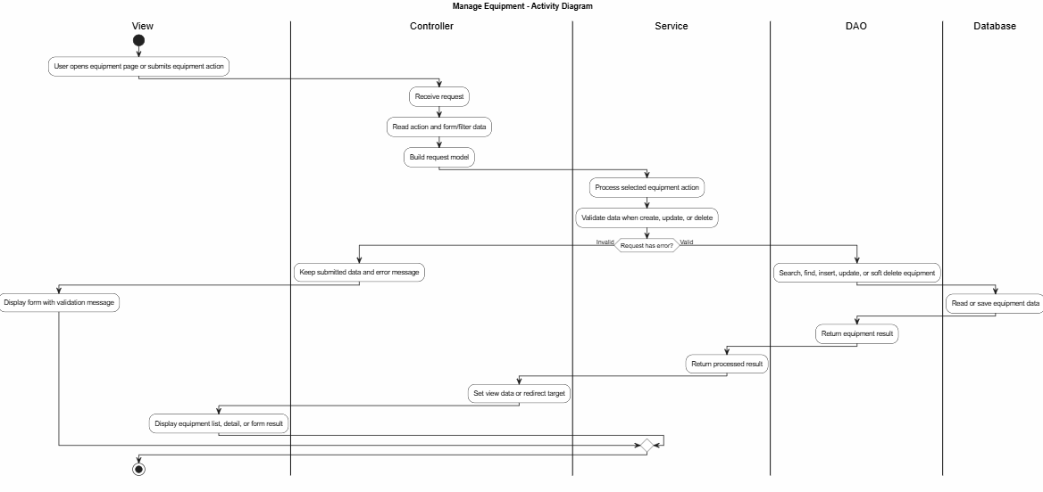

3.4.3 View List
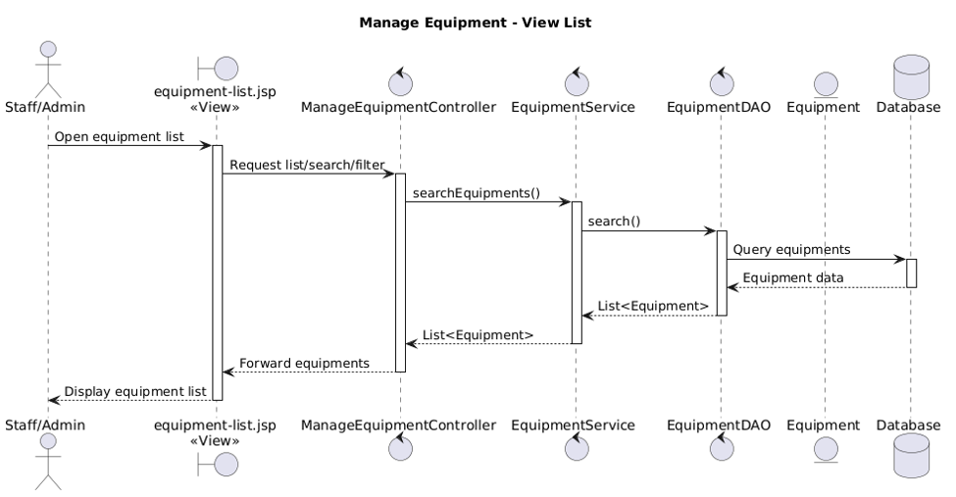

3.4.4 Add equipment
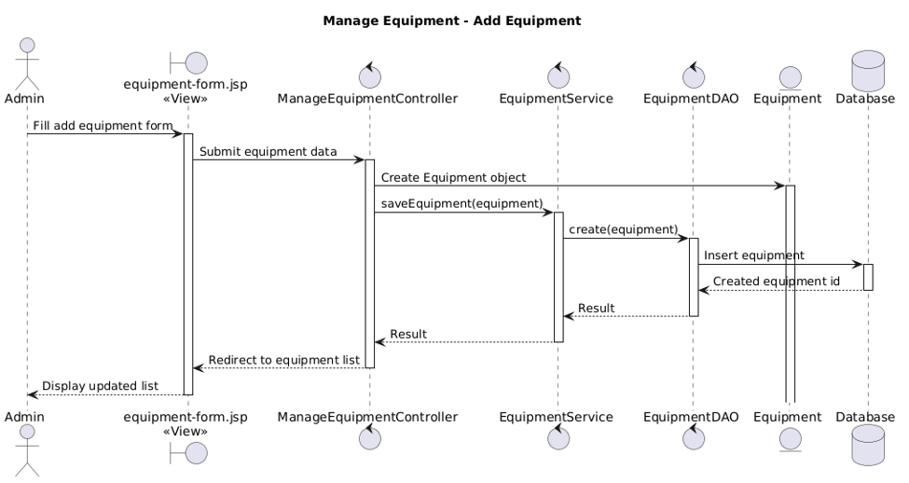

3.4.5 Edit Equipment
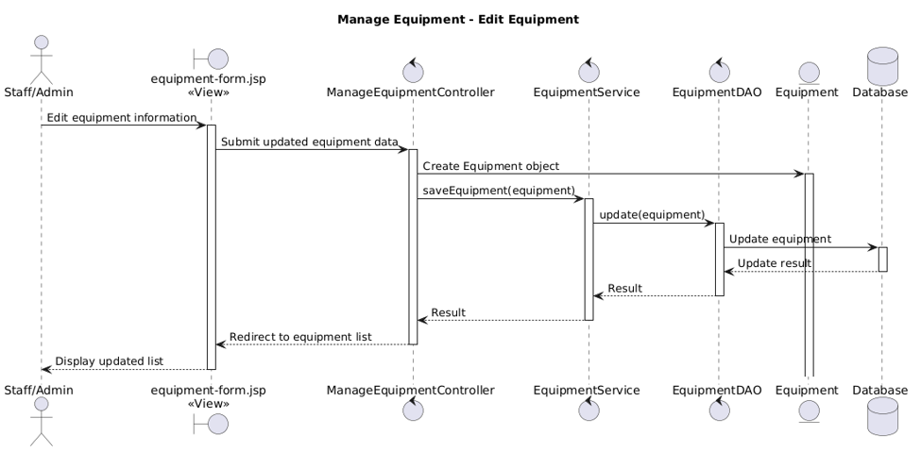

3.4.6 Delete Equipment
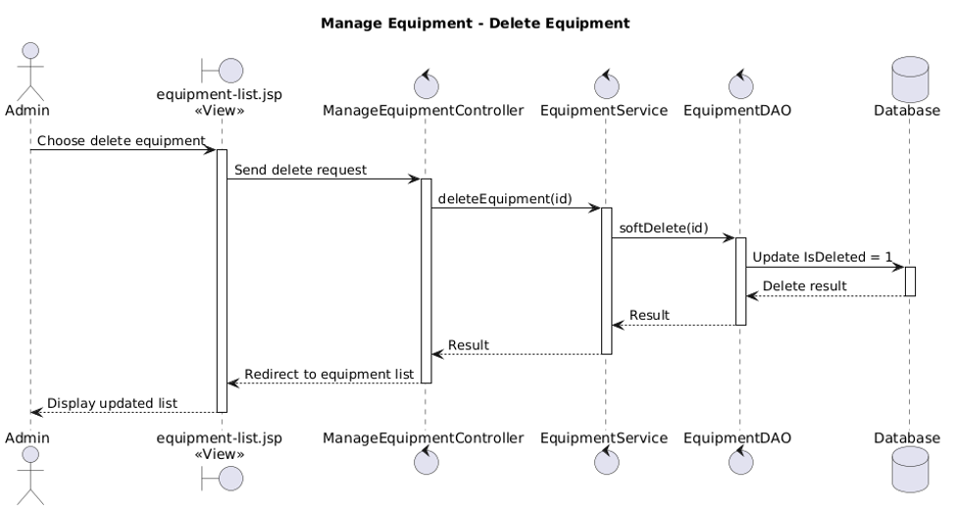

3.4.7 View Detail Equipment
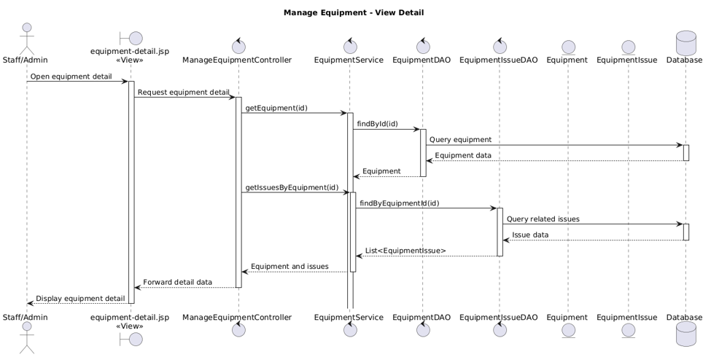

3.5 Manage Equipment Issues

3.5.1 Class Diagram
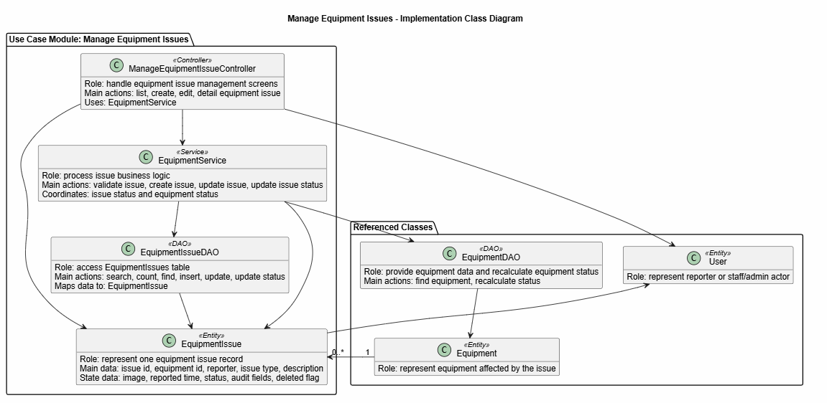
Description:This class diagram describes the main classes used in the Manage Equipment Issues module. ManageEquipmentIssueController handles issue management screens such as listing, creating, editing, and viewing issue detail. EquipmentService processes issue business logic, including validating issue data, creating issues, updating issues, and updating issue status. EquipmentIssueDAO is responsible for working with the EquipmentIssues table in the database. The EquipmentIssue class represents one issue record and stores information such as equipment, reporter, issue type, description, image, reported time, status, and audit data. This module also relates to Equipment because each issue belongs to one equipment item.

3.5.2 Activity diagram
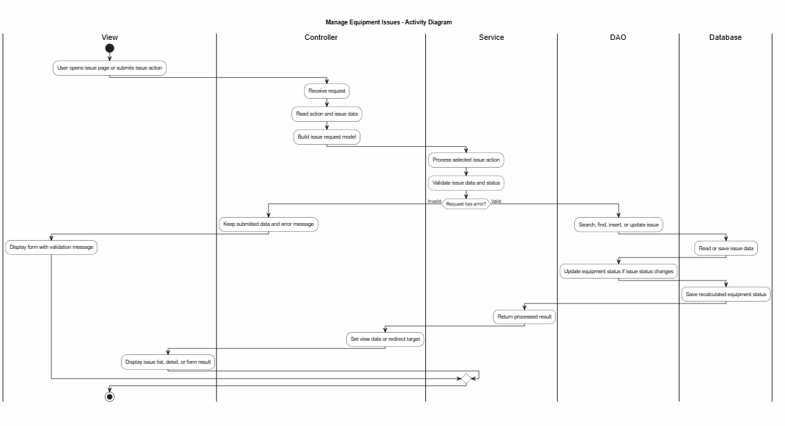

3.5.3 View List Equipment Issues
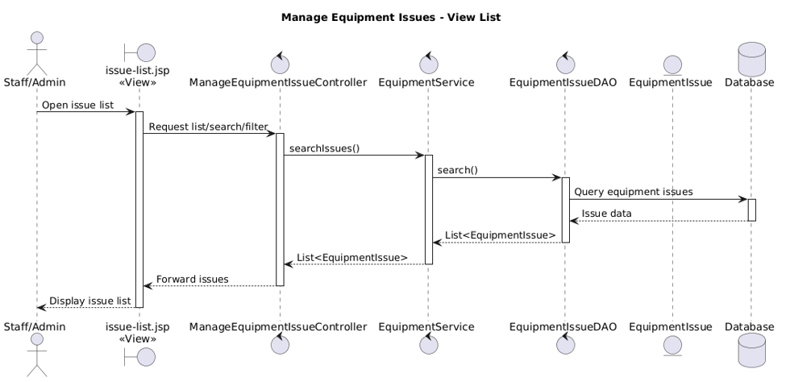

3.5.4 Add Equipment Issues
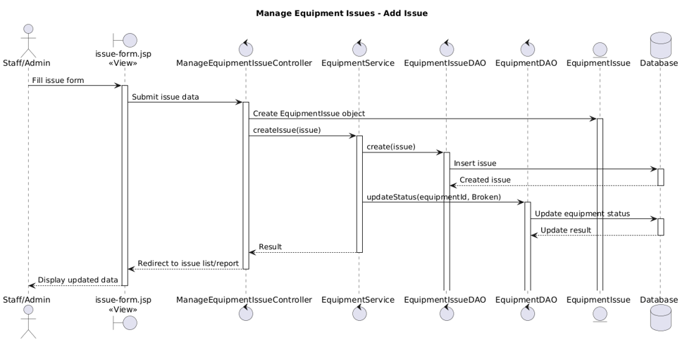

3.5.5 Edit Equipment Issues
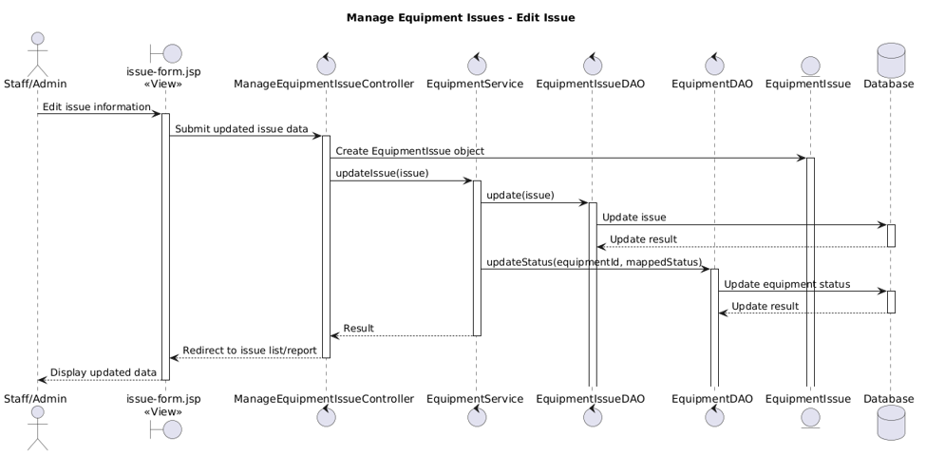

3.5.6 View Detail Equipment Issues
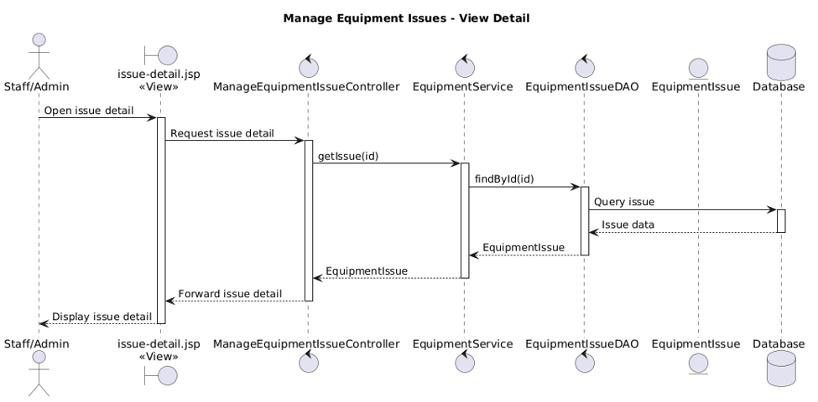

3.6 Equipment Reports

3.6.1 Class Diagram
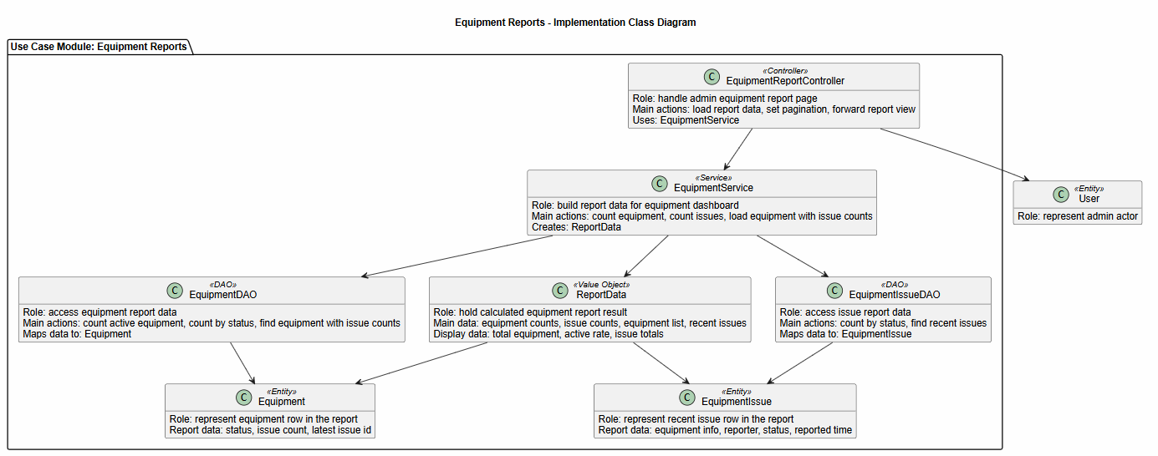
Description:This class diagram describes the main classes used in the Equipment Reports module. EquipmentReportController handles the admin report page and sends requests to EquipmentService. EquipmentService builds the report by collecting equipment counts, issue counts, equipment rows, and recent issue data. EquipmentDAO provides equipment statistics and equipment rows with issue counts. EquipmentIssueDAO provides issue statistics and recent issue records. ReportData stores the calculated report result before it is displayed on the report page. Equipment and EquipmentIssue represent the data shown in the report.

3.6.2 Activity diagram
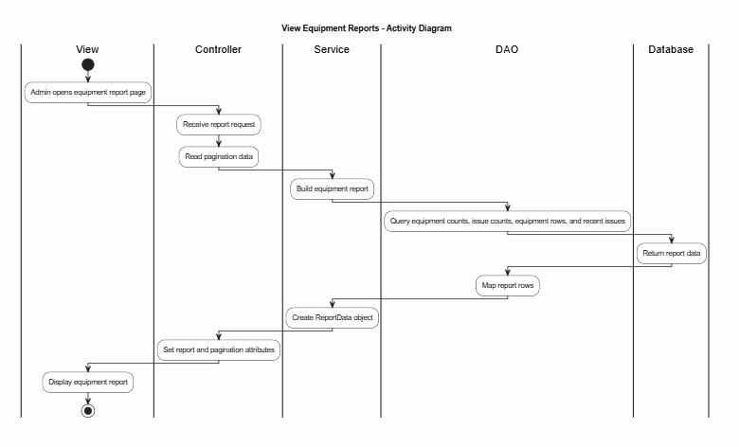

3.6.3 View Equipment Reports
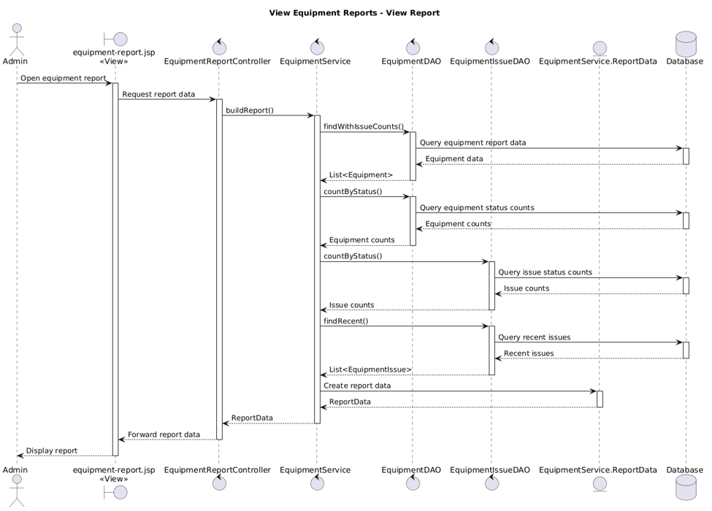

3.7 Create Personal Trainer Module

3.7.1 Create Personal Trainer Class Diagram
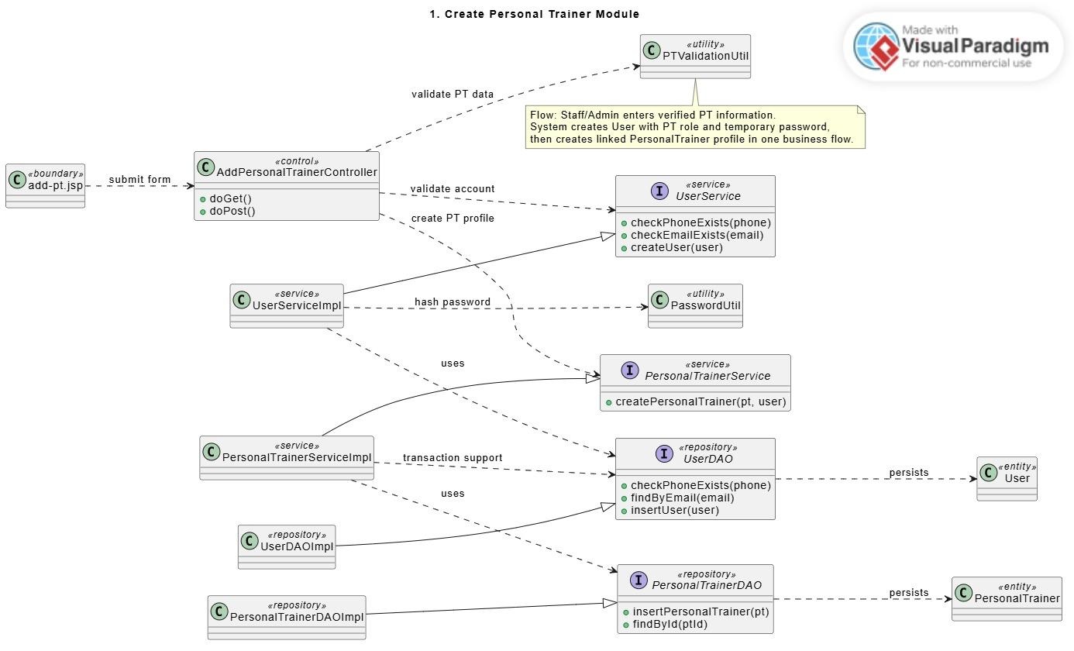
Description: This class diagram represents the main implementation structure for creating a Personal Trainer account and profile. The boundary class receives the submitted PT creation form, while the controller coordinates validation and service calls. The UserService manages account-related operations such as duplicate checking and password preparation, while the PersonalTrainerService manages trainer profile creation. DAO classes persist User and PersonalTrainer entities into the database. Utility classes support password hashing and PT data validation.

3.7.2 Add Personal Trainer Sequence Diagram
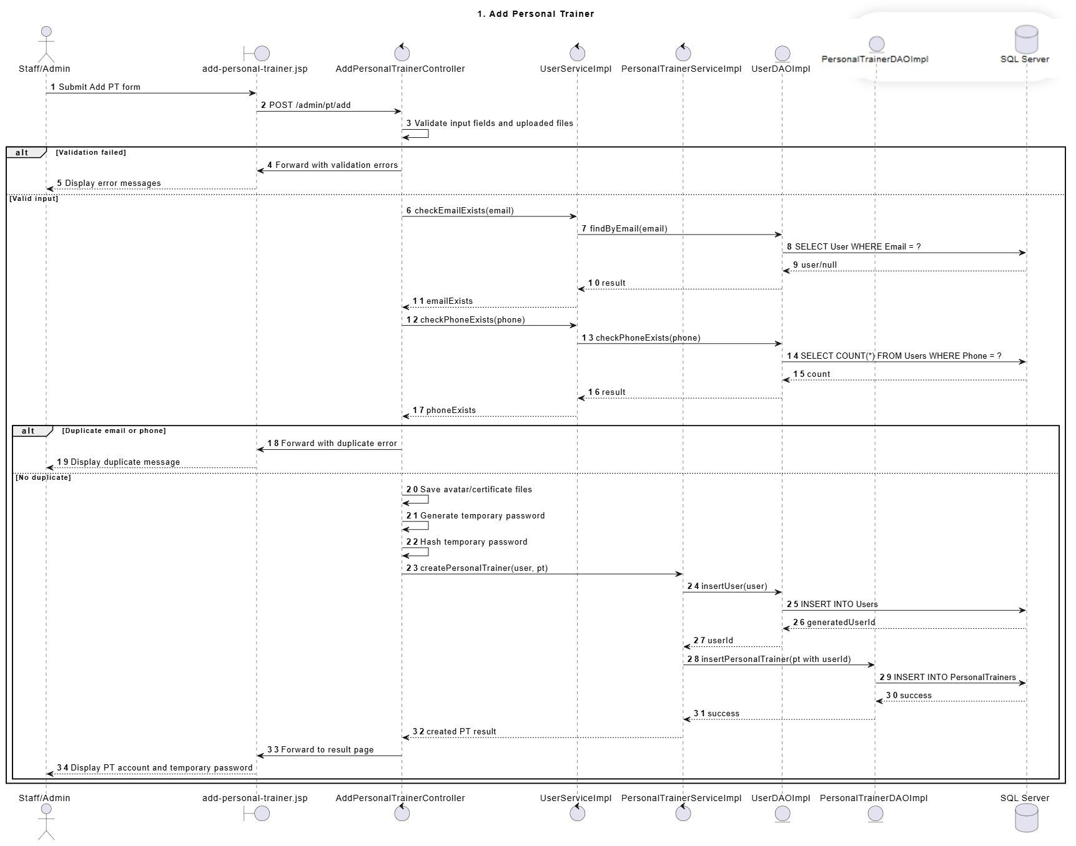
Description: This sequence diagram describes how Staff/Admin creates a new Personal Trainer account after the trainer has passed the offline recruitment process. Staff/Admin submits verified trainer information through the Add PT view. The controller validates the submitted data, checks duplicate email or phone number through the service and DAO layers, generates a temporary password, and creates both the User account and PersonalTrainer profile. If the creation succeeds, the system displays the generated temporary password for handover to the trainer.

3.7.3 Add Personal Trainer Swimlane Activity Diagram
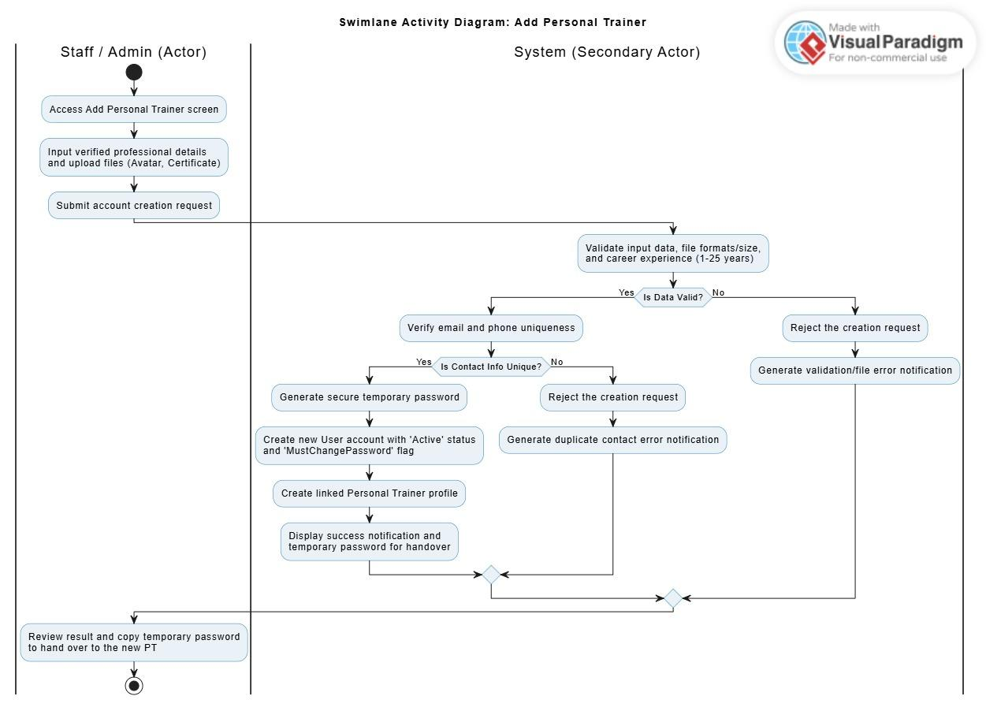
Description: This swimlane activity diagram describes how Staff/Admin creates a new Personal Trainer account. Staff/Admin opens the PT management screen, fills in trainer information, uploads required files, and submits the form. The controller validates input data and checks duplicate email or phone information through the service and DAO layers. If valid, the system saves uploaded files, generates a temporary password, creates a User account, and creates the linked PersonalTrainer profile. The result view displays the temporary password and success message.

3.8 View Personal Trainer Information Module

3.8.1 PT Management Module List & Detail Class Diagram
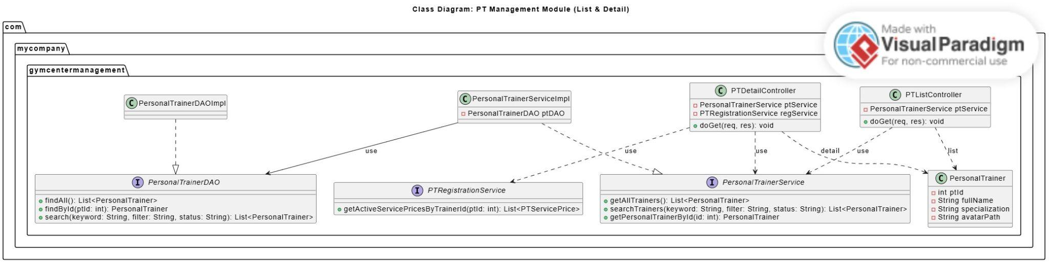
Description: This class diagram describes the structure for viewing, searching, and displaying Personal Trainer information. PTListController handles trainer list and search requests, while PTDetailController handles trainer detail requests. PersonalTrainerService provides trainer list, search, and detail retrieval functions. PersonalTrainerDAO queries trainer data from the database. PTRegistrationService is used by the detail page to retrieve active PT service prices for the selected trainer. The PersonalTrainer entity represents trainer information displayed on the list and detail screens.

3.8.2 View & Search PT List Sequence Diagram
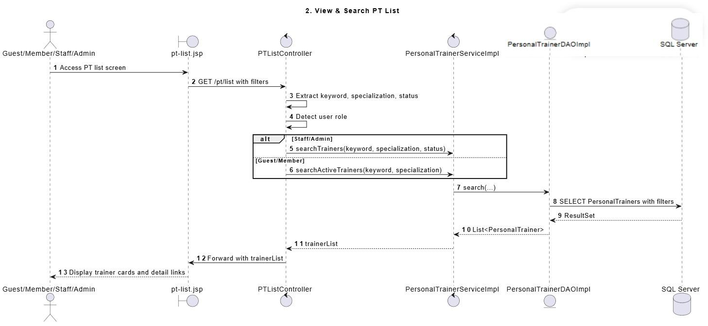
Description: This sequence diagram describes how users view and search the Personal Trainer list. The actor accesses the PT list screen and provides optional keyword or specialization filters. The controller extracts search parameters and detects the user role. The service retrieves matching trainer records through the DAO layer. Guest and Member users can only view active trainers, while Staff/Admin may use additional management filters depending on permission. The view displays the matching trainer cards and detail links.

3.8.3 View PT Detail Sequence Diagram
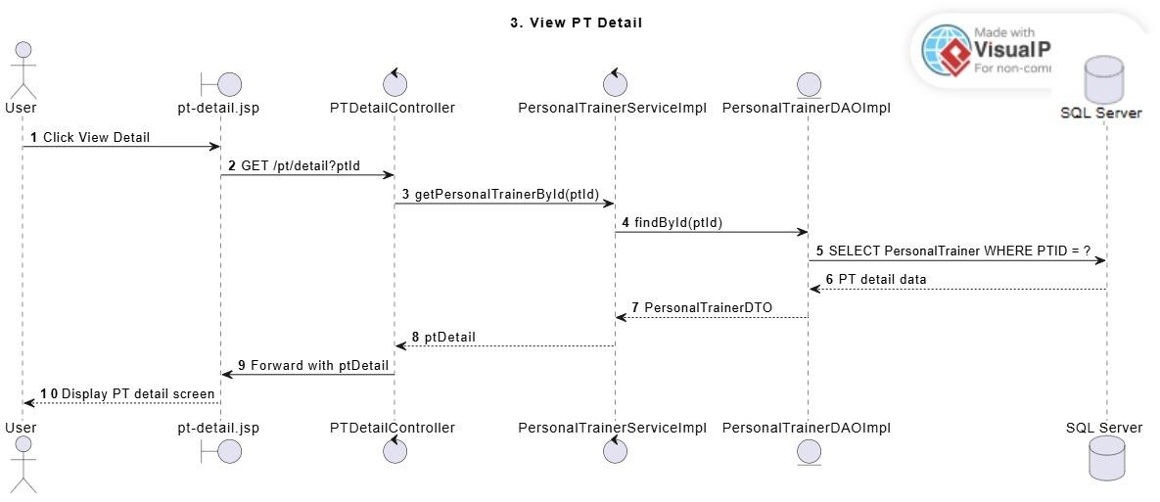
Description: This sequence diagram describes how a user views detailed information about a selected Personal Trainer. The actor selects a trainer from the PT list, and the controller receives the trainer ID. The service retrieves the trainer profile from the DAO and database. The system forwards the trainer information to the detail view. This flow is read-only and does not modify any trainer, registration, or schedule data.

3.8.4 View & Search PT List Swimlane Activity Diagram
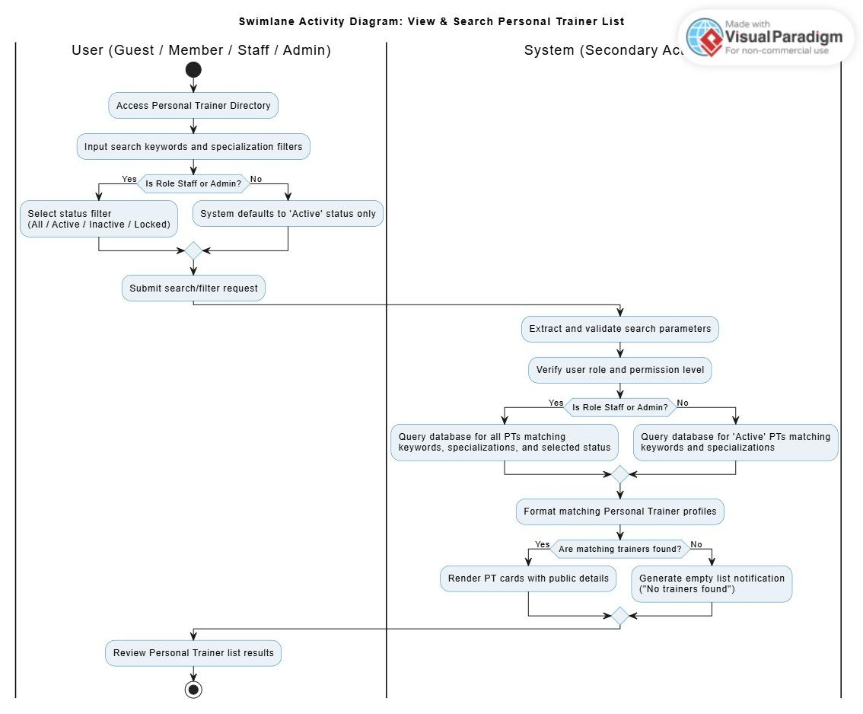
Description: This swimlane activity diagram describes how users view and search the Personal Trainer list. The actor enters search keywords, specialization filters, and optionally status filters depending on role permission. The controller extracts the parameters and checks the user role. Staff/Admin may search trainers by status, while Guest/Member users can only view active trainers. The service and DAO build the query, retrieve matching trainer records, and return them to the view. The view displays trainer cards and detail links.

3.9 Manage Personal Trainer Profile Module

3.9.1 PT Profile Management Class Diagram
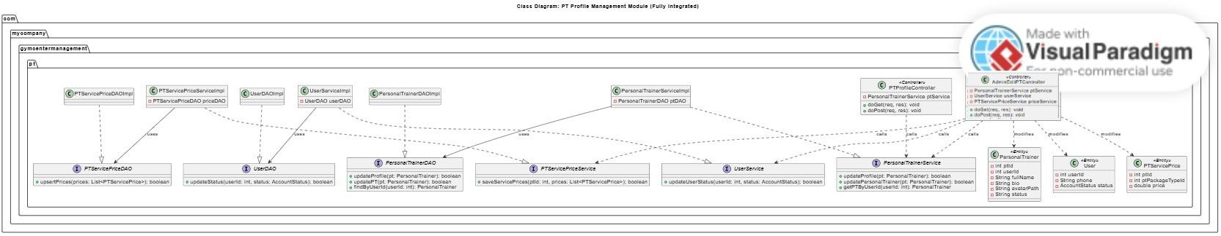
Description: This class diagram describes the structure for managing Personal Trainer profile information, service prices, and account status. PTProfileController supports the trainer’s self-edit profile flow, while AdminEditPTController supports Staff/Admin profile management actions. PersonalTrainerService, UserService, and PTServicePriceService coordinate profile update, account status synchronization, and price configuration. DAO classes update PersonalTrainer, User, and PTServicePrice data in the database. This module covers PT self-edit, Staff/Admin edit profile, Admin price configuration, and trainer deactivation.

3.9.2 PT Self-Edit Profile Sequence Diagram
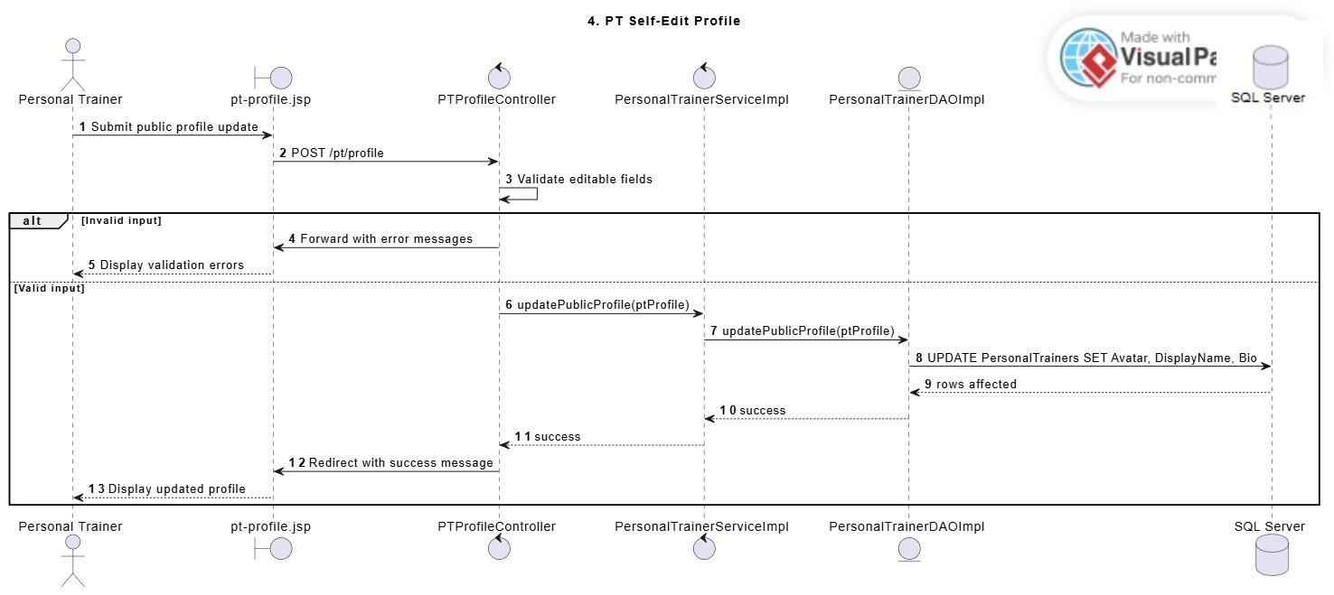
Description: This sequence diagram describes how a Personal Trainer updates limited public profile information. The trainer submits editable fields such as avatar, display name, or biography through the profile view. The controller validates the input and sends the update request to the service layer. The DAO updates the permitted public profile data in the database. Verified professional information such as specialization, certificate, career start date, trainer status, and service prices remains managed by Staff/Admin.

3.9.3 Update Personal Trainer Profile Sequence Diagram
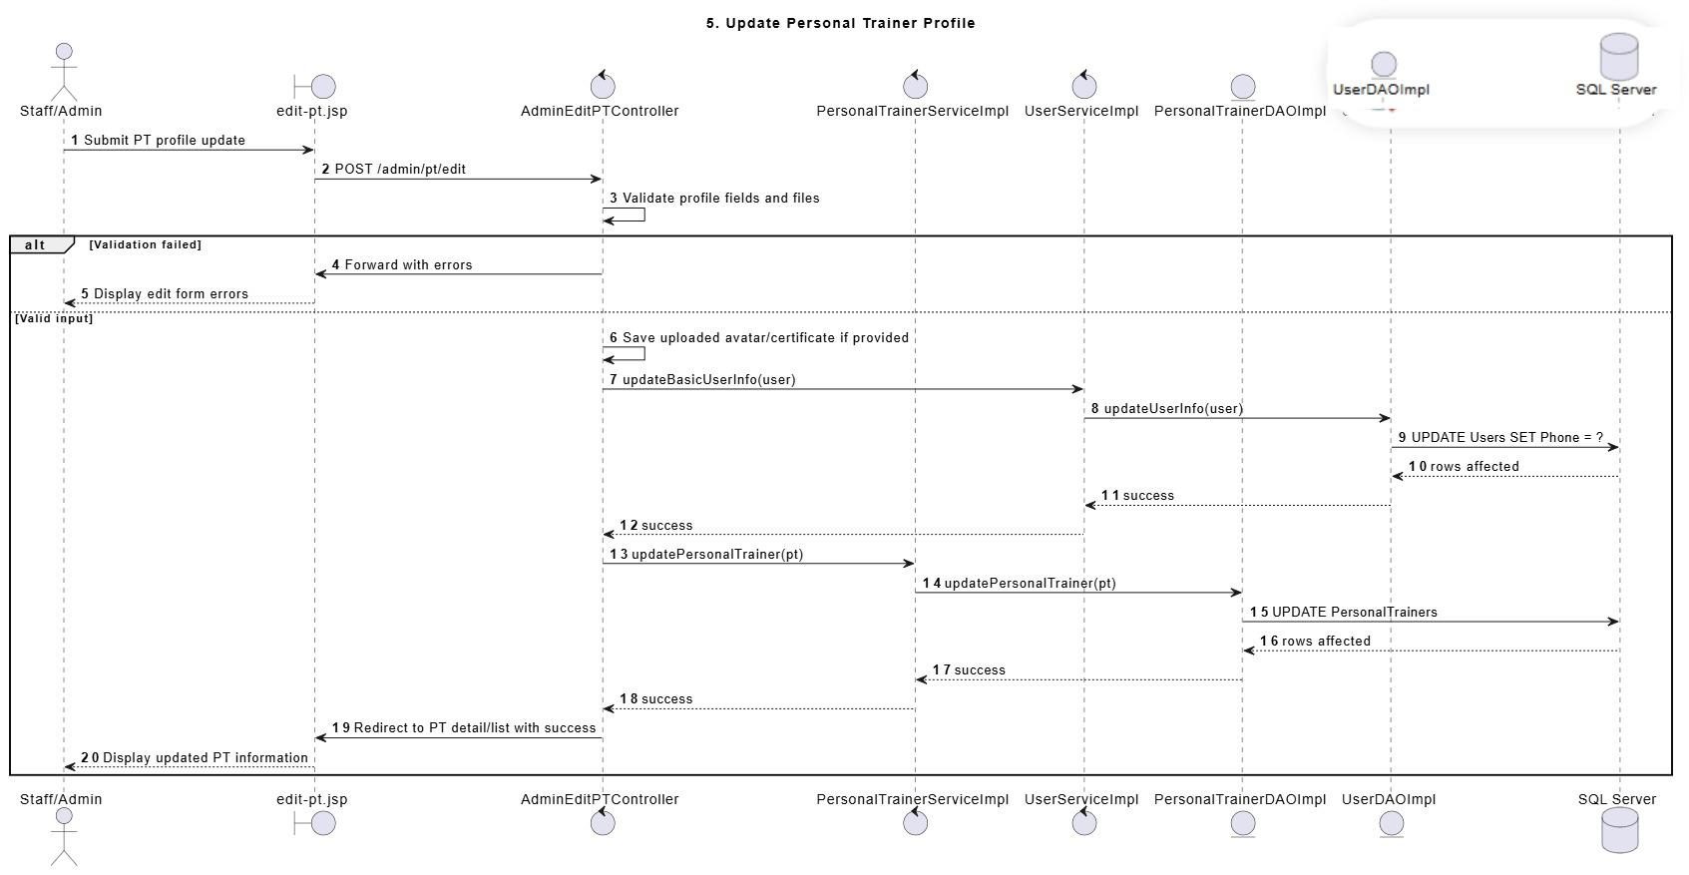
Description: This sequence diagram describes how Staff/Admin updates verified Personal Trainer profile information. Staff/Admin submits updated trainer information through the edit PT view. The controller validates required fields, file uploads, and profile data before calling the service layer. The service updates related User information and PersonalTrainer profile information through DAO operations. If validation fails, the system returns the edit form with error messages. If the update succeeds, the system redirects back to the PT detail or list screen with a success message.

3.9.4 Configure PT Service Price Sequence Diagram
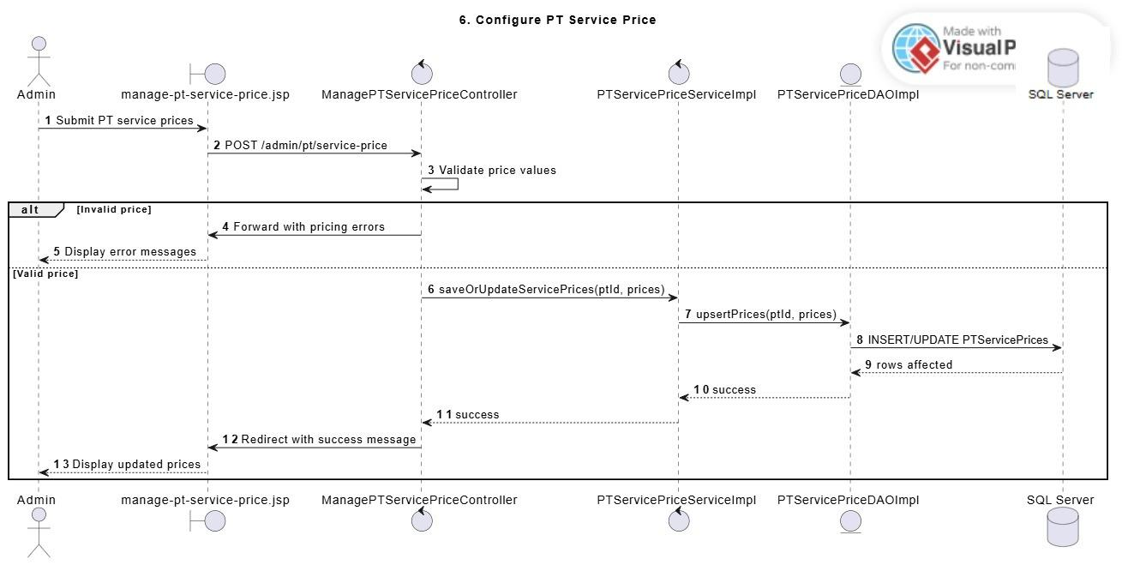
Description: This sequence diagram describes how Admin configures service prices for a Personal Trainer. Admin submits price values for available PT package types. The controller validates that prices are valid, positive, and follow pricing constraints. The service saves or updates PTServicePrice records through the DAO layer. The updated prices are used only for future PT registrations and do not change existing registrations, invoices, or historical payment records.

3.9.5 Deactivate Personal Trainer Account Sequence Diagram
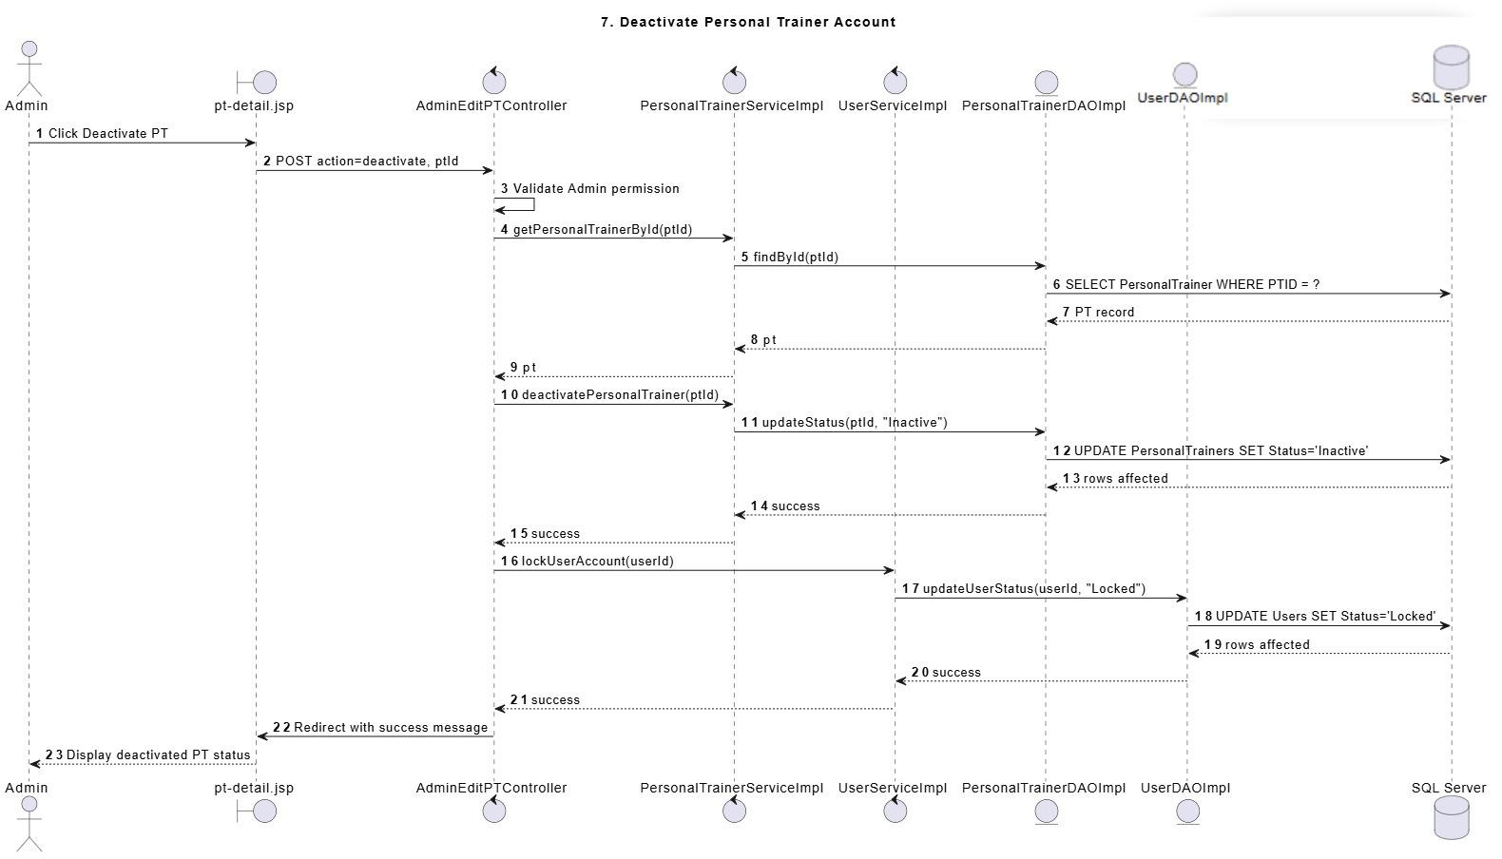
Description: This sequence diagram describes how Admin deactivates a Personal Trainer account. Admin submits a status update for the selected trainer. The controller validates Admin permission and trainer status before calling the service layer. The service updates the PersonalTrainer status to inactive and synchronizes the linked User account status to locked. Historical PT schedules, registrations, and payment records remain unchanged for audit and reporting purposes.

3.9.6 Manage Personal Trainer Profile Swimlane Activity Diagram
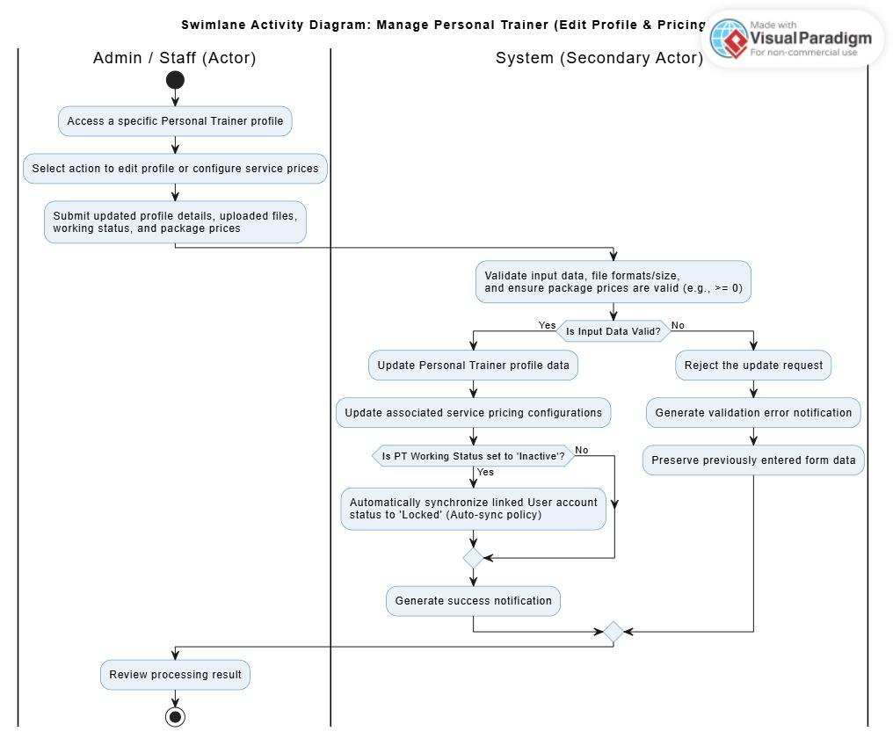
Description: This swimlane activity diagram describes Staff/Admin management actions for Personal Trainer profile and service price configuration. Staff/Admin selects an action from the PT detail screen, such as editing profile information or managing service prices. The controller validates submitted fields, uploaded files, status values, and price values. The service updates User information, PersonalTrainer profile data, and PTServicePrice records through DAO operations. If the trainer status changes to inactive, the related user account can also be synchronized to locked status.

3.10 PT Service Registration Module

3.10.1 Register PT Service Class Diagram
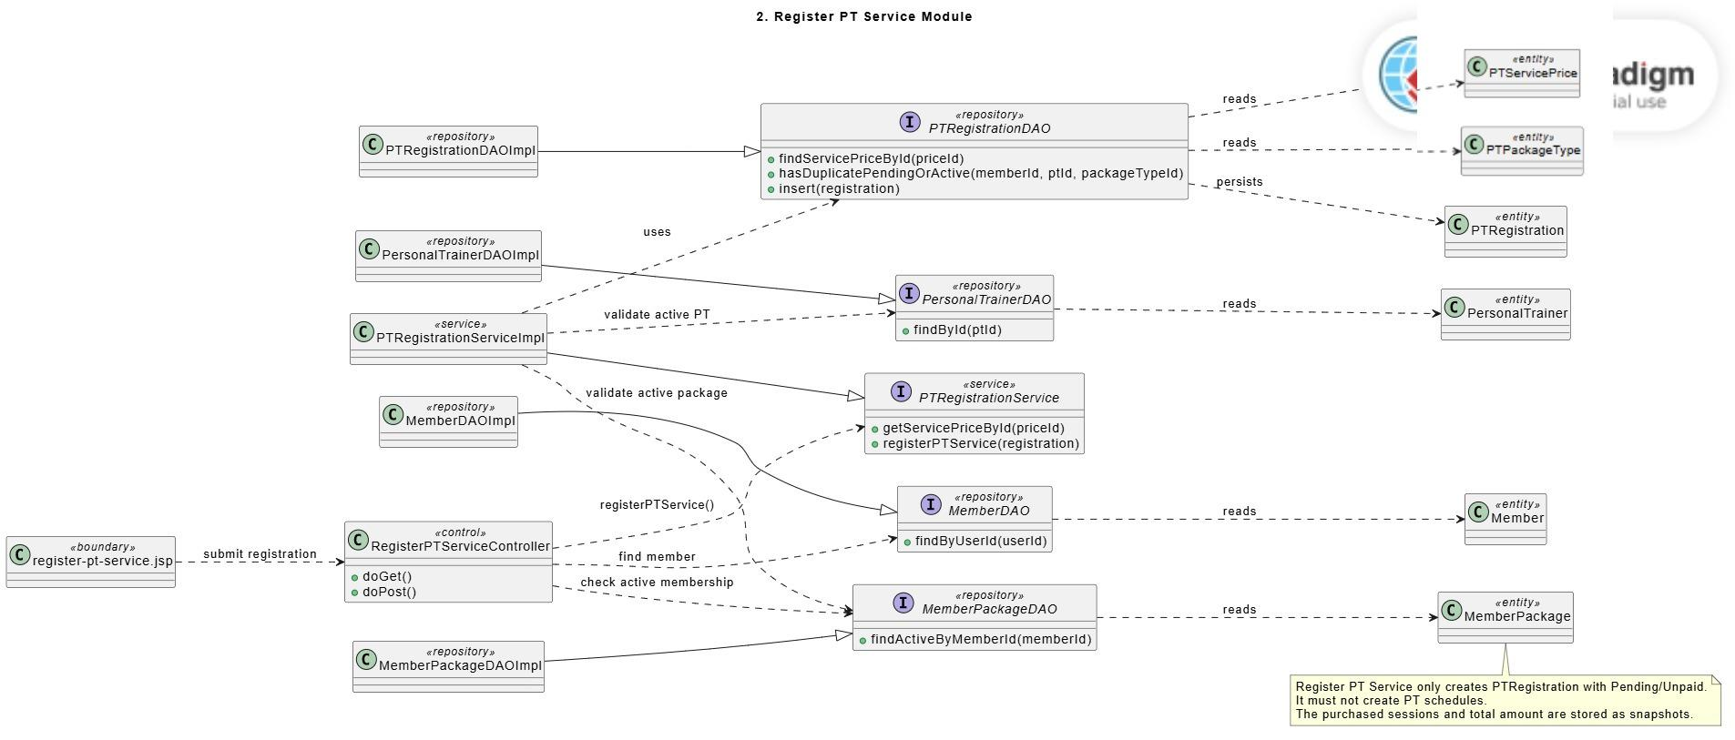
Description: This class diagram describes the classes involved when a Member registers for a PT service. The controller receives the registration request from the view and delegates business validation to the PTRegistrationService. The service uses DAOs to validate the selected PT, service price, active member package, and duplicate registration condition. The PTRegistration entity stores the submitted registration with Pending and Unpaid status. The diagram also shows related entities such as PTServicePrice, PTPackageType, Member, MemberPackage, and PersonalTrainer.

3.10.2 Approve PT Registration Class Diagram
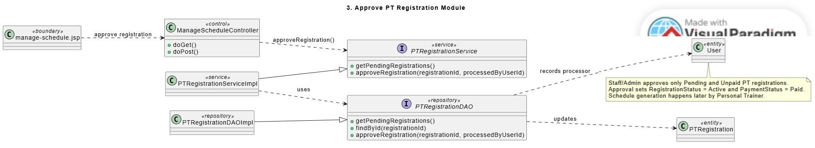
Description: This class diagram shows the structure used by Staff/Admin to approve a PT registration after payment confirmation. The ManageScheduleController receives approval actions from the management view and calls the PTRegistrationService. The service validates the registration state and uses PTRegistrationDAO to update registration status and payment status. The PTRegistration entity represents the approved service registration, while the User entity is used to record processing information.

3.10.3 Register PT Service Sequence Diagram
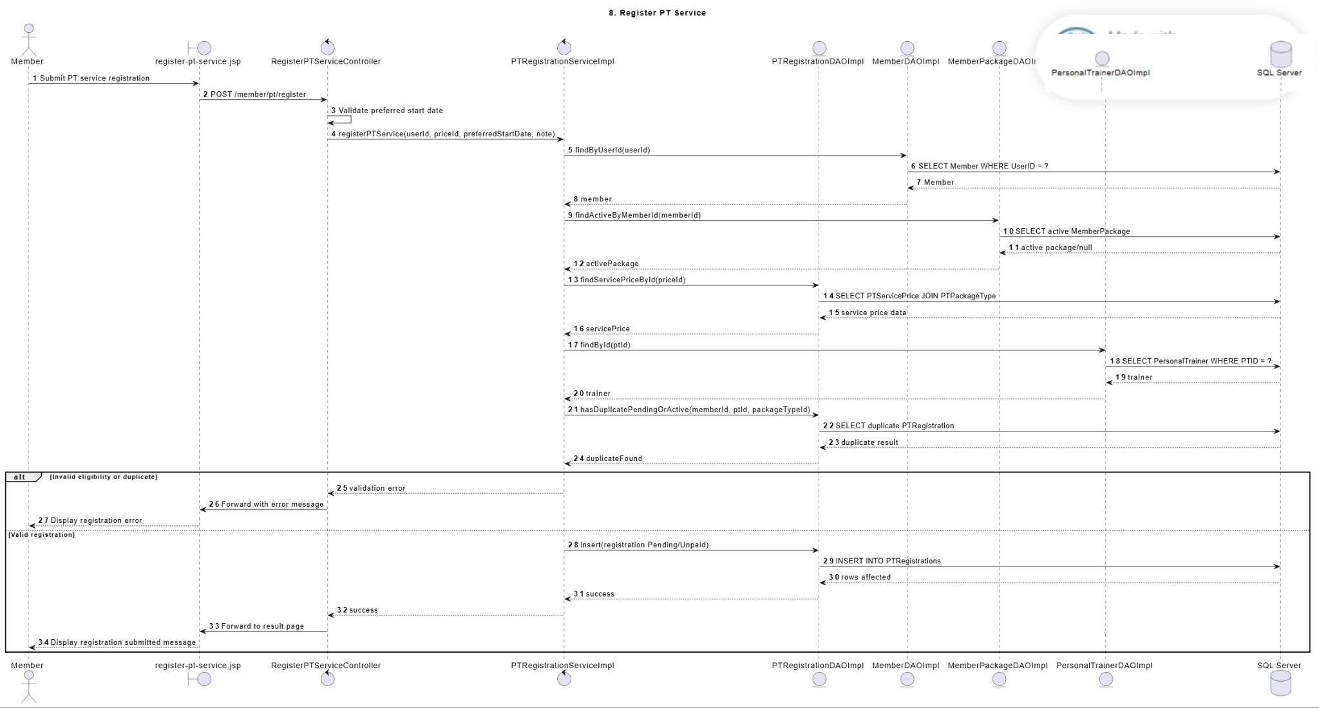
Description: This sequence diagram describes how a Member registers for a Personal Trainer service package. The Member opens the registration form from the PT detail screen, enters a preferred start date and training note, and submits the request. The controller validates the preferred start date and current user session. The service checks member eligibility, active membership, selected PT service price, selected trainer status, and duplicate pending or active registration. If valid, the system creates a PTRegistration record with Pending status and Unpaid payment status. No PT schedule is generated in this flow.

3.10.4 Approve PT Registration Sequence Diagram
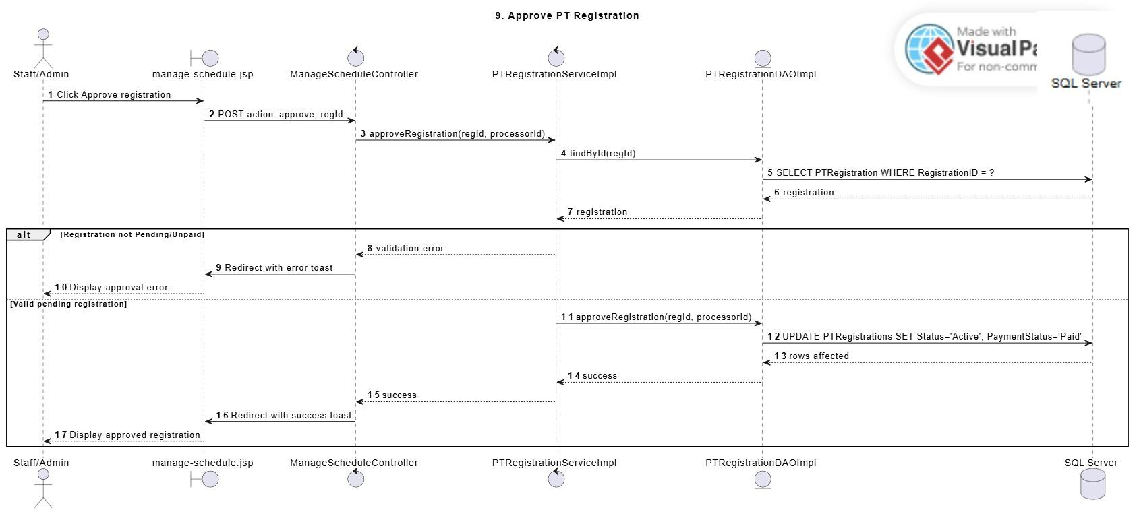
Description: This sequence diagram describes how Staff/Admin approves a pending PT registration after payment confirmation. Staff/Admin selects a pending registration from the schedule management screen and clicks approve. The controller sends the registration ID and processor information to the PTRegistrationService. The service validates that the registration is still pending and unpaid, then updates the registration to Active and payment status to Paid through the DAO layer. After approval, the assigned Personal Trainer can generate the official training schedule.

3.10.5 Register PT Service Swimlane Activity Diagram
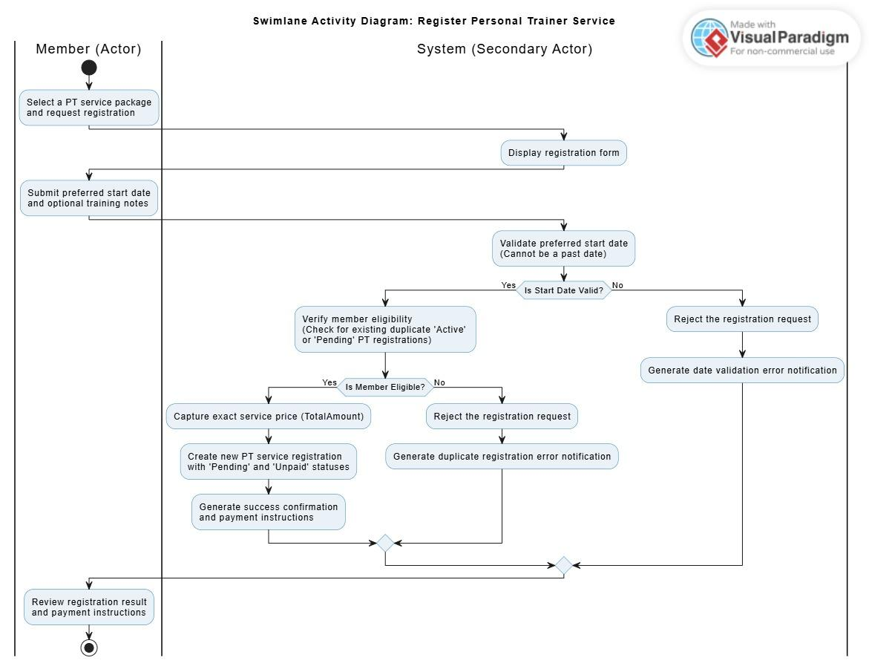
Description: This swimlane activity diagram describes Staff/Admin management actions for Personal Trainer profile and service price configuration. Staff/Admin selects an action from the PT detail screen, such as editing profile information or managing service prices. The controller validates submitted fields, uploaded files, status values, and price values. The service updates User information, PersonalTrainer profile data, and PTServicePrice records through DAO operations. If the trainer status changes to inactive, the related user account can also be synchronized to locked status.

3.10.6 Approve PT Registration Swimlane Activity Diagram
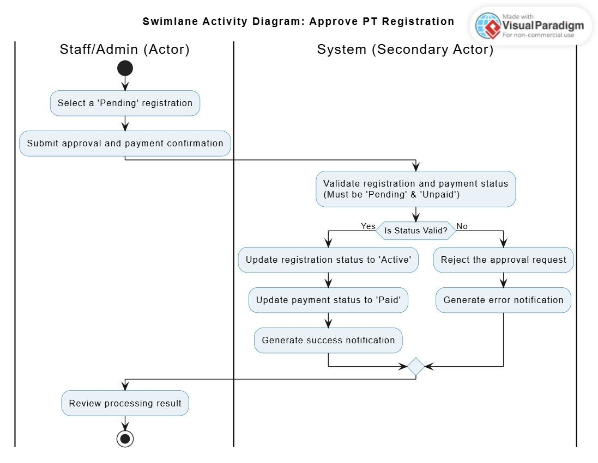
Description: This swimlane activity diagram describes how Staff/Admin approves a pending PT registration after payment confirmation. Staff/Admin selects a pending registration, and the controller validates the current user permission. The service checks that the registration is still Pending and Unpaid. If valid, the DAO updates the registration status to Active and payment status to Paid. The screen then displays either a success message or an error message.

3.11 Generate PT Schedule Module

3.11.1 Generate PT Schedule Class Diagram
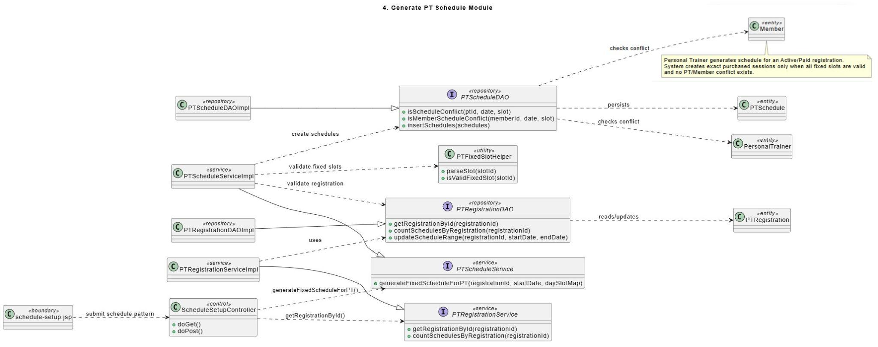
Description: This class diagram describes the structure for automatic PT schedule generation. The ScheduleSetupController receives selected start date, weekdays, and fixed slots from the view. PTRegistrationService validates registration information, while PTScheduleService handles schedule generation logic. PTScheduleDAO checks PT and Member conflicts and inserts generated sessions. PTFixedSlotHelper validates fixed-slot values. PTRegistration and PTSchedule entities represent the registration and generated training sessions.

3.11.2 Generate PT Schedule Automatically Sequence Diagram
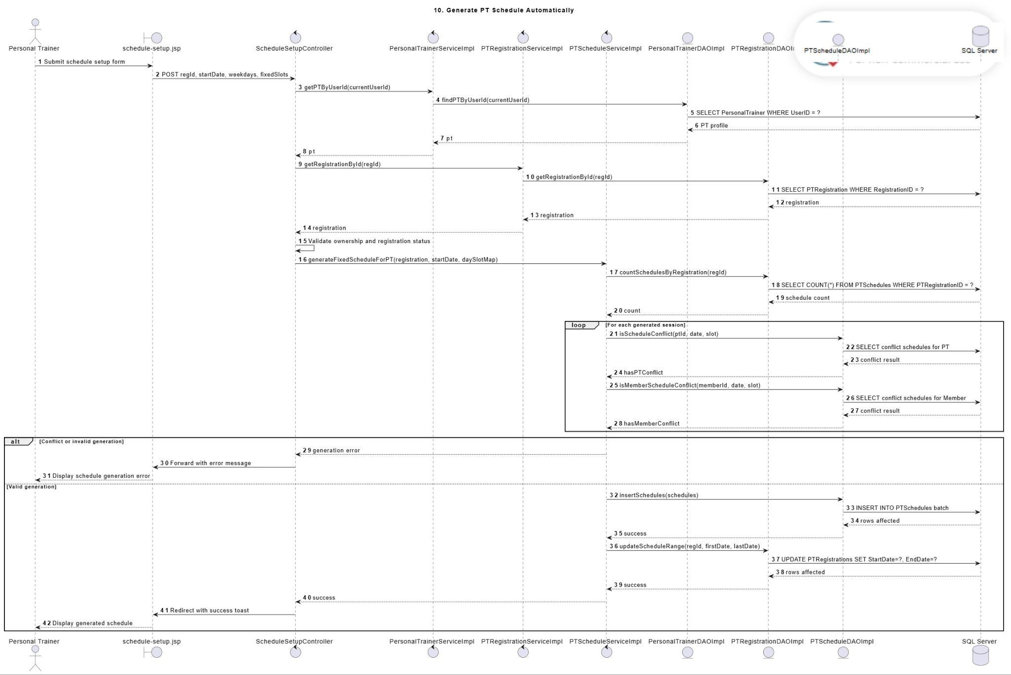
Description: This sequence diagram describes how a Personal Trainer generates the official training schedule for an active and paid PT registration. The trainer opens the schedule setup view, selects the official start date, training days, and fixed time slots. The controller checks PT ownership and sends the generation request to the PTScheduleService. The service retrieves the PT registration, validates that no schedule has already been generated, checks fixed-slot validity, and verifies PT/Member schedule conflicts for each session. If all checks pass, the DAO inserts the exact purchased number of Upcoming sessions and updates the registration start/end schedule dates.

3.11.3 Generate PT Schedule Automatically Swimlane Activity Diagram
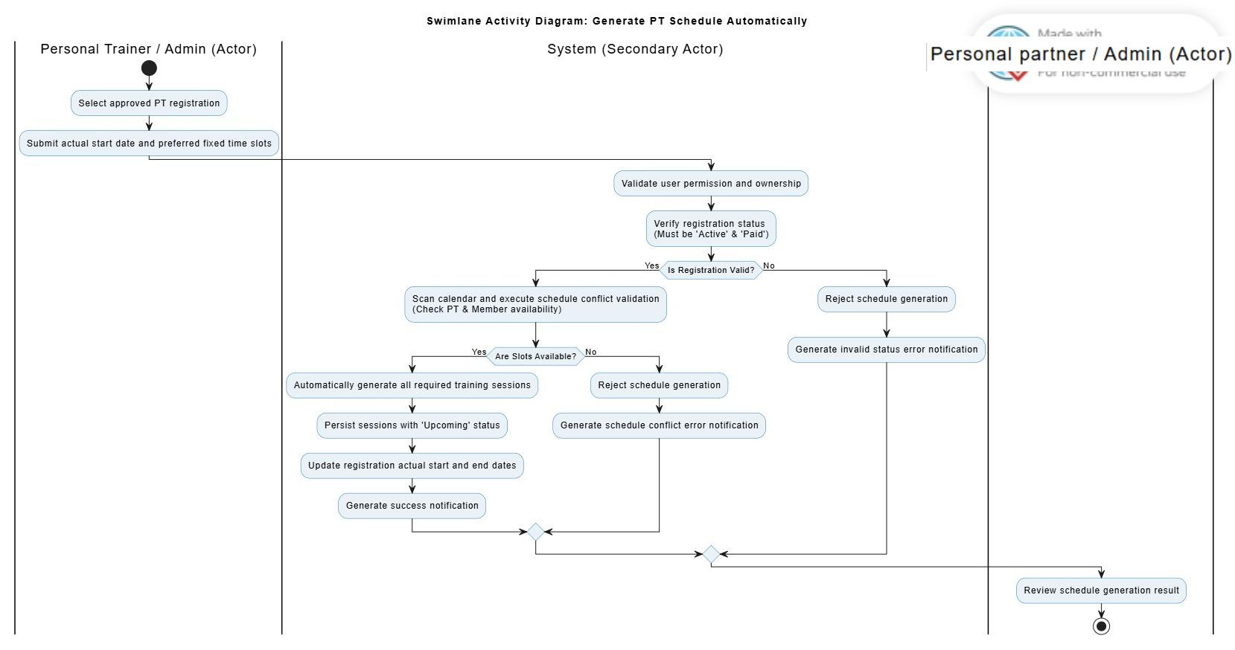
Description: This swimlane activity diagram describes how a Personal Trainer generates the official PT schedule after a registration has been approved. The Personal Trainer submits the official start date, weekdays, and fixed slots. The system validates PT ownership, active and paid registration status, duplicate schedule prevention, fixed-slot validity, and PT/Member schedule conflicts. If all sessions are valid, the system inserts the exact purchased sessions and updates the registration’s actual start and end dates.

3.12 PT Work Dashboard Module

3.12.1 View PT Schedule Dashboard Class Diagram
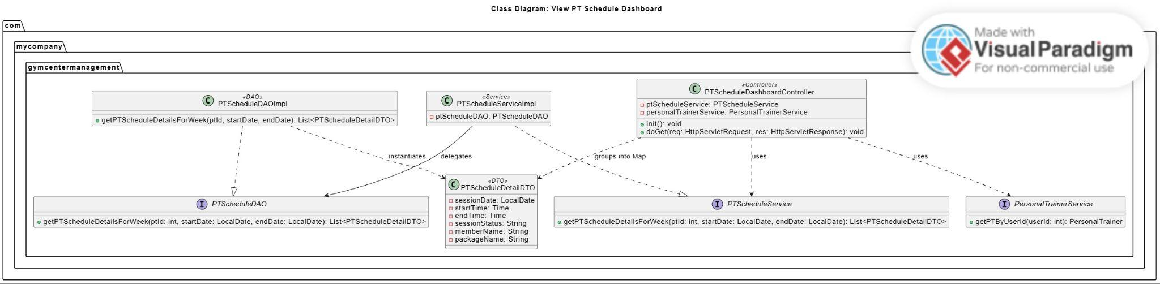
Description: This class diagram describes the structure for displaying a Personal Trainer’s weekly teaching schedule. PTScheduleDashboardController receives the selected week request and validates the logged-in PT. PersonalTrainerService retrieves the PT profile by user ID, while PTScheduleService retrieves weekly schedule details. PTScheduleDAO queries schedule records and maps them into PTScheduleDetailDTO. The DTO stores session date, time, member name, package name, and session status for display on the PT dashboard.

3.12.2 PT My Members Class Diagram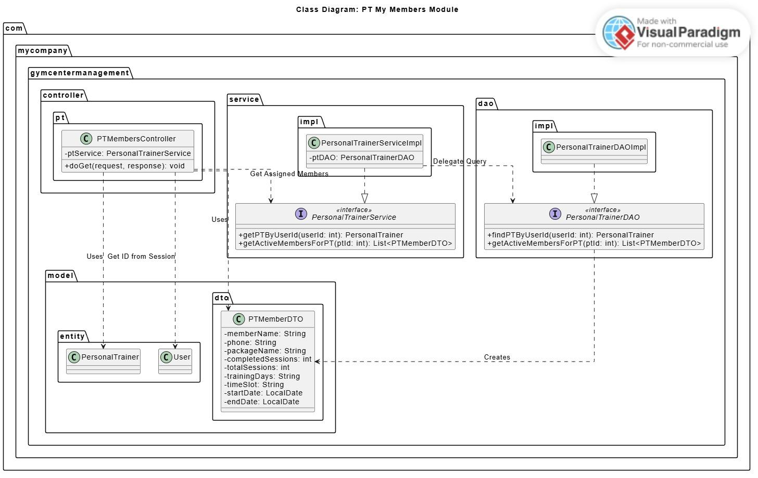
Description: This class diagram describes how a Personal Trainer views assigned members and training progress. PTMembersController validates the logged-in PT and calls PersonalTrainerService. The service uses PersonalTrainerDAO to retrieve active members assigned to the trainer. PTMemberDTO stores member name, phone, package name, completed sessions, total sessions, training days, time slot, and registration date range. This diagram belongs to the PT Work Dashboard module because “My Members” is part of the trainer’s working dashboard.

3.12.3 View PT Schedule Dashboard Sequence Diagram
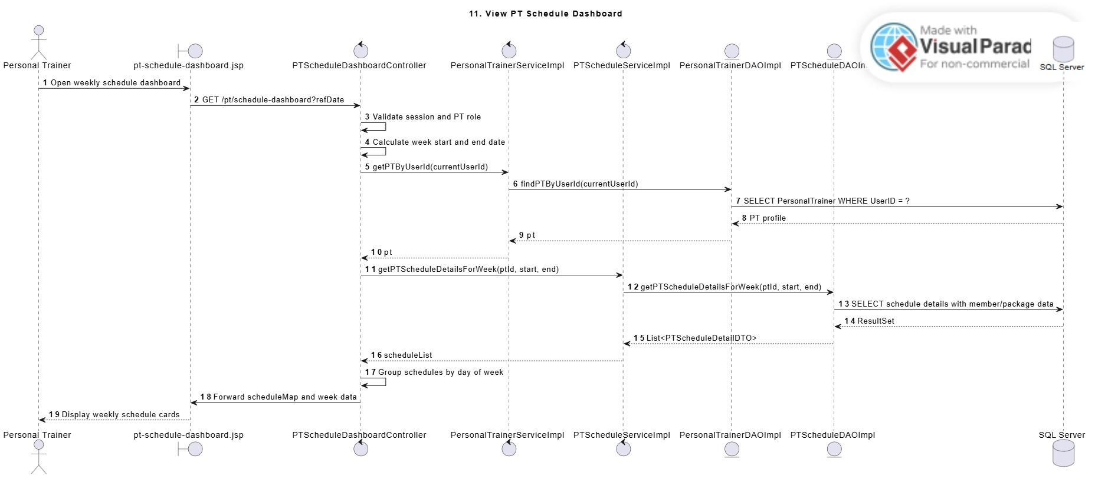
Description: This sequence diagram describes how a Personal Trainer views the weekly teaching schedule. The PT opens the schedule dashboard, and the controller validates the PT session and calculates the selected week range. The service retrieves the PT profile and weekly schedule details through DAO queries. The controller groups the returned schedule DTOs by day and forwards them to the dashboard view. The view displays session cards with status information such as Upcoming, Completed, Cancelled, substitute assignment, and make-up status when available.

3.12.4 View Assigned Members Sequence Diagram
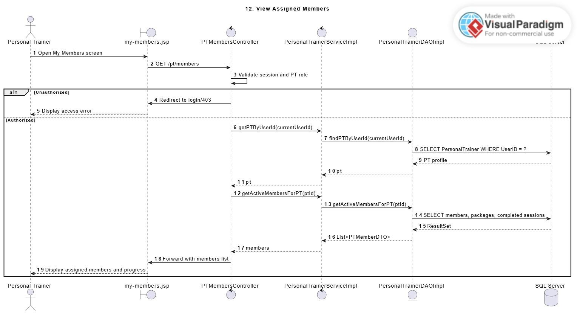
Description: This sequence diagram describes how a Personal Trainer views assigned members and their training progress. The PT opens the “My Members” screen, and the controller validates the logged-in PT account. The service retrieves the PT profile by user ID and loads active assigned members through DAO queries. The returned data includes member information, PT package information, and training progress. Progress is calculated from completed sessions over purchased sessions, while cancelled sessions are excluded.

3.12.5 PT Dashboard Views Swimlane Activity Diagram
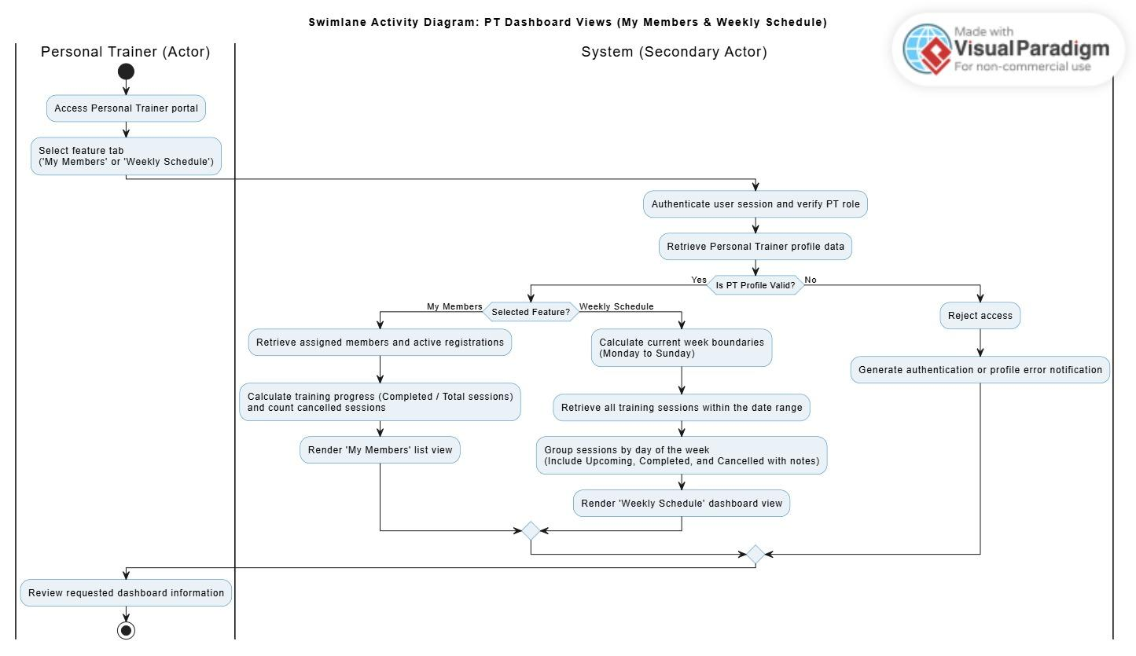
Description: This swimlane activity diagram describes how a Personal Trainer views dashboard information, including assigned members and weekly teaching schedule. The PT logs in, opens the dashboard, and selects either the “My Members” tab or the weekly schedule view. The controller validates the PT session and retrieves the PT profile. The service loads assigned member data or weekly schedule data through DAO queries. The view displays member information, package progress, and weekly session cards grouped by day.

3.13 Schedule Change Request Module

3.13.1 Create Reschedule Request Class Diagram
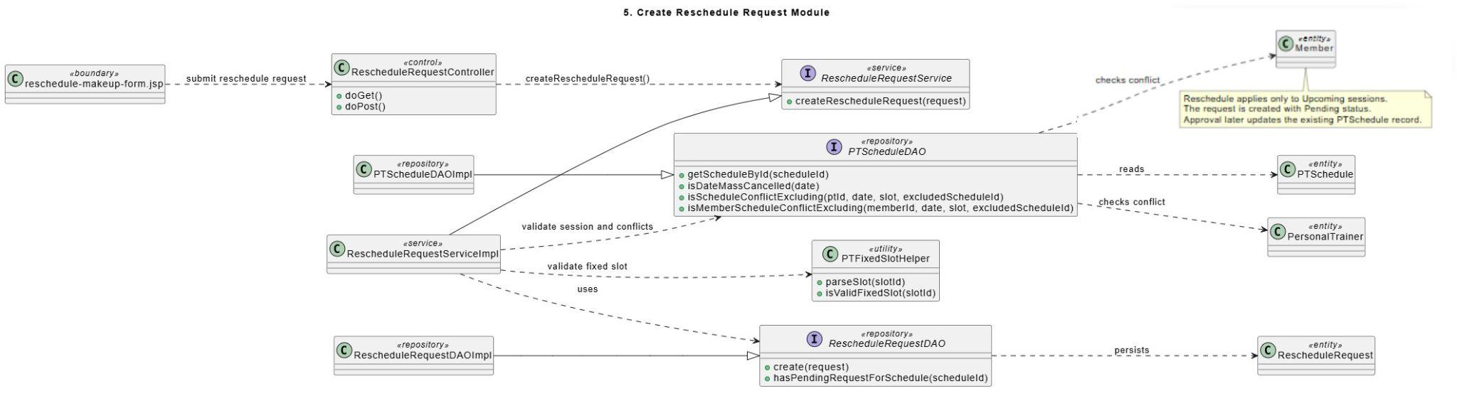
Description: This class diagram represents the classes used to create a reschedule request for an Upcoming PT session. The controller receives the submitted request and calls the RescheduleRequestService. The service validates session status, requester relationship, fixed-slot validity, mass-cancelled date restriction, and PT/Member schedule conflicts through PTScheduleDAO. RescheduleRequestDAO stores the Pending request. The RescheduleRequest entity represents the submitted schedule change request.

3.13.2 Respond Reschedule Request Class Diagram
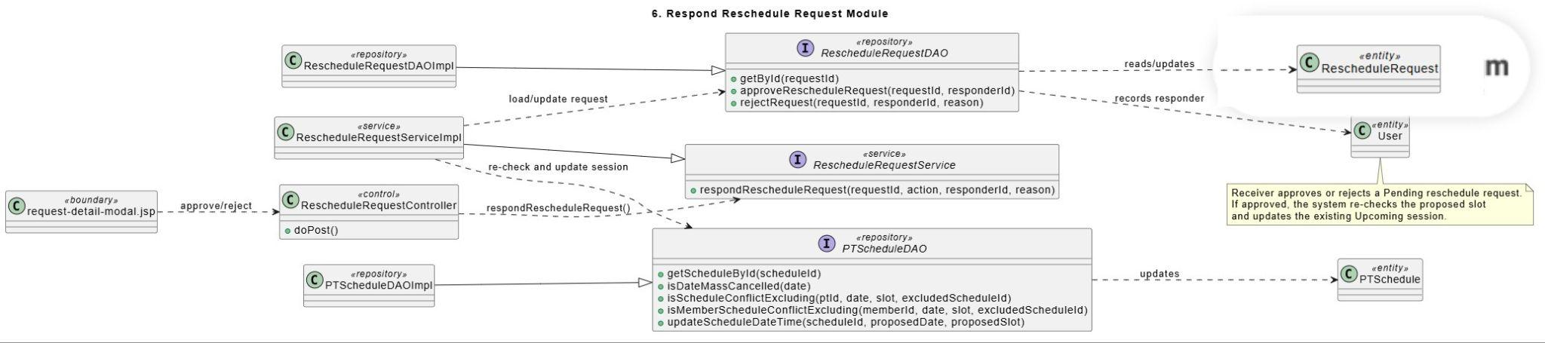
Description: This class diagram describes the classes involved when a receiver approves or rejects a reschedule request. The request detail view sends the response to the controller, which delegates processing to the RescheduleRequestService. The service retrieves the request, re-checks the proposed slot through PTScheduleDAO, and updates either the request status or the existing session schedule. RescheduleRequestDAO records approval or rejection information, while PTScheduleDAO updates the session date and time when approval succeeds.

3.13.3 Request Staff/Admin Support Class Diagram
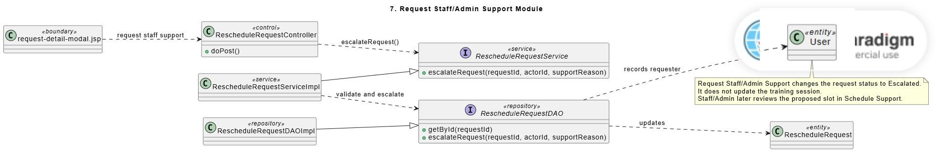
Description: This class diagram shows the structure for escalating a schedule request to Staff/Admin. The controller receives the support request from the request detail modal and calls the RescheduleRequestService. The service validates that the actor is related to the request and that the request can be escalated. RescheduleRequestDAO updates the request status to Escalated and stores the support reason. No PTSchedule record is updated in this module.

3.13.4 Create Reschedule Request Sequence Diagram
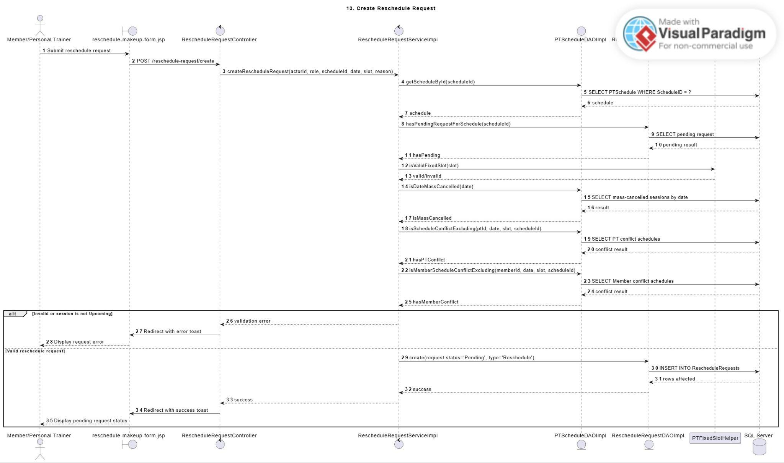
Description: This sequence diagram describes how a Member or Personal Trainer creates a reschedule request for an Upcoming PT session. The requester selects an Upcoming session, proposed future date, fixed slot, and reason from the dashboard. The controller sends the request data to the RescheduleRequestService. The service validates requester permission, session status, fixed-slot validity, mass-cancelled date restriction, duplicate pending request condition, and PT/Member schedule conflicts. If valid, the DAO creates a reschedule request with Pending status. The original session remains unchanged until approval.

3.13.5 Respond Reschedule Request Sequence Diagram
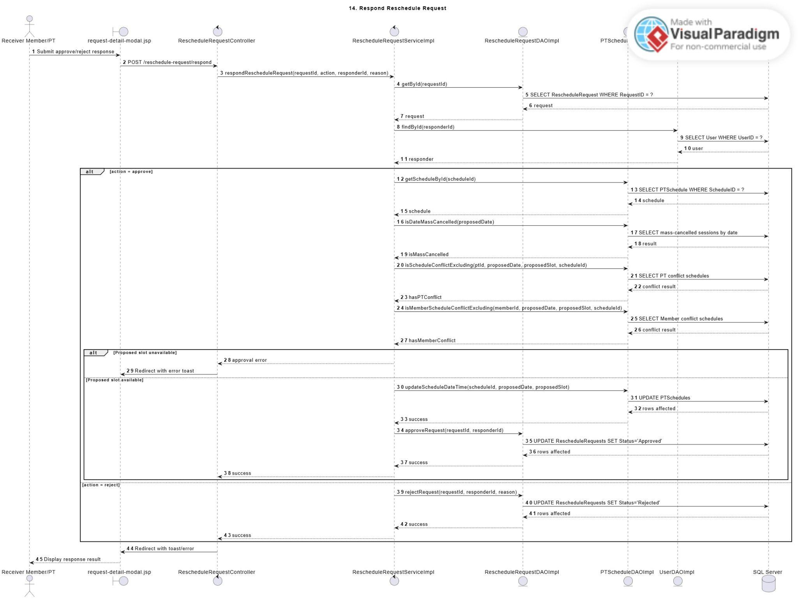
Description: This sequence diagram describes how the receiver responds to a reschedule request. The receiver opens the response modal and submits approve or reject. The controller sends the action, request ID, responder ID, and response reason to the service. If approved, the service retrieves the request, re-checks proposed slot availability, and updates the existing Upcoming session to the proposed date and fixed slot. If rejected, the DAO updates the request status to Rejected and keeps the original session unchanged.

3.13.6 Request Staff/Admin Support Sequence Diagram
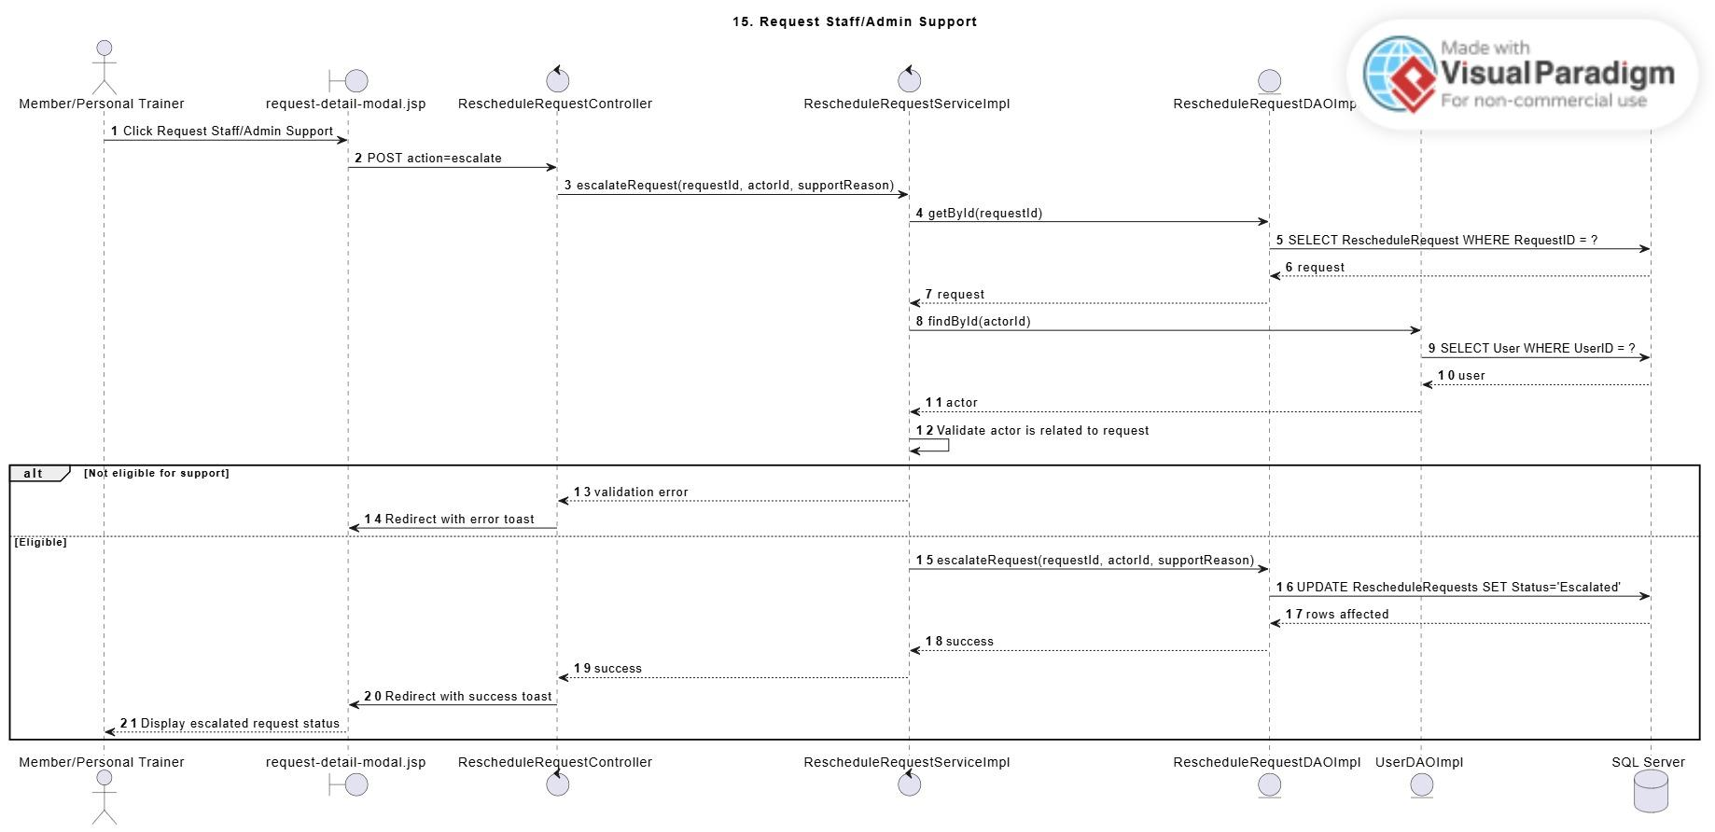
Description: This sequence diagram describes how a Member or Personal Trainer requests Staff/Admin support for a schedule request. The actor submits a support reason from the response modal. The controller calls the RescheduleRequestService with action escalate. The service validates the request and the actor relationship before updating the request status to Escalated. This flow does not update any PT session. Staff/Admin later reviews the existing proposed slot in the Schedule Support screen.

3.13.7 Create Reschedule Request Swimlane Activity Diagram
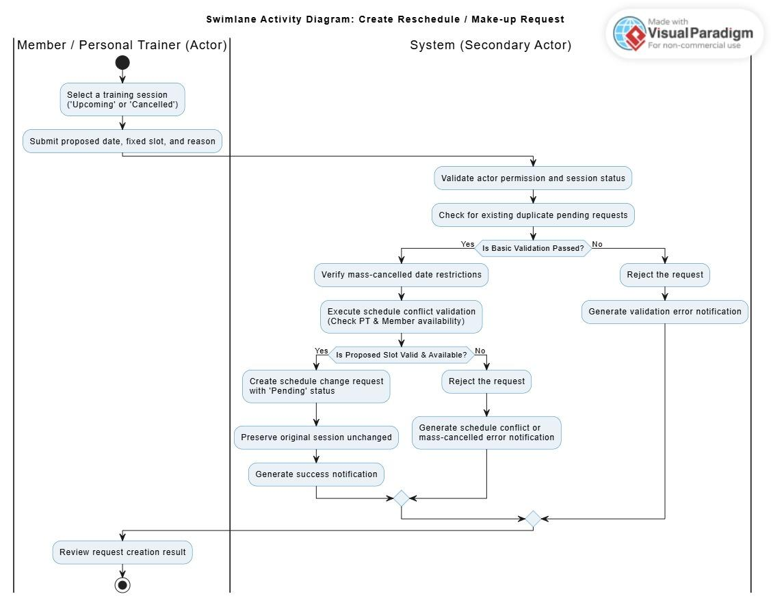
Description: This swimlane activity diagram describes how a Member or Personal Trainer creates a reschedule request for an Upcoming session. The requester selects a proposed future date, fixed time slot, and reason. The system validates actor permission, session status, duplicate pending request, fixed-slot validity, mass-cancelled date restriction, and PT/Member conflicts. If valid, the system creates a Pending reschedule request while the original session remains unchanged.

3.13.8 Respond Reschedule Request Swimlane Activity Diagram
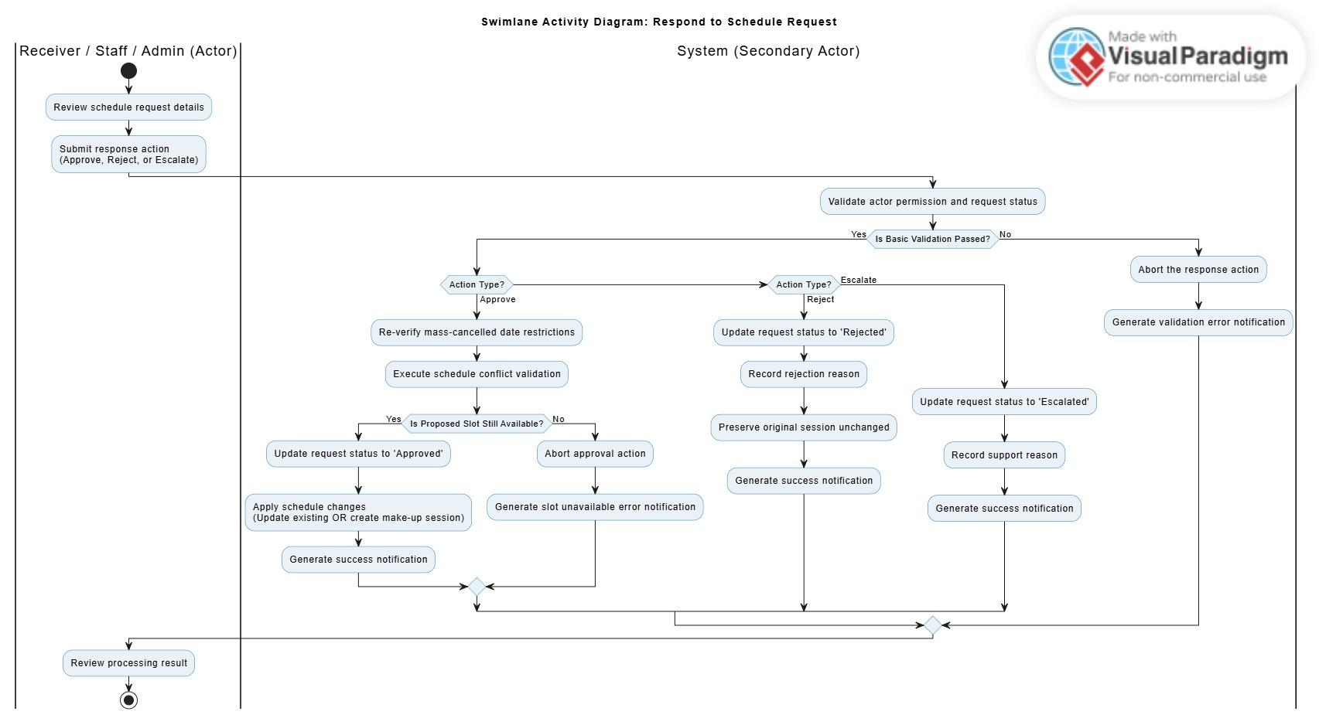
Description: This swimlane activity diagram describes how a receiver responds to a reschedule request. The receiver opens the request detail modal and chooses to approve or reject the proposed schedule. If approved, the system re-checks the proposed slot availability and updates the existing Upcoming session. If rejected, the system updates the request status to Rejected and keeps the original session unchanged. Staff/Admin may also process escalated requests using the same proposed-slot review logic.

3.13.9 Request Staff/Admin Support Swimlane Activity Diagram
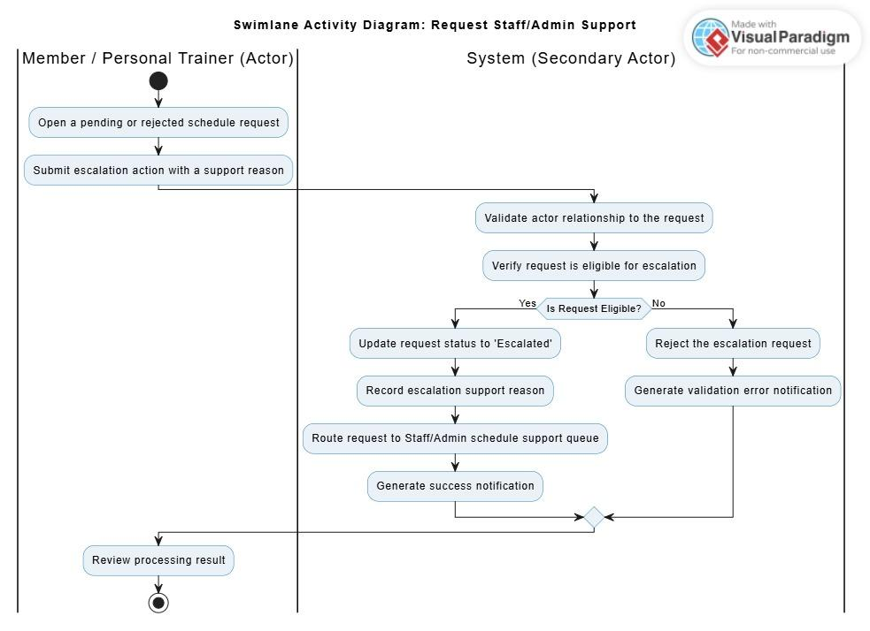
Description: This swimlane activity diagram describes how a Member or Personal Trainer escalates a schedule request to Staff/Admin. The actor enters a support reason and submits the escalation action. The system validates that the actor is related to the request and that the request is eligible for support. If valid, the request status becomes Escalated and appears in the Staff/Admin Schedule Support screen for review.

3.14 Manage Member

3.14.1 Class Diagram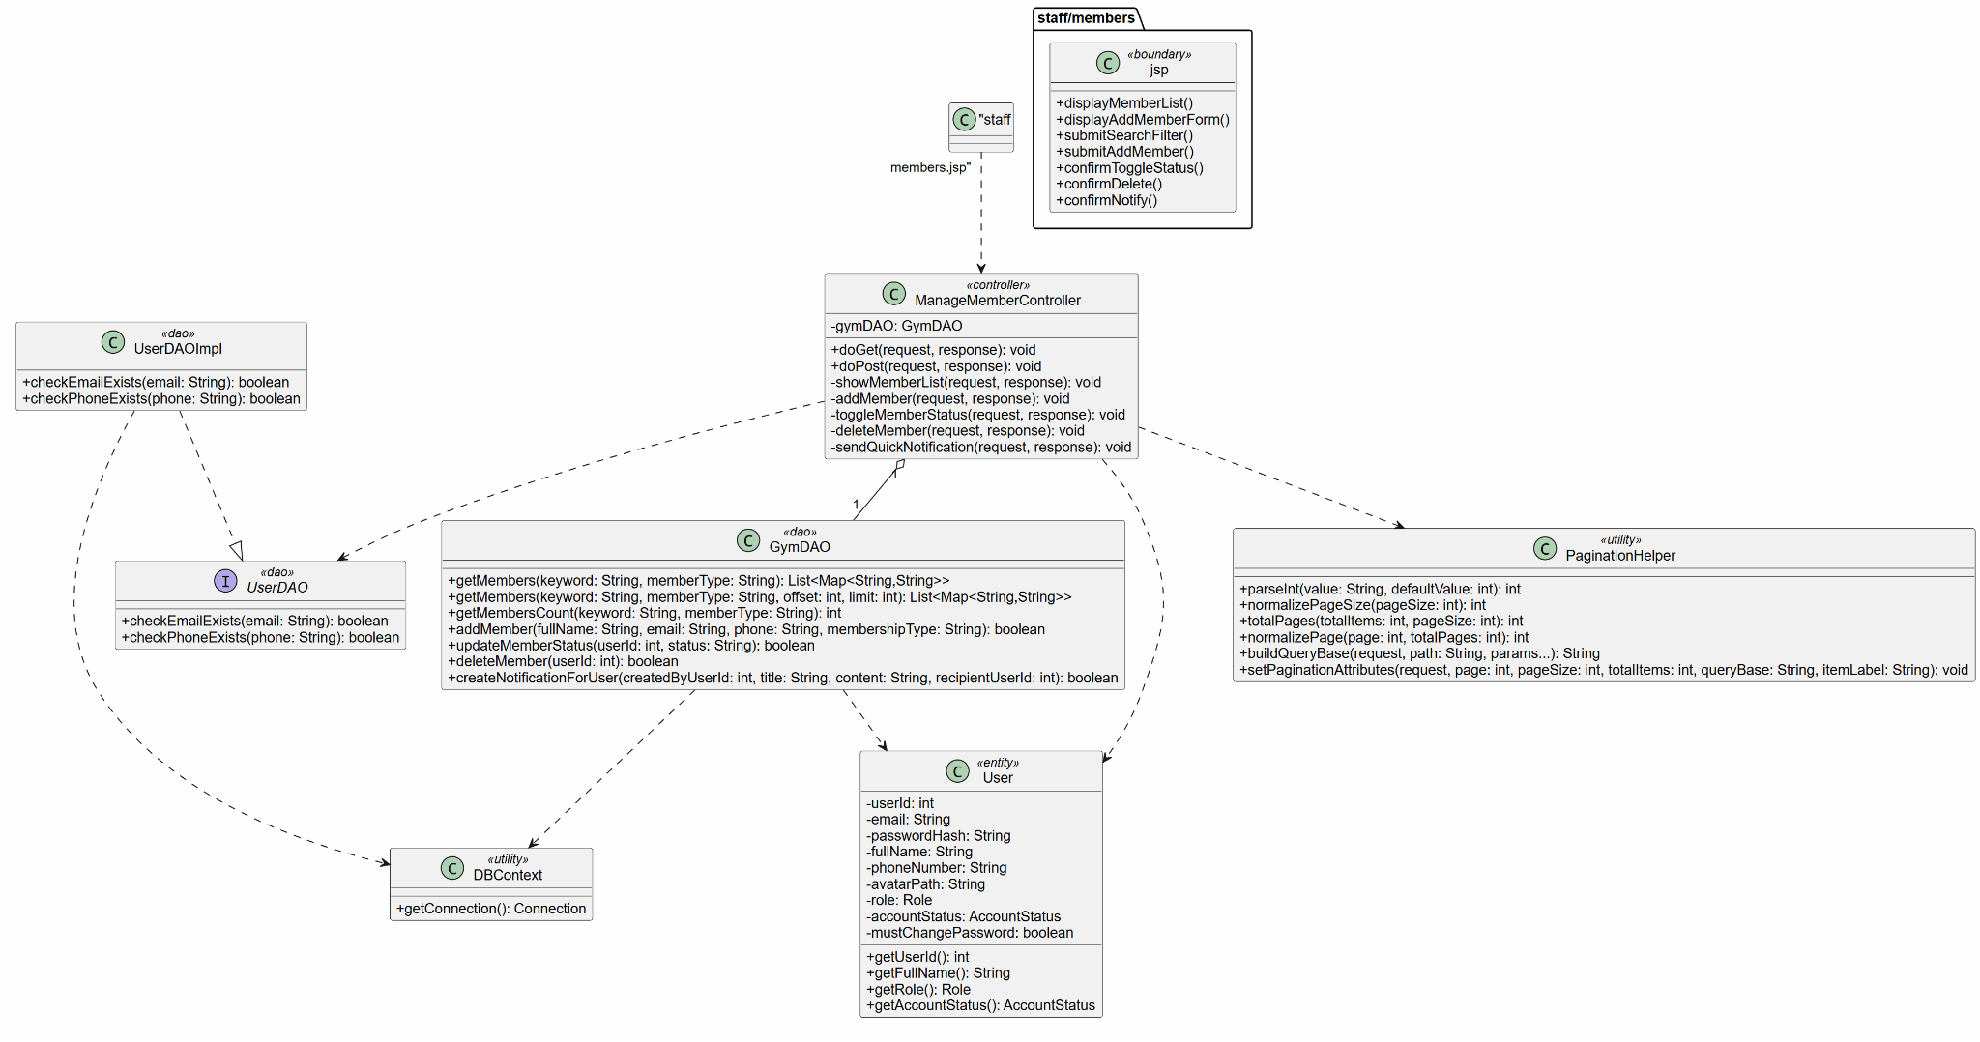

3.14.2 Sequence Diagram

3.14.2.1 Add Member
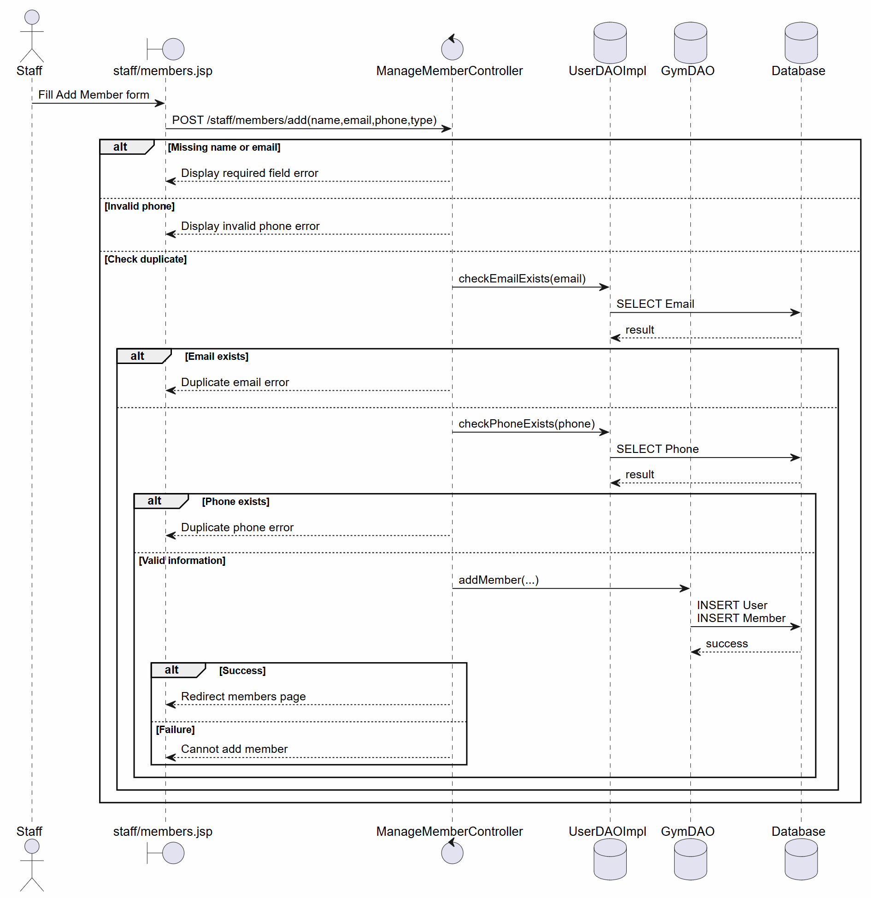
Description: Describes the flow where Staff opens the member management page, chooses to add a member, enters details, confirms the request, and the system validates and saves the new member. It also includes error flows for invalid phone number, invalid email format, and duplicate account information.

3.14.2.2 Search & View Member
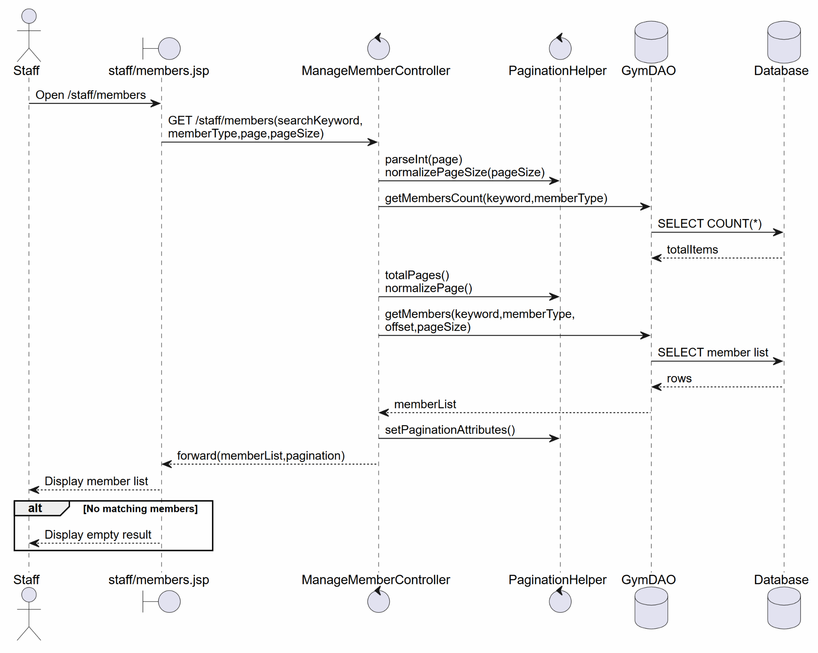
Description: Describes the flow where Staff opens the member management page, the system displays the default member list and filter tools, Staff enters search criteria, and the system retrieves matching records. If no data matches, the system displays a no-data message.

3.14.2.3 Update Member Status & Notification

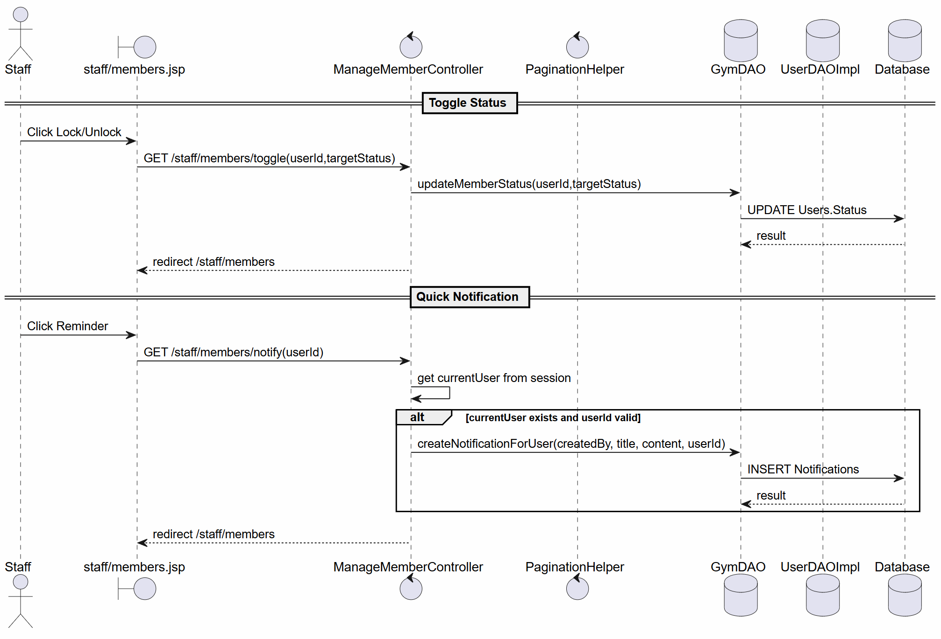
Description: Describes the flows for locking a member account, unlocking a locked account, and sending a renewal notification. It shows confirmation steps, account state validation, database updates, and notification creation.

3.14.2.4 Delete Member

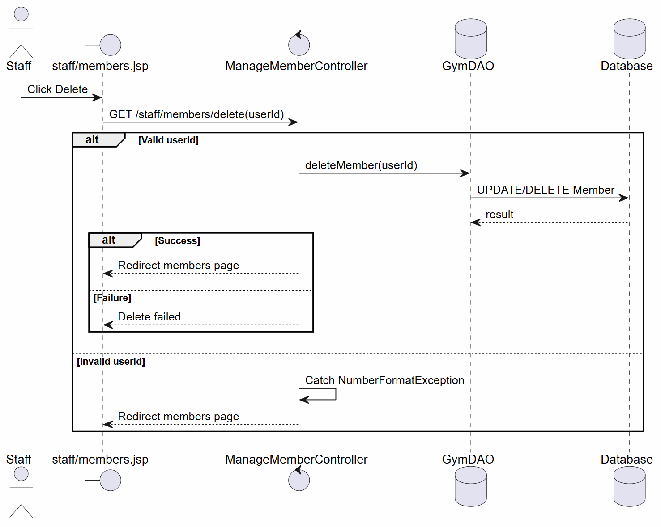
Description: Describes the flow where Staff selects a member to delete, the system validates permission, shows a confirmation prompt, and either cancels the operation or performs a soft delete in the database.

3.14.3 Swimlane Activity Diagram

3.14.3.1 Add Member
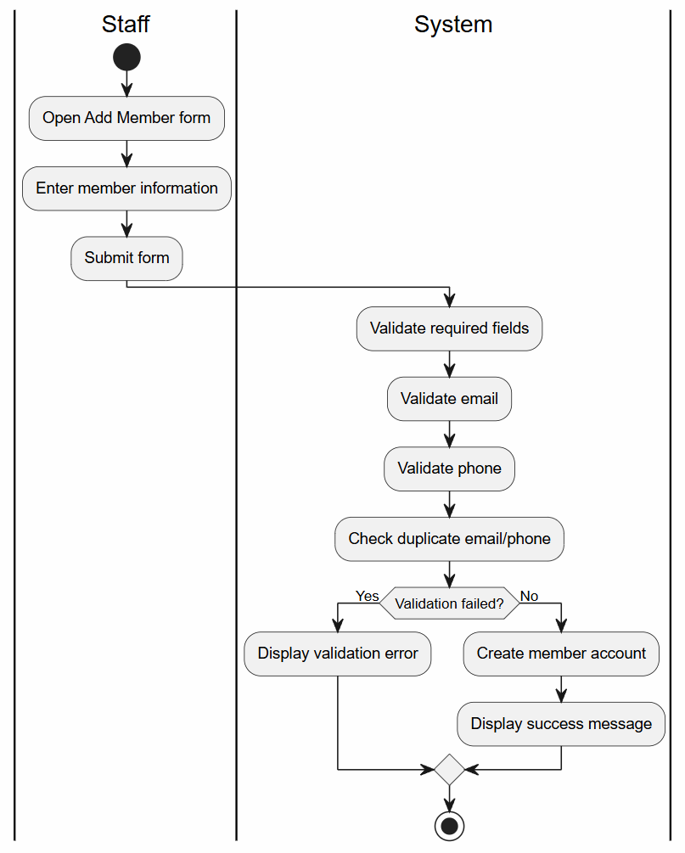
Description: Describes the flow where Staff opens the member management page, chooses to add a member, enters details, confirms the request, and the system validates and saves the new member. It also includes error flows for invalid phone number, invalid email format, and duplicate account information.

3.14.3.2 Search & View Member
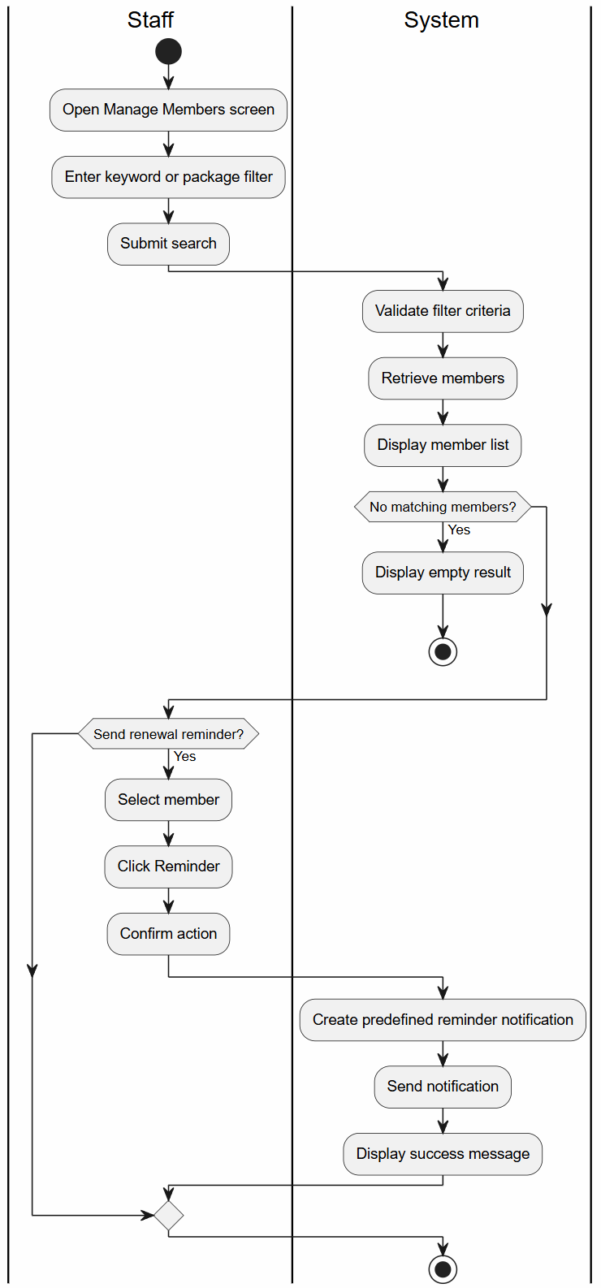
Description: Describes the flow where Staff opens the member management page, the system displays the default member list and filter tools, Staff enters search criteria, and the system retrieves matching records. If no data matches, the system displays a no-data message.

3.14.3.3 Update Member Status & Notification


Description: Describes the flows for locking a member account, unlocking a locked account, and sending a renewal notification. It shows confirmation steps, account state validation, database updates, and notification creation.

3.14.3.4 Delete Member


Description: Describes the flow where Staff selects a member to delete, the system validates permission, shows a confirmation prompt, and either cancels the operation or performs a soft delete in the database.

3.15 View Member Portal

3.15.1 Class Diagram
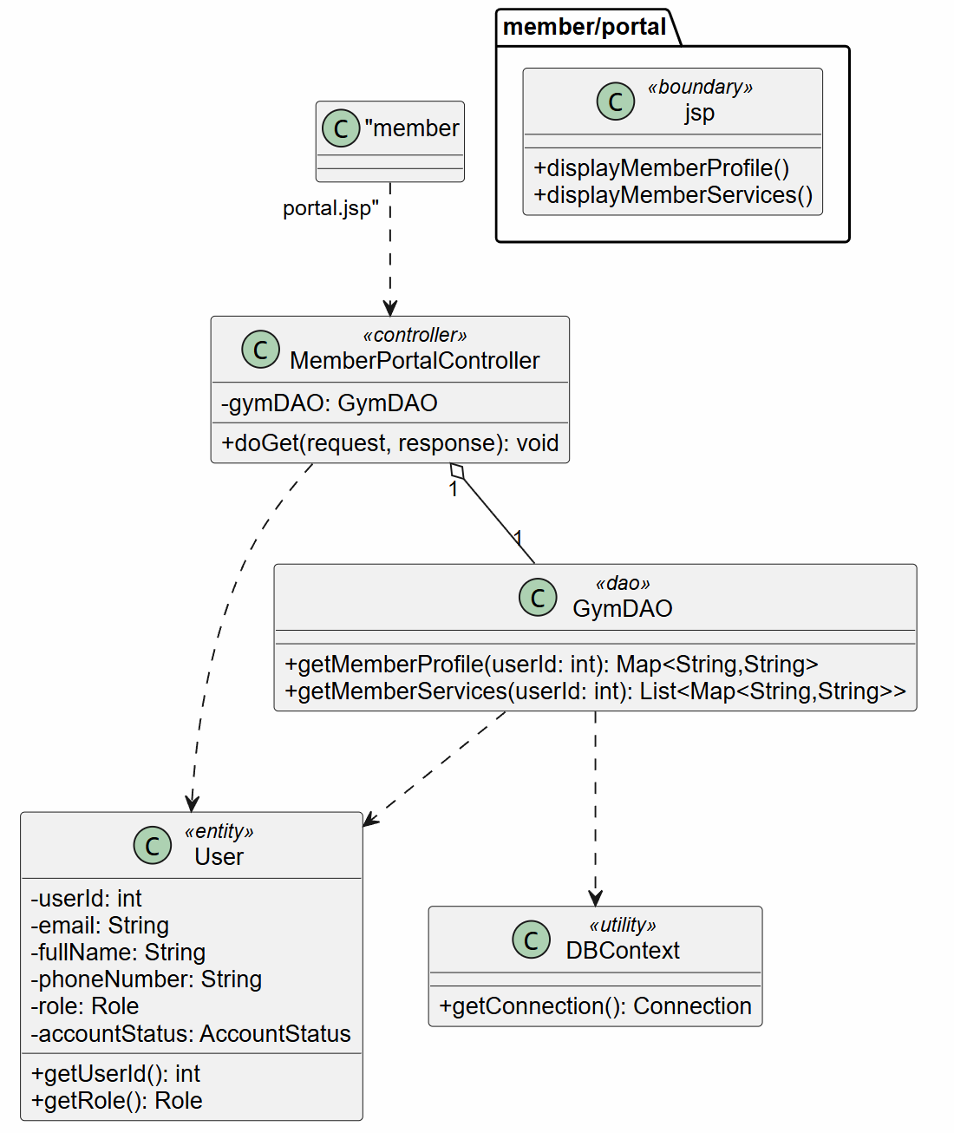
Description: Describes the classes involved in displaying the member portal, including Member, portal page, authentication service, controller, portal service, repositories, member profile, and service package history.

3.15.2 Sequence Diagram

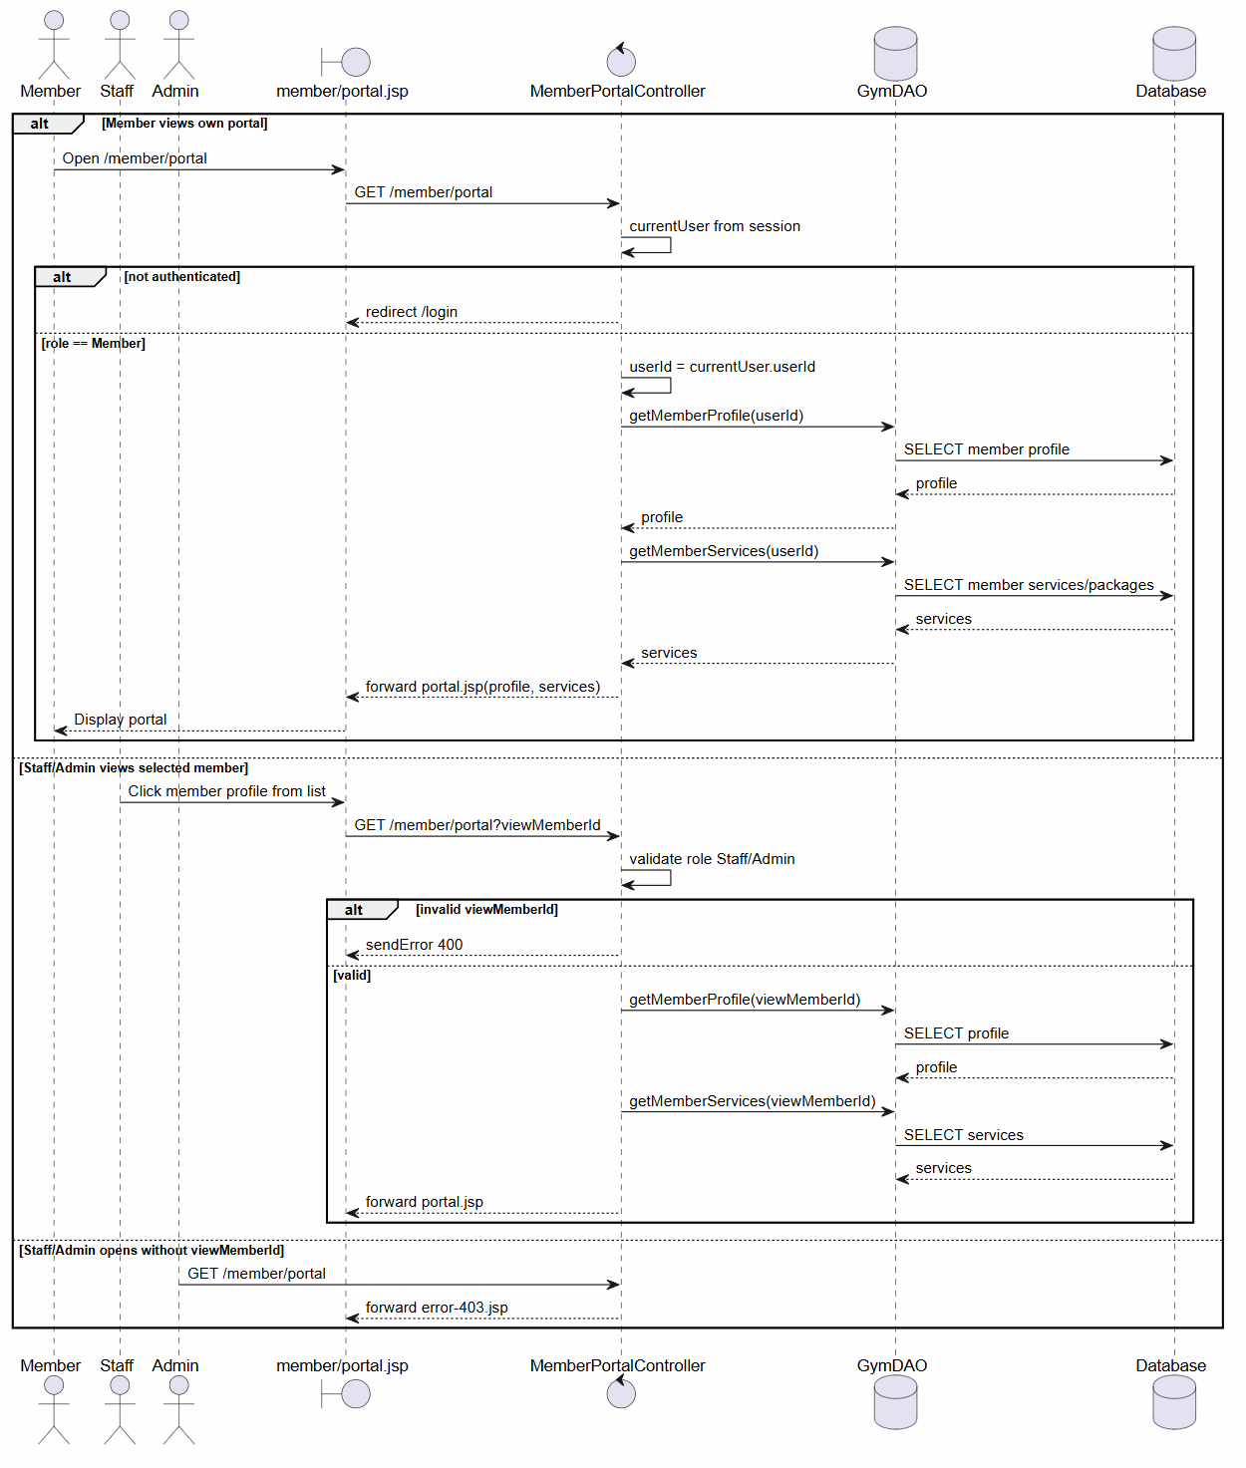
Description: Describes the flow where a Member logs in, navigates to the personal profile section, and the system retrieves profile details and registered service package history from the database. It also includes the invalid login flow.

3.15.3 State Diagram
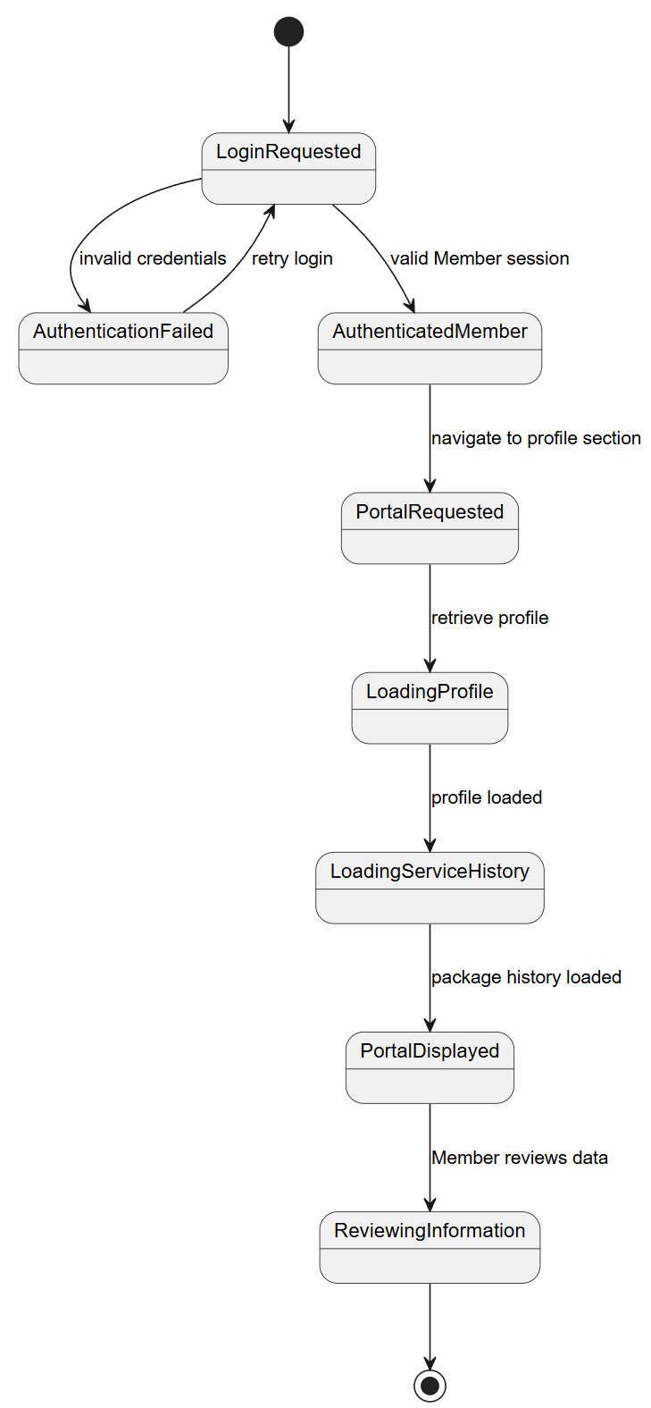
Description: Describes the portal access states, from login request and authentication result to loading profile information, loading service history, displaying the portal, and reviewing information.

3.16 View Member Notifications

3.16.1 Class Diagram
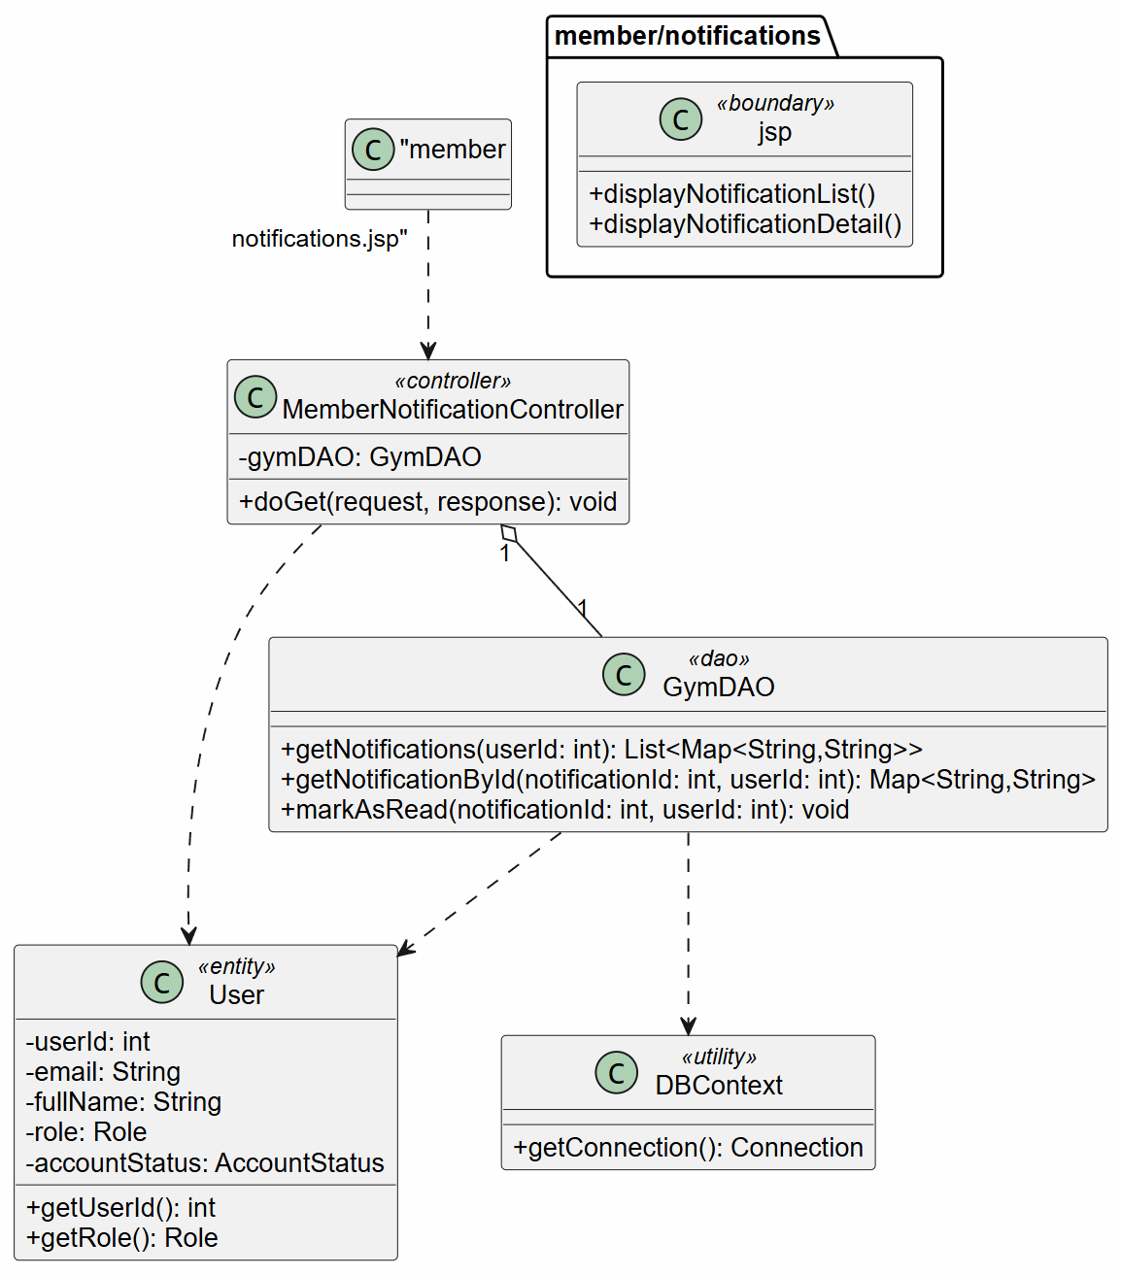
Description: Describes the classes involved in displaying targeted notifications for members. It includes Member, Notification page, controller, service, repository, Notification, and NotificationRecipient.

3.16.2 Sequence Diagram
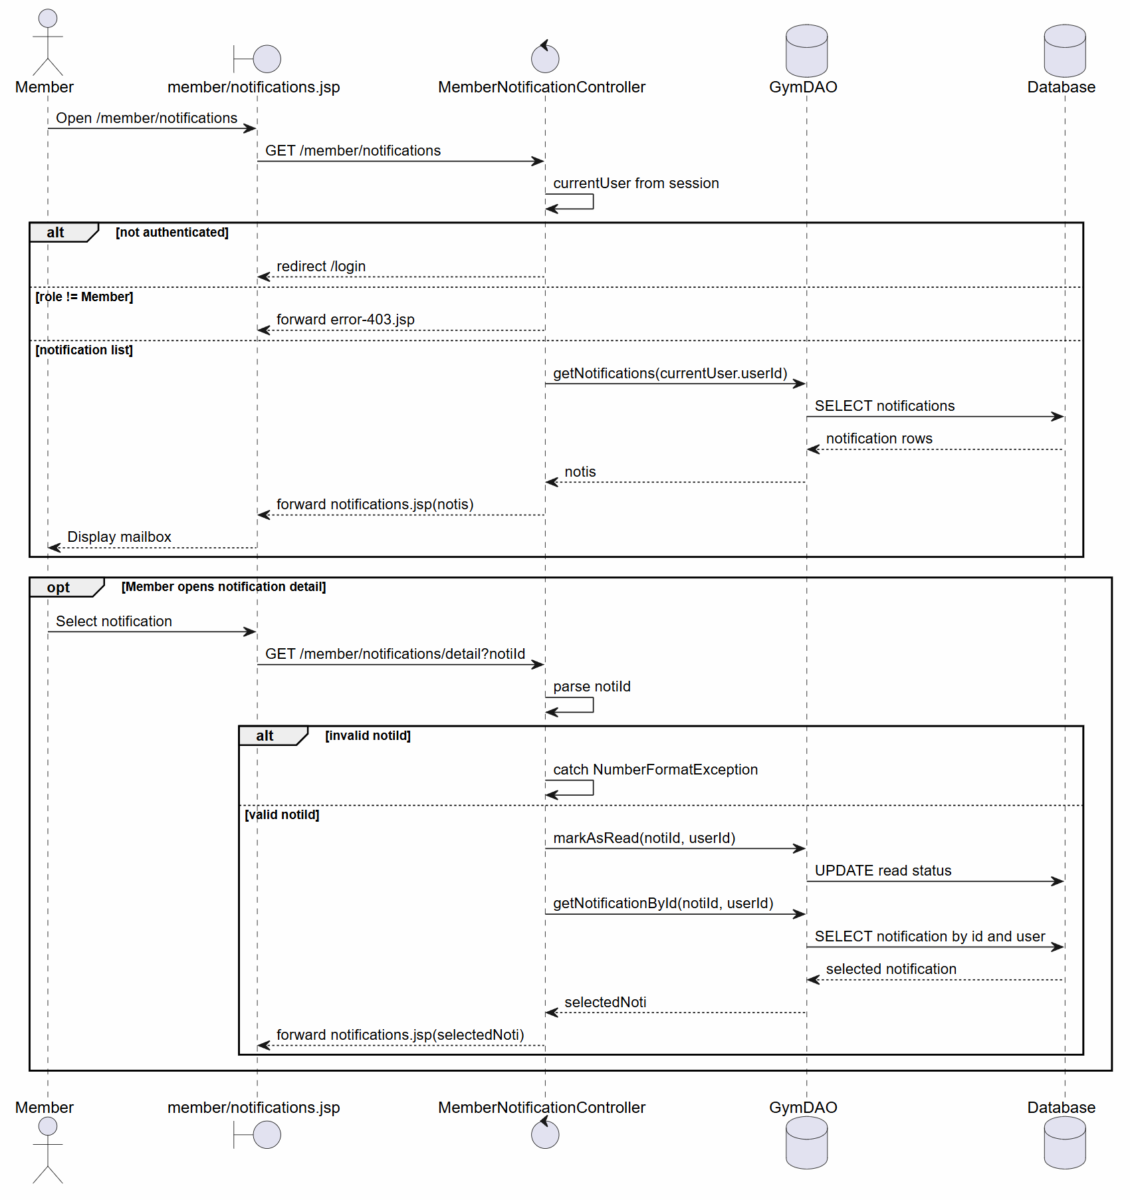
Description: Describes the flow where a Member opens the notification section, the system retrieves active notifications for the member role or specific member, displays the list, shows notification details, and marks the selected notification as read.

3.16.3 State Diagram
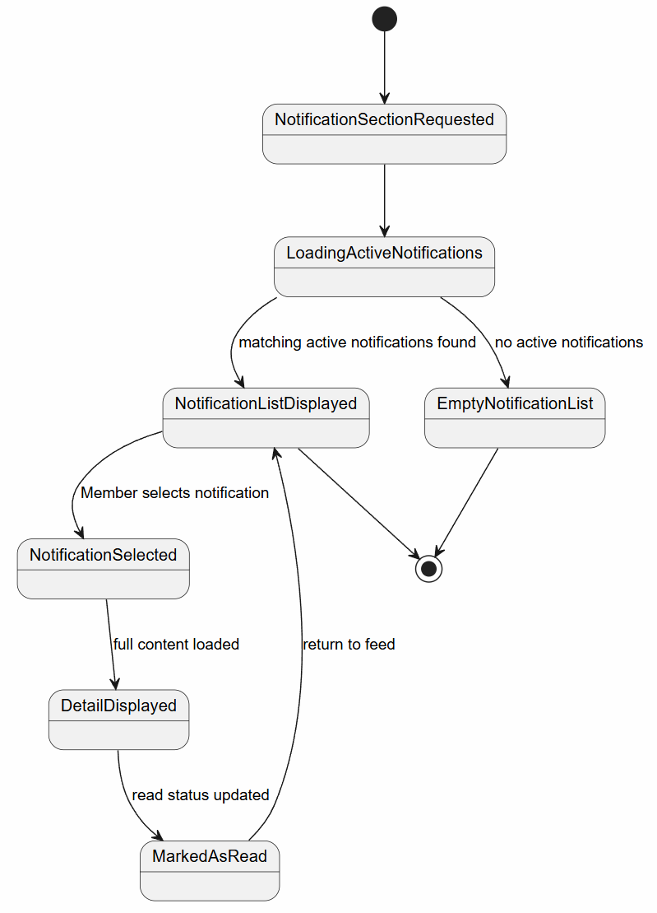
Description: Describes the notification viewing states, from requesting the notification section and loading active notifications to displaying the list, showing an empty list, viewing details, and marking a notification as read.

3.17 Make-up Request Module

3.17.1 Create Make-up Request Class Diagram
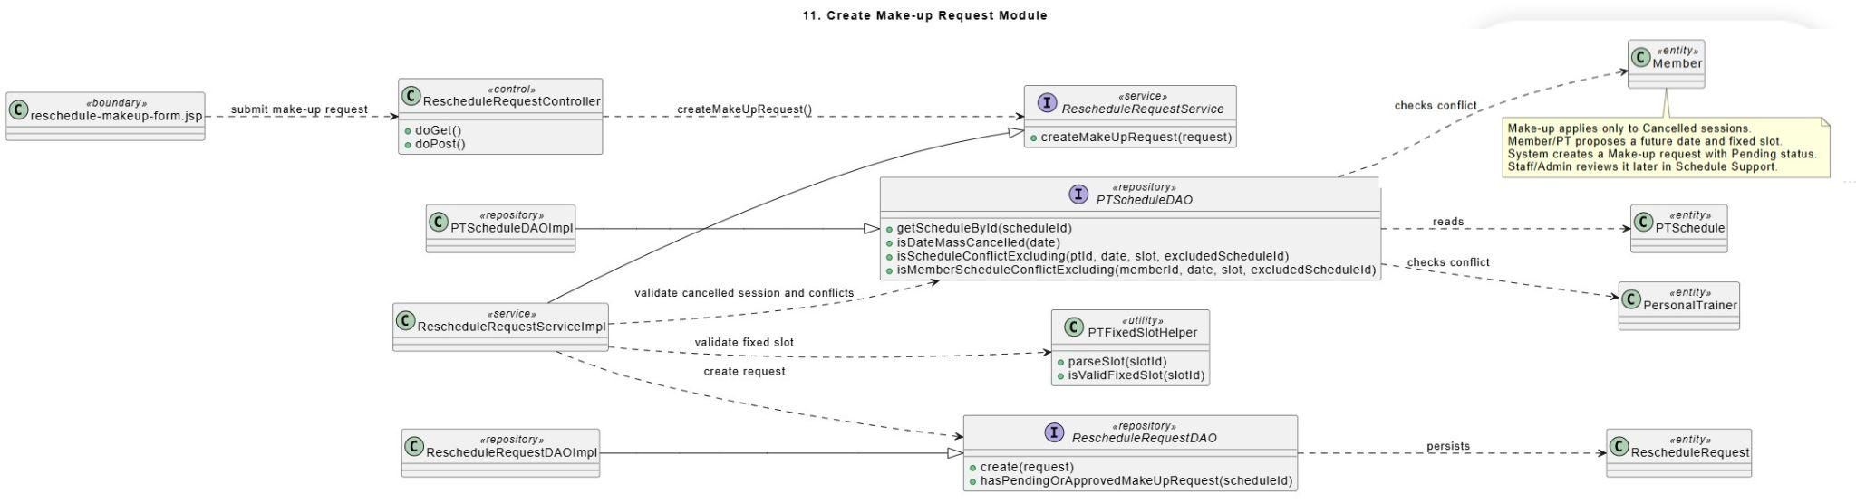
Description: This class diagram represents the classes used when a Member or Personal Trainer creates a make-up request for a Cancelled session. The request form view sends the proposed make-up date, fixed slot, and reason to the controller. RescheduleRequestService validates that the original session is Cancelled, the actor is related to the session, the proposed slot is valid, and no pending or approved make-up request already exists. RescheduleRequestDAO creates a Pending make-up request for Staff/Admin review.

3.17.2 Process Make-up Request Class Diagram
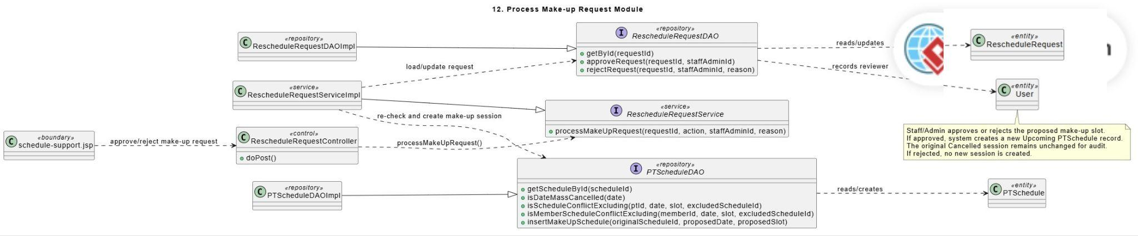
Description: This class diagram describes the classes used by Staff/Admin to approve or reject a make-up request. The Schedule Support view sends the decision to the RescheduleRequestController, which delegates processing to RescheduleRequestService. The service loads the make-up request, re-checks the proposed slot, and uses PTScheduleDAO to create a new Upcoming make-up session when approved. RescheduleRequestDAO records approval or rejection information. The original Cancelled PTSchedule record remains unchanged.

3.17.3 Create Make-up Request For Cancelled Session Sequence Diagram
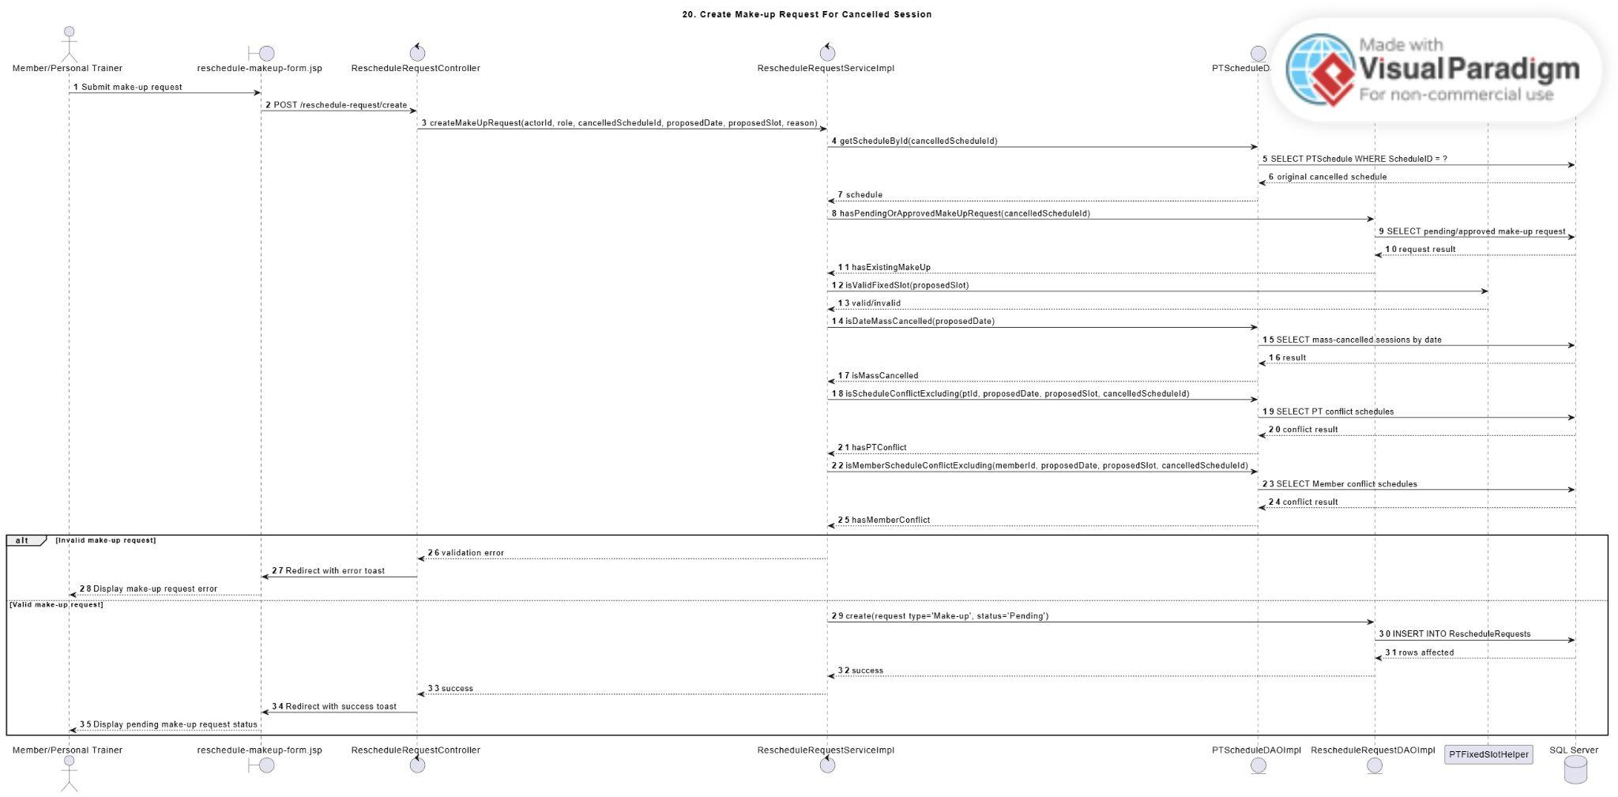
Description: This sequence diagram describes how a Member or Personal Trainer creates a make-up request for a Cancelled PT session. The requester opens the Cancelled session, selects a proposed future date and fixed slot, enters a reason, and submits the request. The controller sends the data to the RescheduleRequestService. The service validates that the original session is Cancelled, the actor is related to the session, no pending or approved make-up request already exists, the proposed date is not mass-cancelled, and the proposed slot does not conflict with the PT or Member schedule. If valid, the DAO creates a make-up request with Pending status for Staff/Admin review.

3.17.4 Process Make-up Request Sequence Diagram
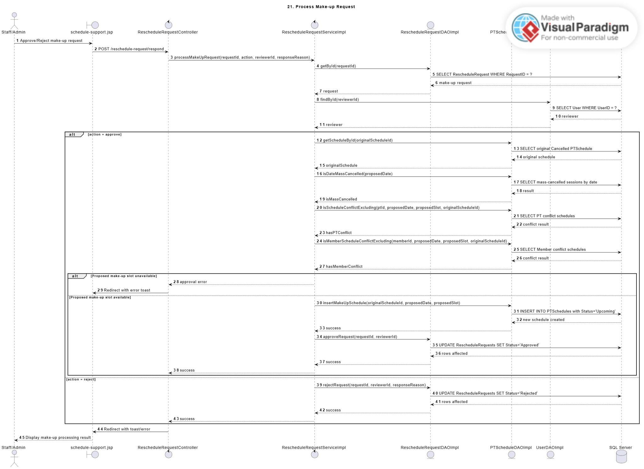
Description: This sequence diagram describes how Staff/Admin approves or rejects a make-up request. Staff/Admin opens the Schedule Support screen, reviews the original Cancelled session, cancellation reason, requester, and proposed make-up slot. The controller sends the approval or rejection action to the RescheduleRequestService. If approved, the service re-checks the proposed slot and creates a new Upcoming PTSchedule record for the make-up session. The original Cancelled session remains unchanged for audit. If rejected, the DAO updates the request status to Rejected and no new session is created.

3.17.5 Create Make-up Request For Cancelled Session Swimlane Activity Diagram
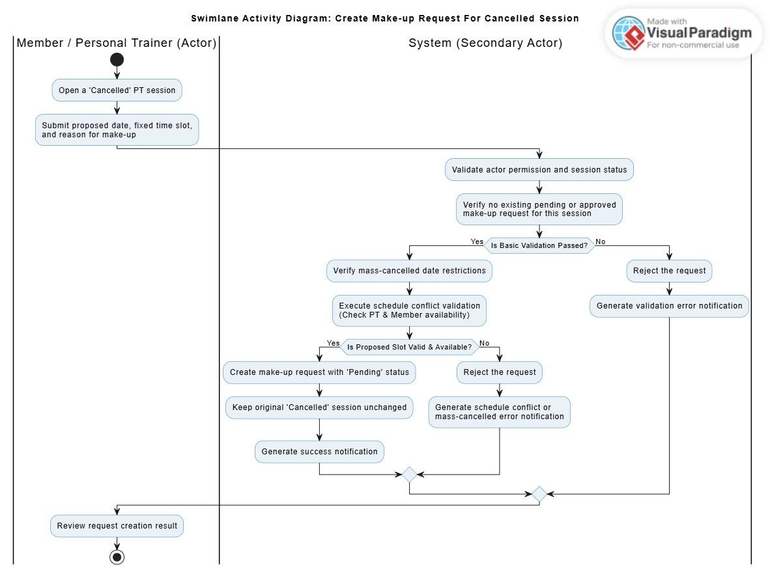
Description: This swimlane activity diagram describes how a Member or Personal Trainer creates a make-up request for a Cancelled PT session. The requester opens the Cancelled session, selects a proposed future date and fixed slot, and enters a reason. The system validates that the original session is Cancelled, the actor is related to the session, no pending or approved make-up request already exists, and the proposed slot does not conflict with PT or Member schedules. If valid, the system creates a Pending make-up request for Staff/Admin review.

3.17.6 Process Make-up Request Swimlane Activity Diagram
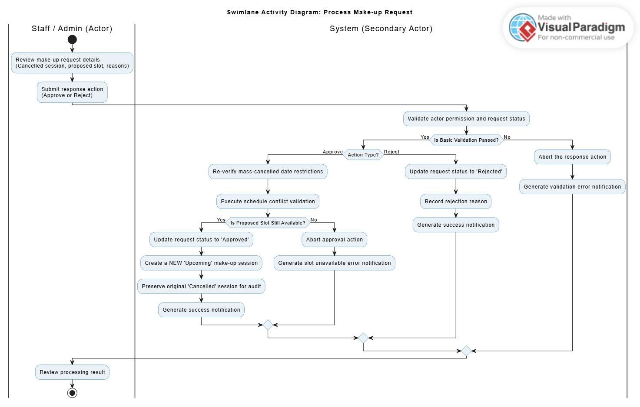
Description: This swimlane activity diagram describes how Staff/Admin processes a make-up request. Staff/Admin reviews the original Cancelled session, cancellation reason, requester, and proposed make-up slot. If approved, the system re-checks slot availability and creates a new Upcoming PT session. The original Cancelled session remains unchanged. If rejected, no new session is created and the request status becomes Rejected.

3.18 Staff/Admin PT Schedule Operations Module

3.18.1 Assign Substitute PT Class Diagram
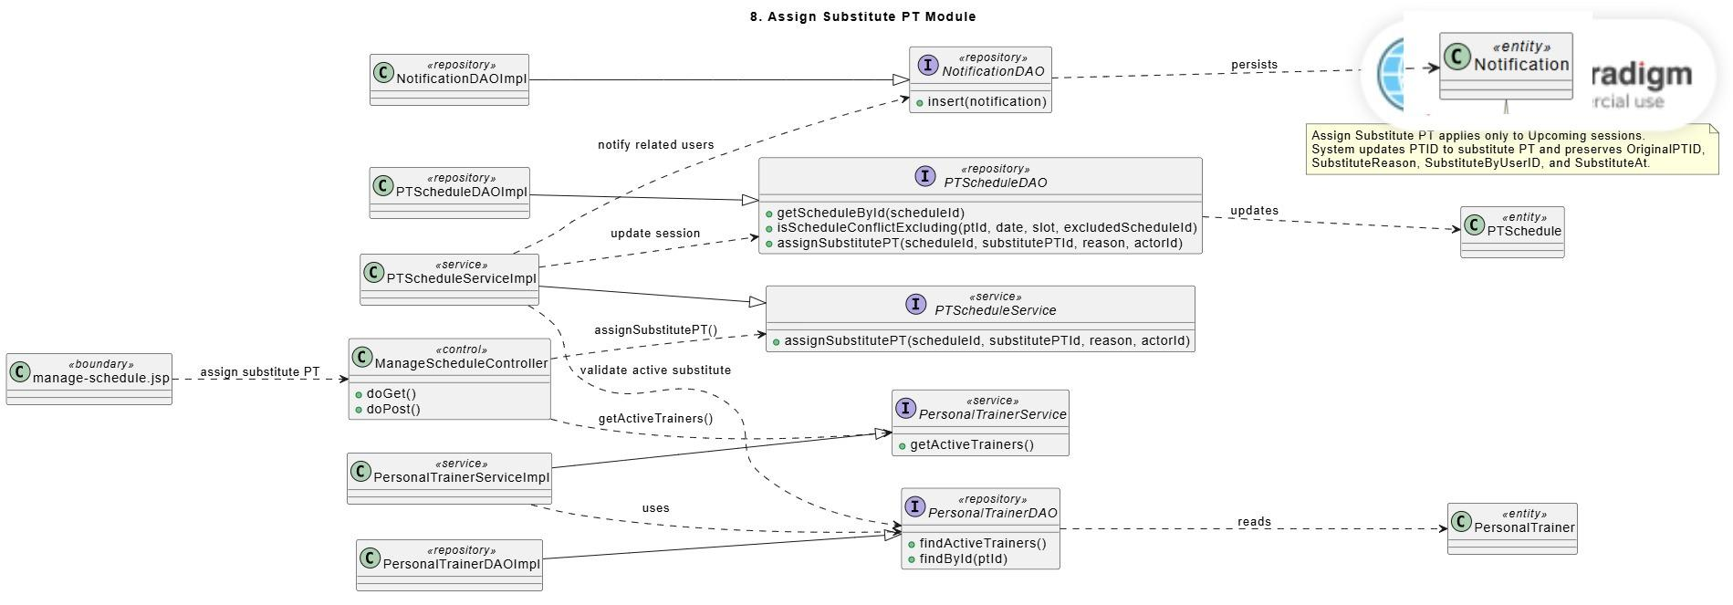
Description: This class diagram describes the classes used when Staff/Admin assigns a substitute Personal Trainer to an Upcoming session. The controller loads active trainers and submits substitute assignment data to the PTScheduleService. The service validates the selected session, substitute PT status, and schedule conflicts using PTScheduleDAO and PersonalTrainerDAO. The DAO updates the PTSchedule record by replacing the assigned PT while preserving original PT audit information. NotificationDAO may create notifications for affected users.

3.18.2 Update Training Session Status Class Diagram
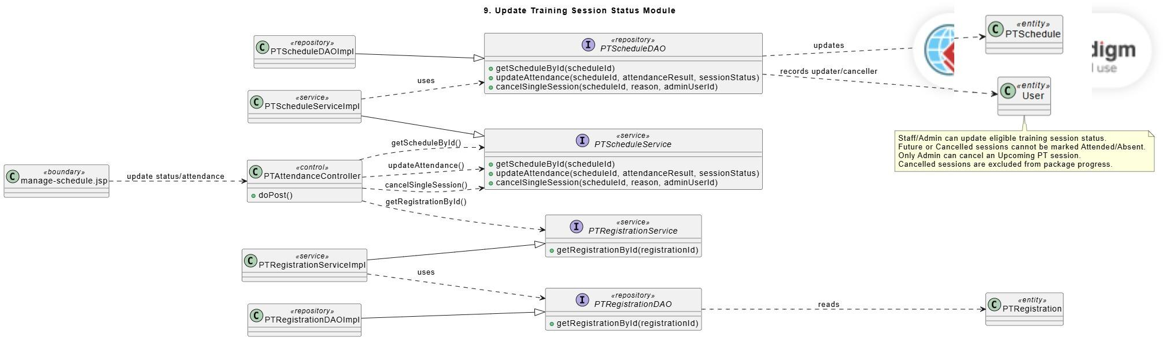
Description: This class diagram represents the classes used for updating PT session attendance and status. The view sends the selected status or attendance result to the PTAttendanceController. The controller validates session eligibility and calls the PTScheduleService. The service uses PTScheduleDAO to update attendance result, session status, or single-session cancellation information. PTRegistrationService may be used to retrieve registration information for progress-related display or validation. The PTSchedule entity stores the training session result.

3.18.3 Mass Cancel PT Sessions Class Diagram
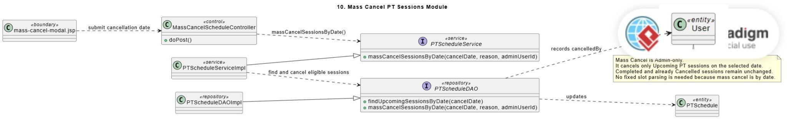
Description: This class diagram describes the classes used for Admin-only mass cancellation. The mass cancel view submits a selected cancellation date and reason to the MassCancelScheduleController. The controller calls PTScheduleService to find and cancel eligible Upcoming sessions on the selected date. PTScheduleDAO updates the affected PTSchedule records and stores cancellation audit information. The User entity represents the Admin who performed the cancellation.

3.18.4 Assign Substitute PT Sequence Diagram
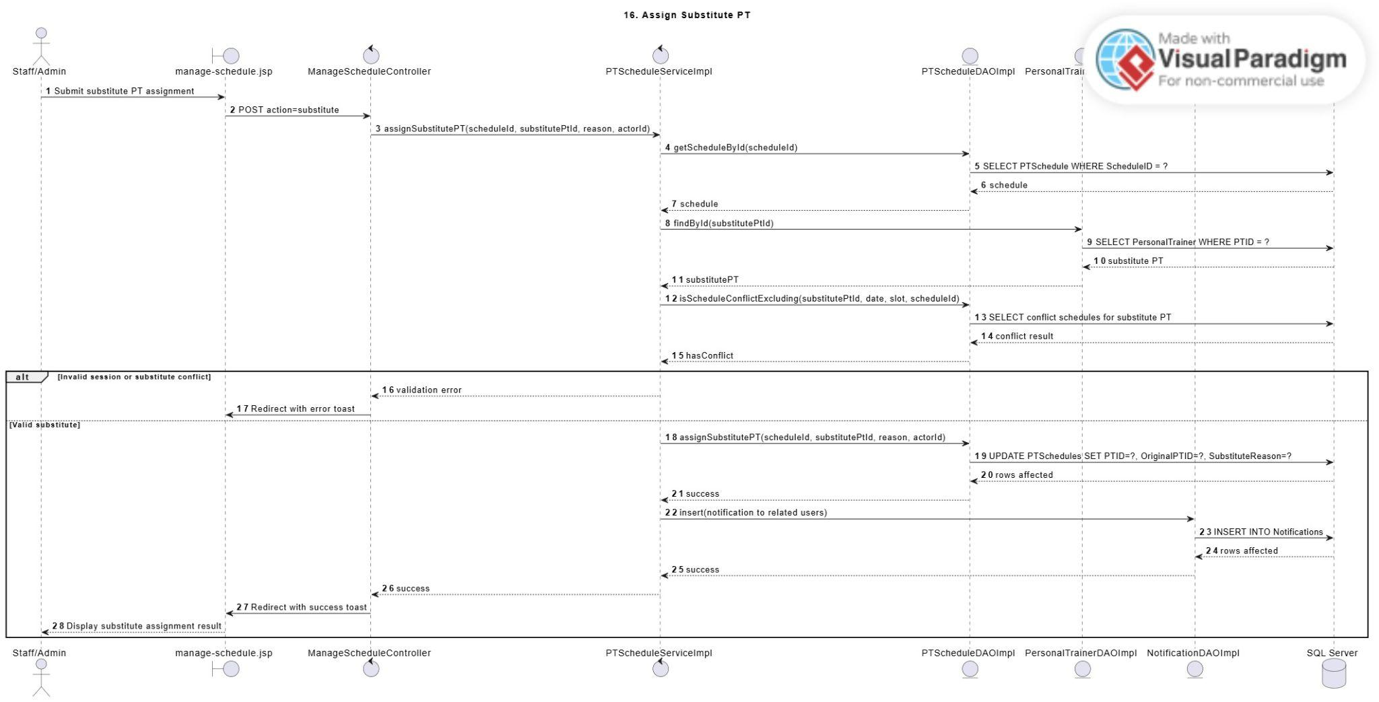
Description: This sequence diagram describes how Staff/Admin assigns a substitute Personal Trainer to an Upcoming PT session. Staff/Admin selects a session, chooses an active substitute trainer, and enters a substitute reason. The controller sends the request to the PTScheduleService. The service validates the selected session, checks that the substitute PT is active, and verifies there is no schedule conflict. The DAO updates the PTSchedule record by replacing the assigned PT, preserving the original PT information, and storing substitute audit fields. The system may also create notifications for related users.

3.18.5 Update Training Session Status Sequence Diagram
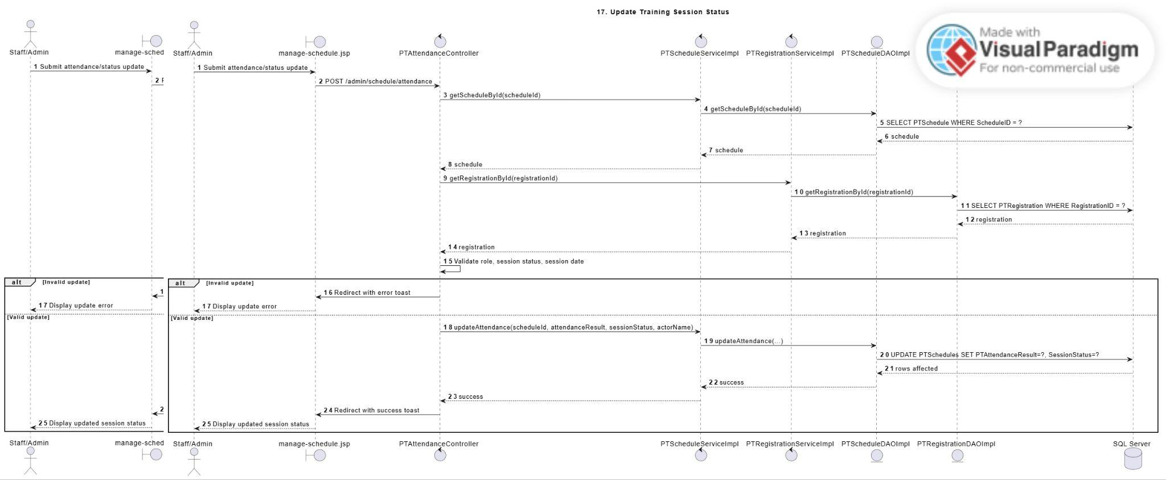
Description: This sequence diagram describes how Staff/Admin updates a PT training session’s attendance or session status. Staff/Admin selects a schedule record and submits the attendance result. The controller retrieves the session and related registration information, then validates that the session is eligible for update. If valid, the service updates the attendance result and session status through the DAO layer. Future sessions and Cancelled sessions cannot be marked as Attended or Absent. Completed sessions count toward package progress, while Cancelled sessions are excluded.

3.18.6 Admin Cancel One PT Session Sequence Diagram
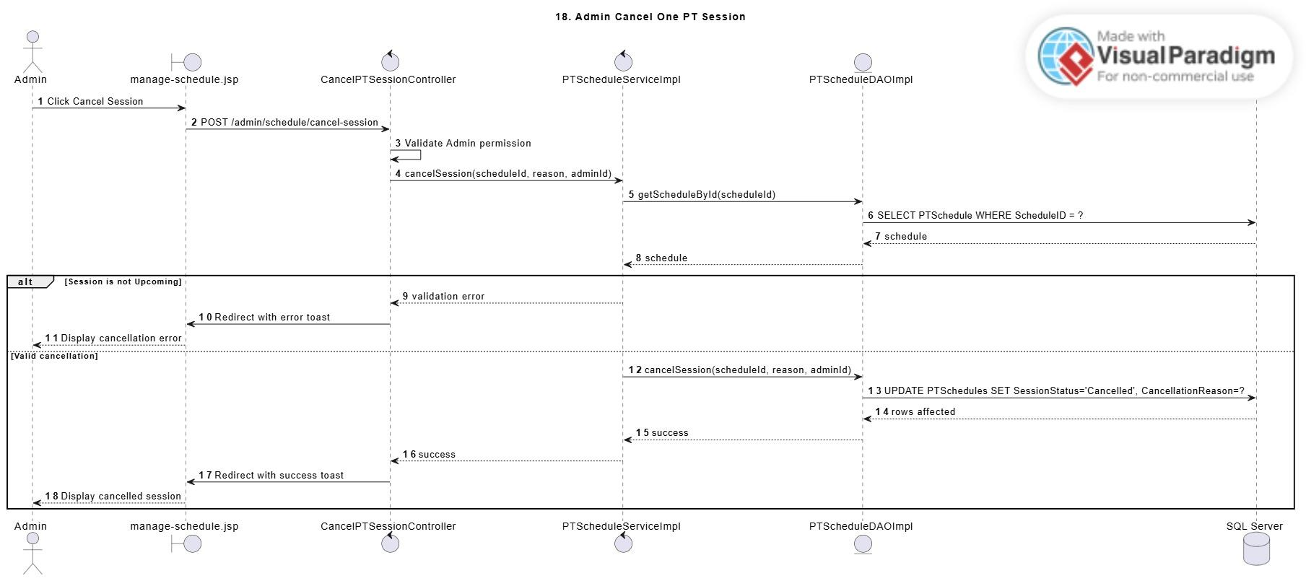
Description: This sequence diagram describes how Admin cancels a single Upcoming PT session due to gym-level or operational reasons. Admin selects an eligible session and submits a cancellation reason. The controller validates Admin permission and calls the PTScheduleService. The DAO updates the selected PTSchedule record to Cancelled and stores cancellation audit information such as cancellation reason, cancelled time, and cancelled-by user. The original session remains visible as a Cancelled record and can later be used for make-up request creation.

3.18.7 Mass Cancel PT Sessions Sequence Diagram
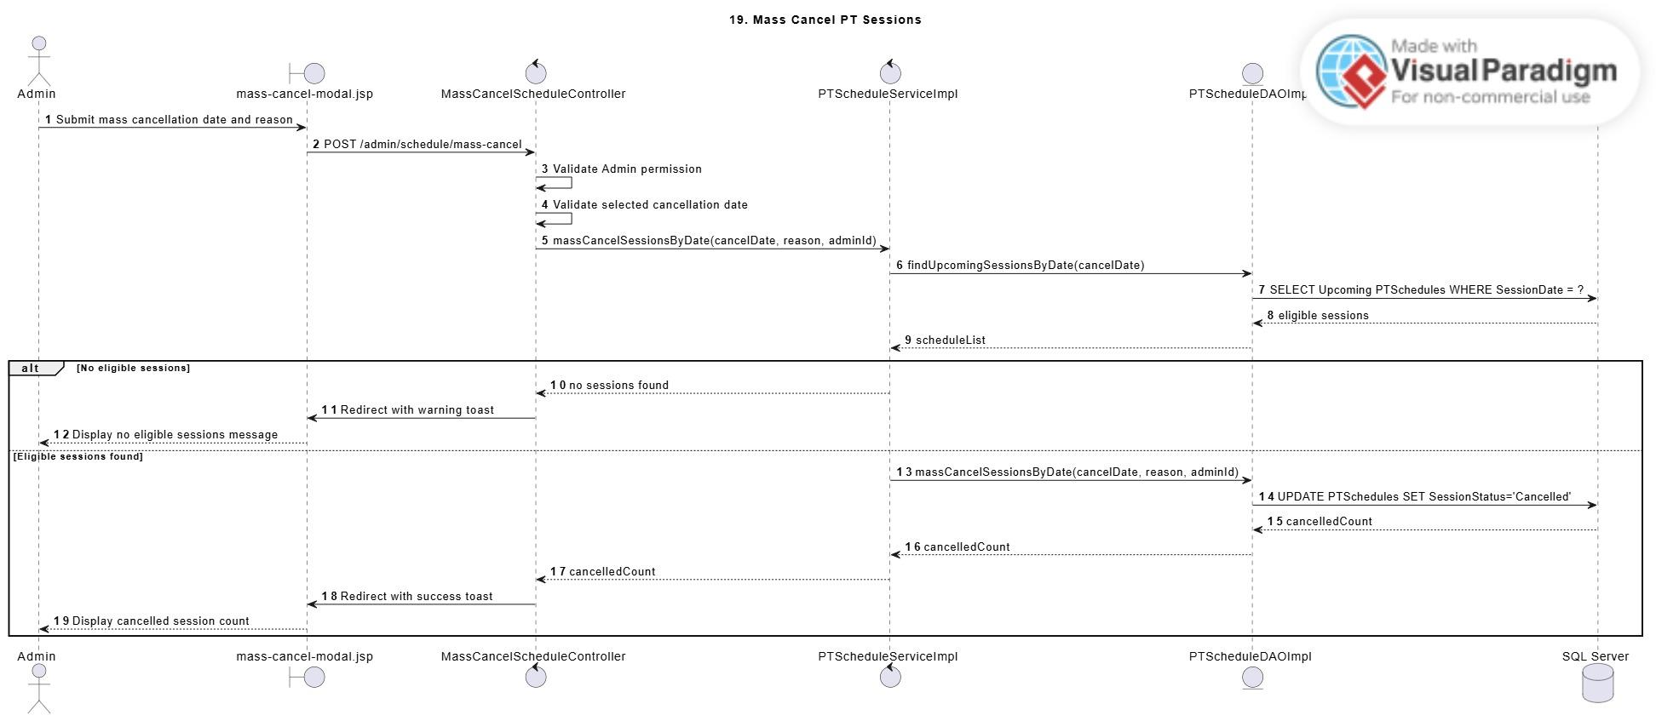
Description: This sequence diagram describes how Admin cancels all eligible Upcoming PT sessions on a selected date. Admin opens the mass cancel function, enters a cancellation date and reason, and confirms the action. The controller sends the cancellation request to the PTScheduleService. The service retrieves Upcoming sessions on the selected date and excludes Completed or already Cancelled sessions. The DAO updates all eligible sessions to Cancelled and stores cancellation audit information. Cancelled sessions remain historical records and may later receive make-up requests.

3.18.8 Assign Substitute PT Swimlane Activity Diagram
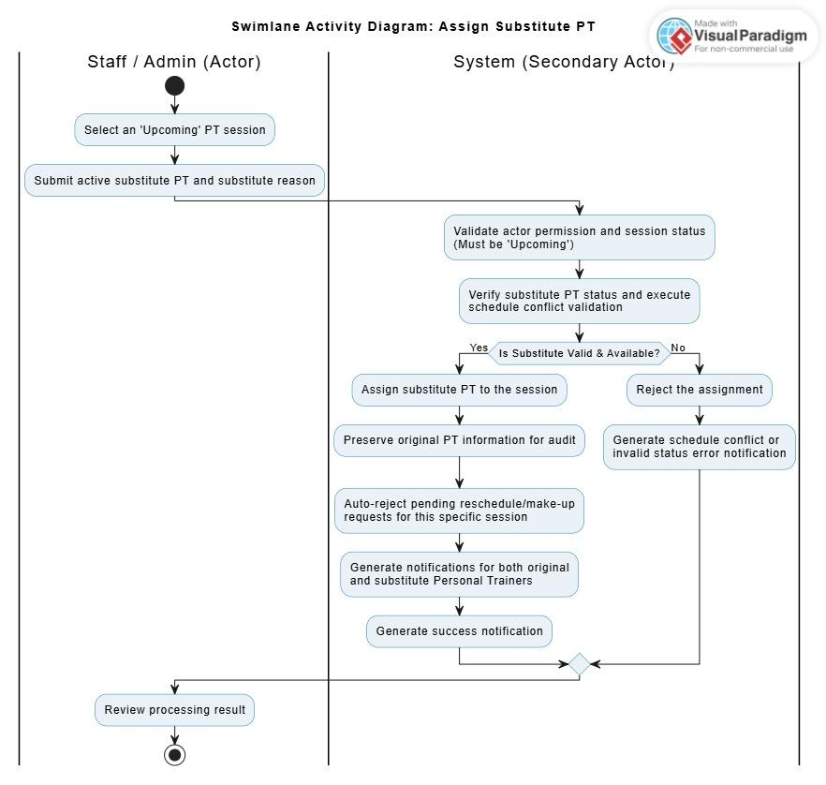
Description: This swimlane activity diagram describes how Staff/Admin assigns a substitute Personal Trainer to an Upcoming session. Staff/Admin selects an eligible session, chooses an active substitute trainer, and provides a reason. The system validates session status, substitute trainer status, and schedule conflict. If valid, the system updates the session with the substitute PT while preserving the original PT information and substitute audit fields. Related users may receive notifications.

3.18.9 Update Training Session Status Swimlane Activity Diagram
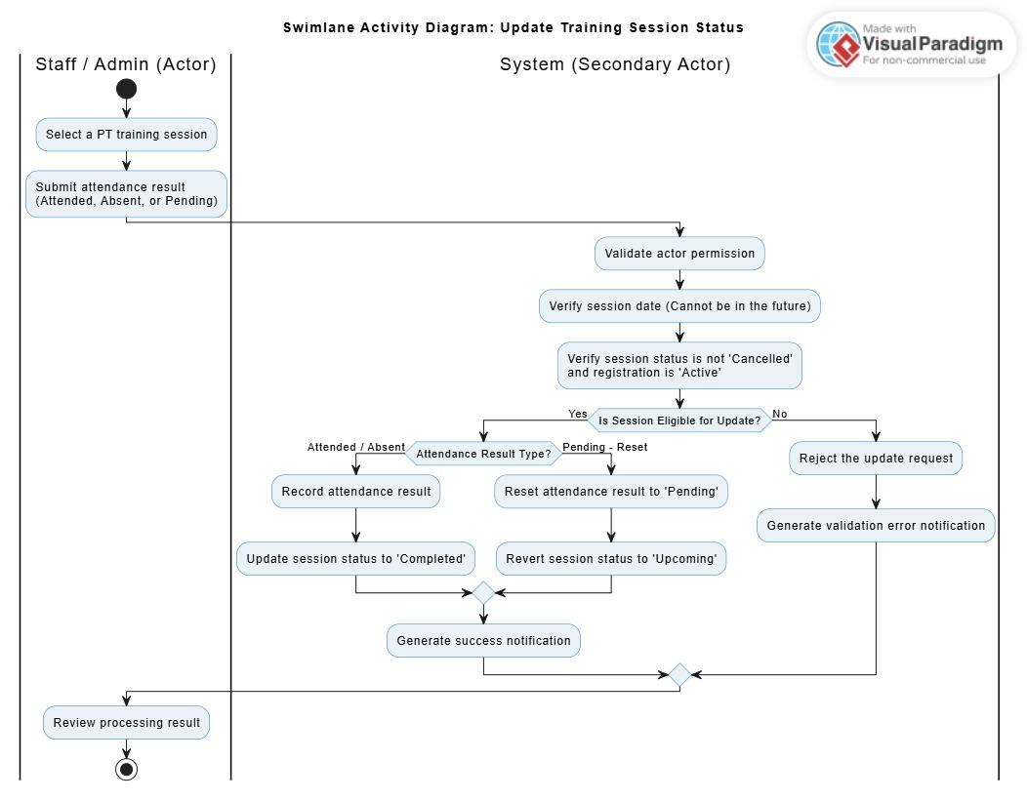
Description: This swimlane activity diagram describes how Staff/Admin updates the attendance or status of a PT training session. Staff/Admin selects a session and submits an attendance result. The system validates user permission, schedule existence, session date, session status, and active registration status. If the session is eligible, the system updates attendance result and session status. Future or Cancelled sessions cannot be marked as Attended or Absent.

3.18.10 Admin Cancel One PT Session Swimlane Activity Diagram
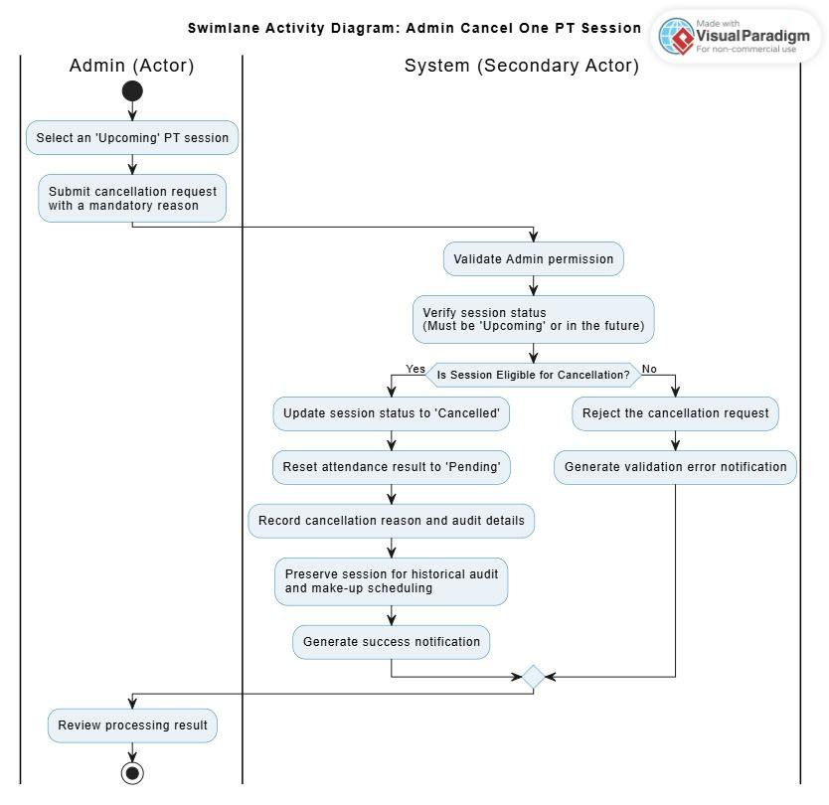
Description: This swimlane activity diagram describes how Admin cancels a single Upcoming PT session due to gym-level or operational reasons. Admin selects an eligible session and submits a cancellation reason. The system validates Admin permission and session status. If valid, the system updates the session to Cancelled, sets attendance result to Pending, and stores cancellation audit information. The Cancelled session remains visible for history and make-up handling.

3.18.11 Mass Cancel PT Sessions Swimlane Activity Diagram
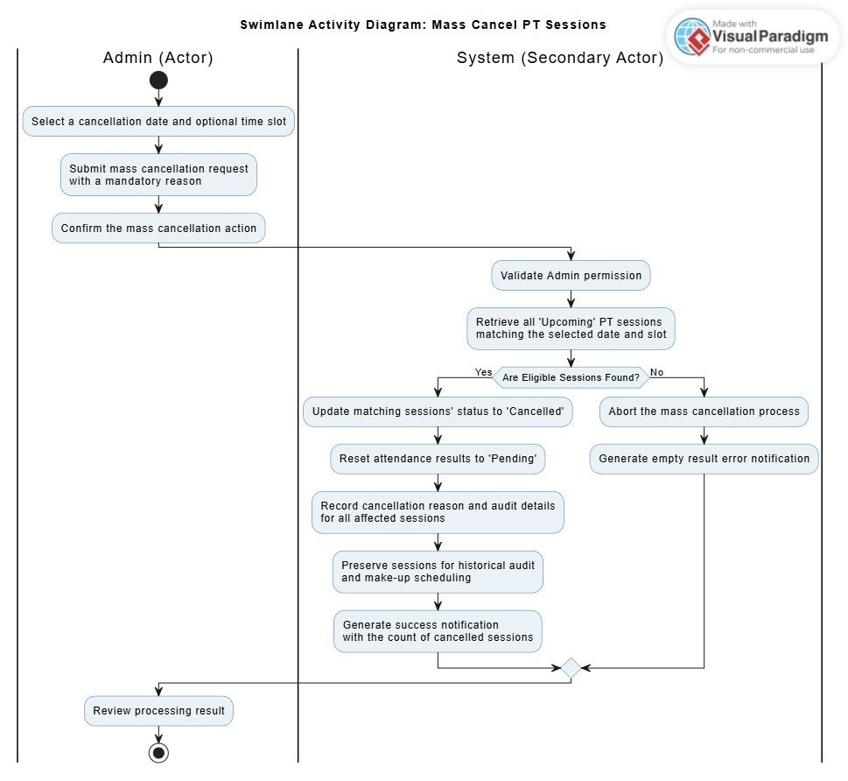
Description: This swimlane activity diagram describes how Admin cancels all eligible Upcoming PT sessions on a selected date. Admin enters a cancellation date and reason, then confirms the mass cancellation. The system validates Admin permission and finds Upcoming PT sessions on the selected date. Completed and already Cancelled sessions are ignored. If eligible sessions exist, the system changes them to Cancelled, stores audit information, and displays the number of cancelled sessions.

3.19 Manage Maintenance Schedules

3.19.1 Class diagram
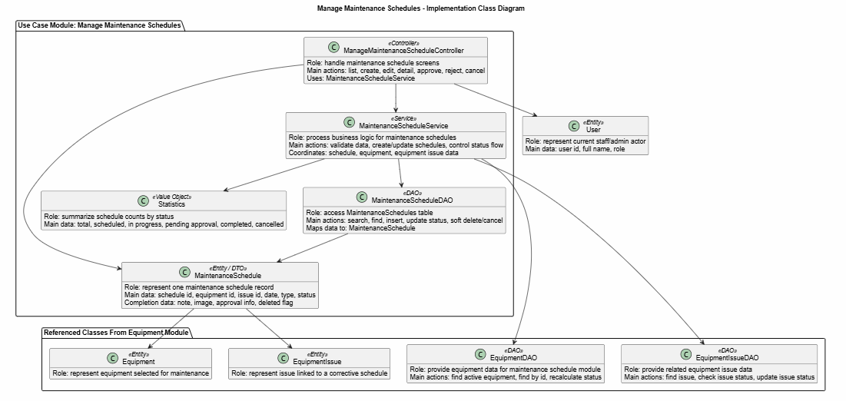
Description: This class diagram shows the main classes used to manage equipment maintenance schedules. The controller receives requests from the screen, the service handles business logic, and the DAO works with the database. The Maintenance Schedules class stores schedule information such as equipment, date, type, status, completion note, and approval data. The module also connects with equipment, equipment issue, and user classes to check related data and record who performs each action

3.19.2 View Maintenance Schedules Sequence Diagram
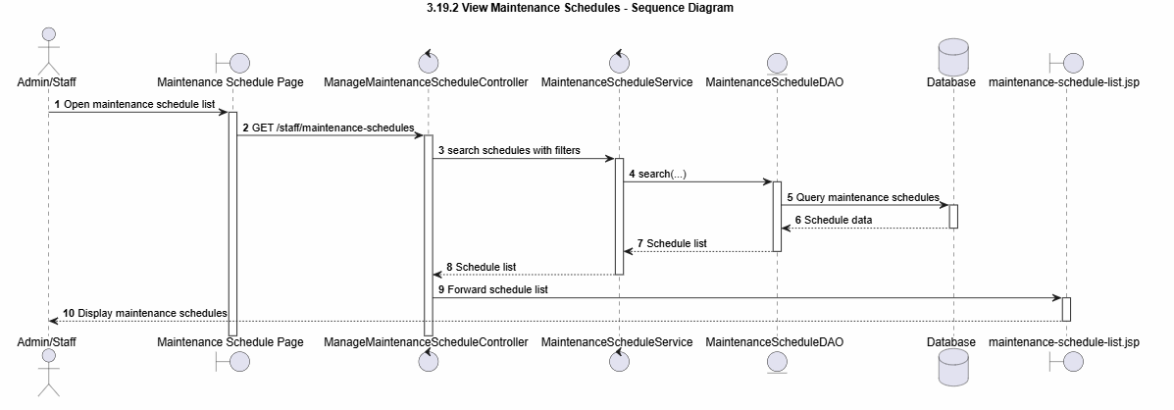
Description:This sequence diagram describes the process of viewing the maintenance schedule list. Admin or Staff opens the maintenance schedule page. The request is sent to ManageMaintenanceScheduleController. The controller calls MaintenanceScheduleService to get the schedule list. The service calls MaintenanceScheduleDAO to query data from the database. After the data is returned, the controller forwards the schedule list to the view page. The user can then see the maintenance schedules on the screen.

3.19.3 View Maintenance Schedule Detail Sequence Diagram
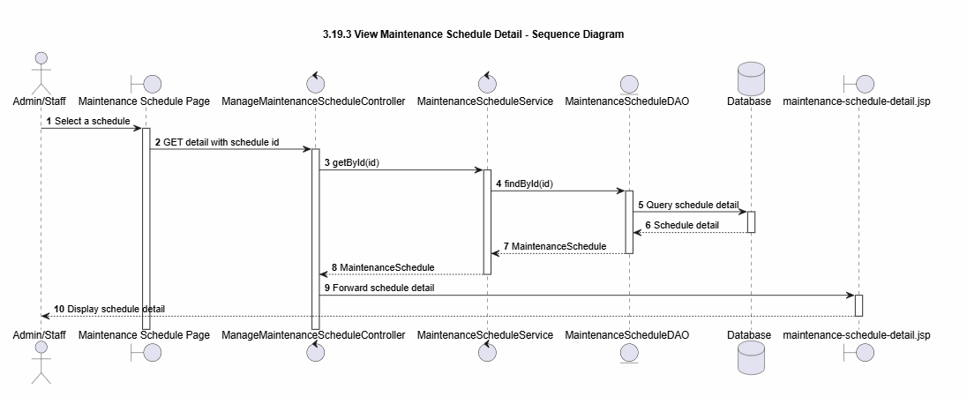
Description: This sequence diagram describes the process of viewing the detail of one maintenance schedule. Admin or Staff selects a schedule from the list. The request with the schedule id is sent to ManageMaintenanceScheduleController. The controller calls MaintenanceScheduleService to find the selected schedule. The service calls MaintenanceScheduleDAO to get the schedule detail from the database. After the detail data is returned, the controller forwards it to the detail page. The user can then view the full maintenance schedule information.

3.19.4 Create Maintenance Schedule Sequence Diagram
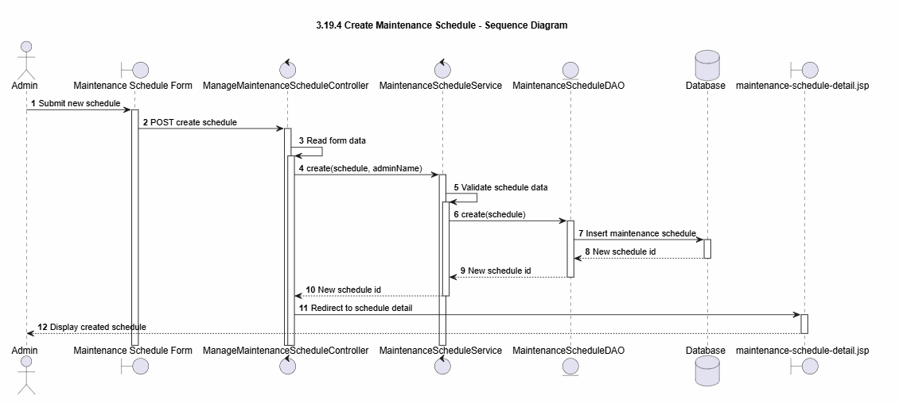
Description: This sequence diagram describes the process of creating a new maintenance schedule. Admin submits the maintenance schedule form. ManageMaintenanceScheduleController receives the request and reads the form data. The controller sends the schedule information to MaintenanceScheduleService. The service validates the input data and calls MaintenanceScheduleDAO to insert a new schedule into the database. After the database returns the new schedule id, the system redirects Admin to the maintenance schedule detail page.

3.19.5 Update Maintenance Schedule Sequence Diagram
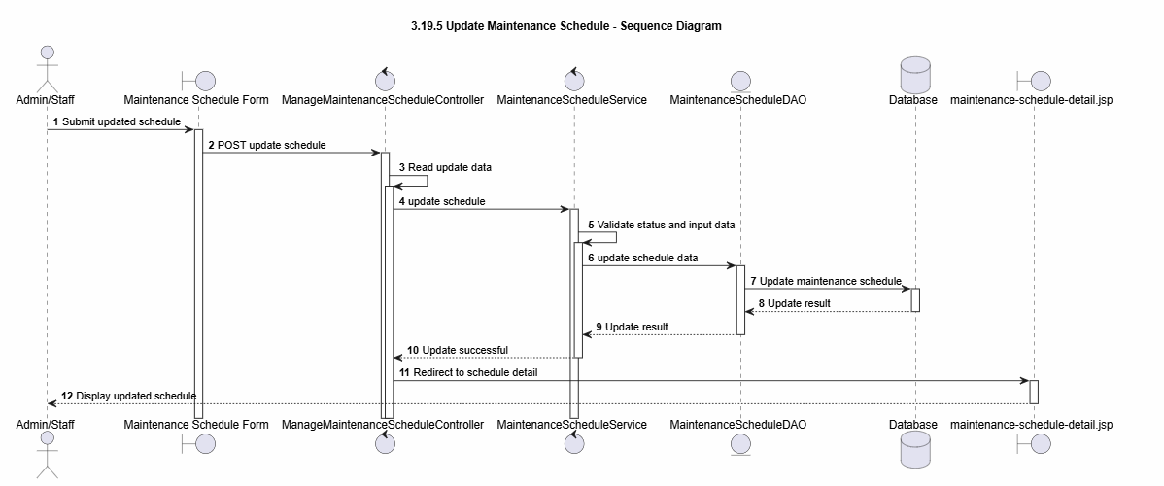
Description: This sequence diagram describes the process of updating a maintenance schedule. Admin or Staff submits updated schedule information through the form. ManageMaintenanceScheduleController receives the request and reads the update data. The controller sends the data to MaintenanceScheduleService. The service validates the input and checks whether the schedule can be updated. Then the service calls MaintenanceScheduleDAO to update the schedule in the database. After the update is successful, the system redirects the user to the maintenance schedule detail page.

3.19.6 Cancel Maintenance Schedule Sequence Diagram
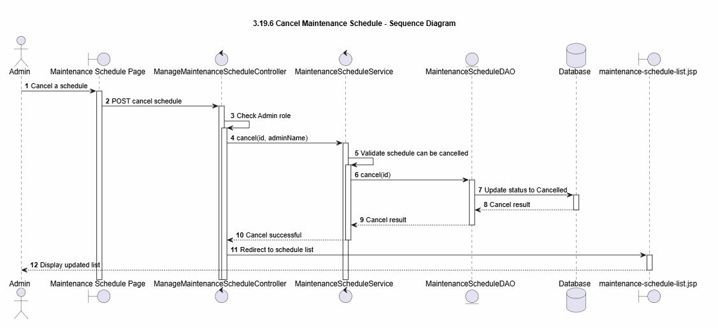
Description: This sequence diagram describes the process of cancelling a maintenance schedule. Admin selects the cancel action for a schedule. ManageMaintenanceScheduleController receives the request and checks the Admin role. The controller sends the schedule id to MaintenanceScheduleService. The service checks whether the schedule can be cancelled. Then the service calls MaintenanceScheduleDAO to update the schedule status to Cancelled in the database. After the cancellation is successful, the system redirects Admin to the maintenance schedule list page.

3.20 Manage PT Package

3.20.1 Manage PT Package Class Diagram
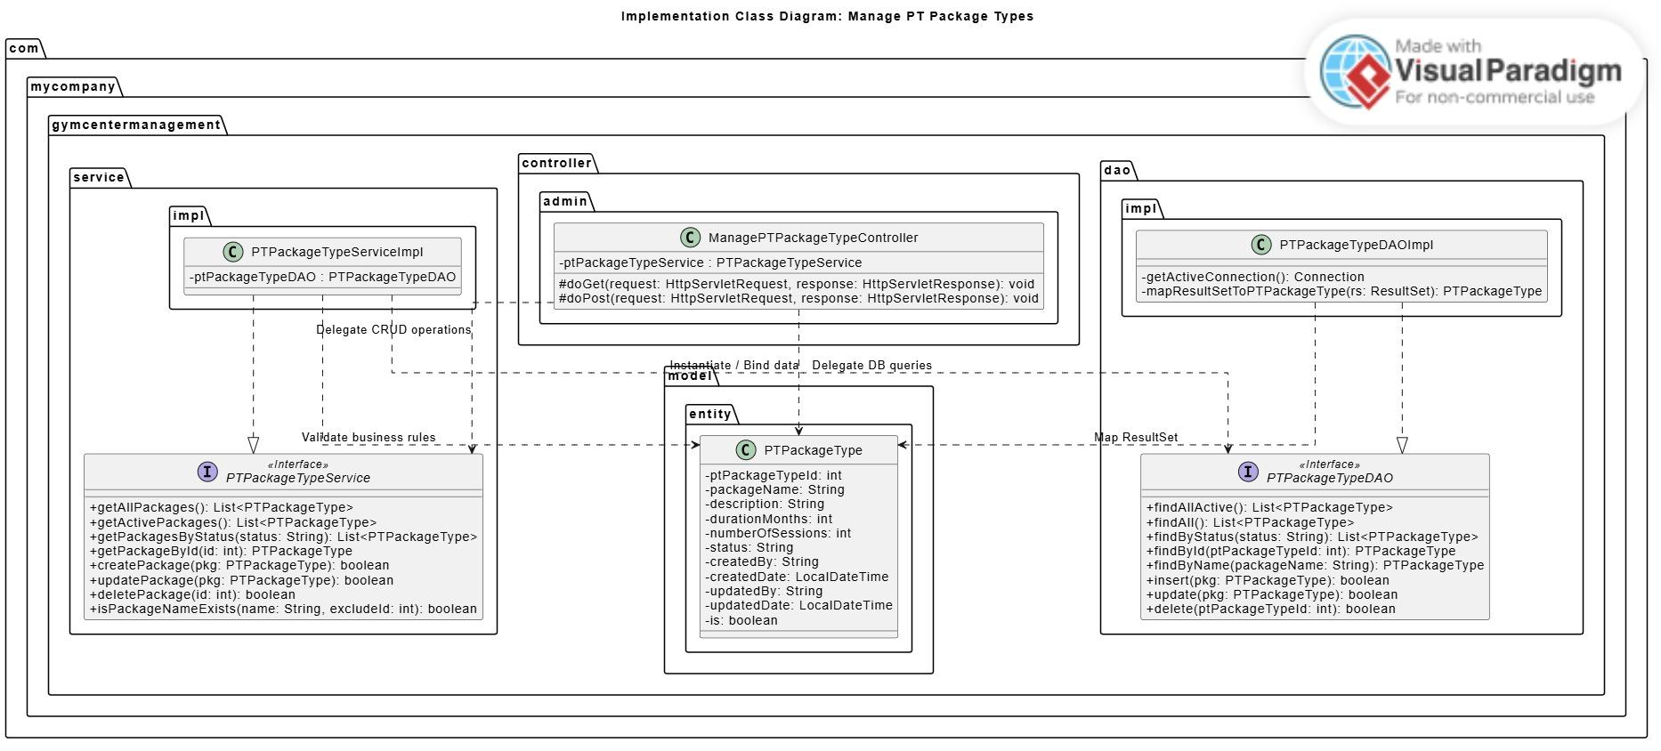
Description: This class diagram illustrates the structure for managing PT package types. It shows the relationships between the Controller, Service, DAO, and Entity layers, highlighting that Admin has full CRUD capabilities while Staff only has read-only access.

3.20.2 View PT Package List & Detail Sequence Diagram
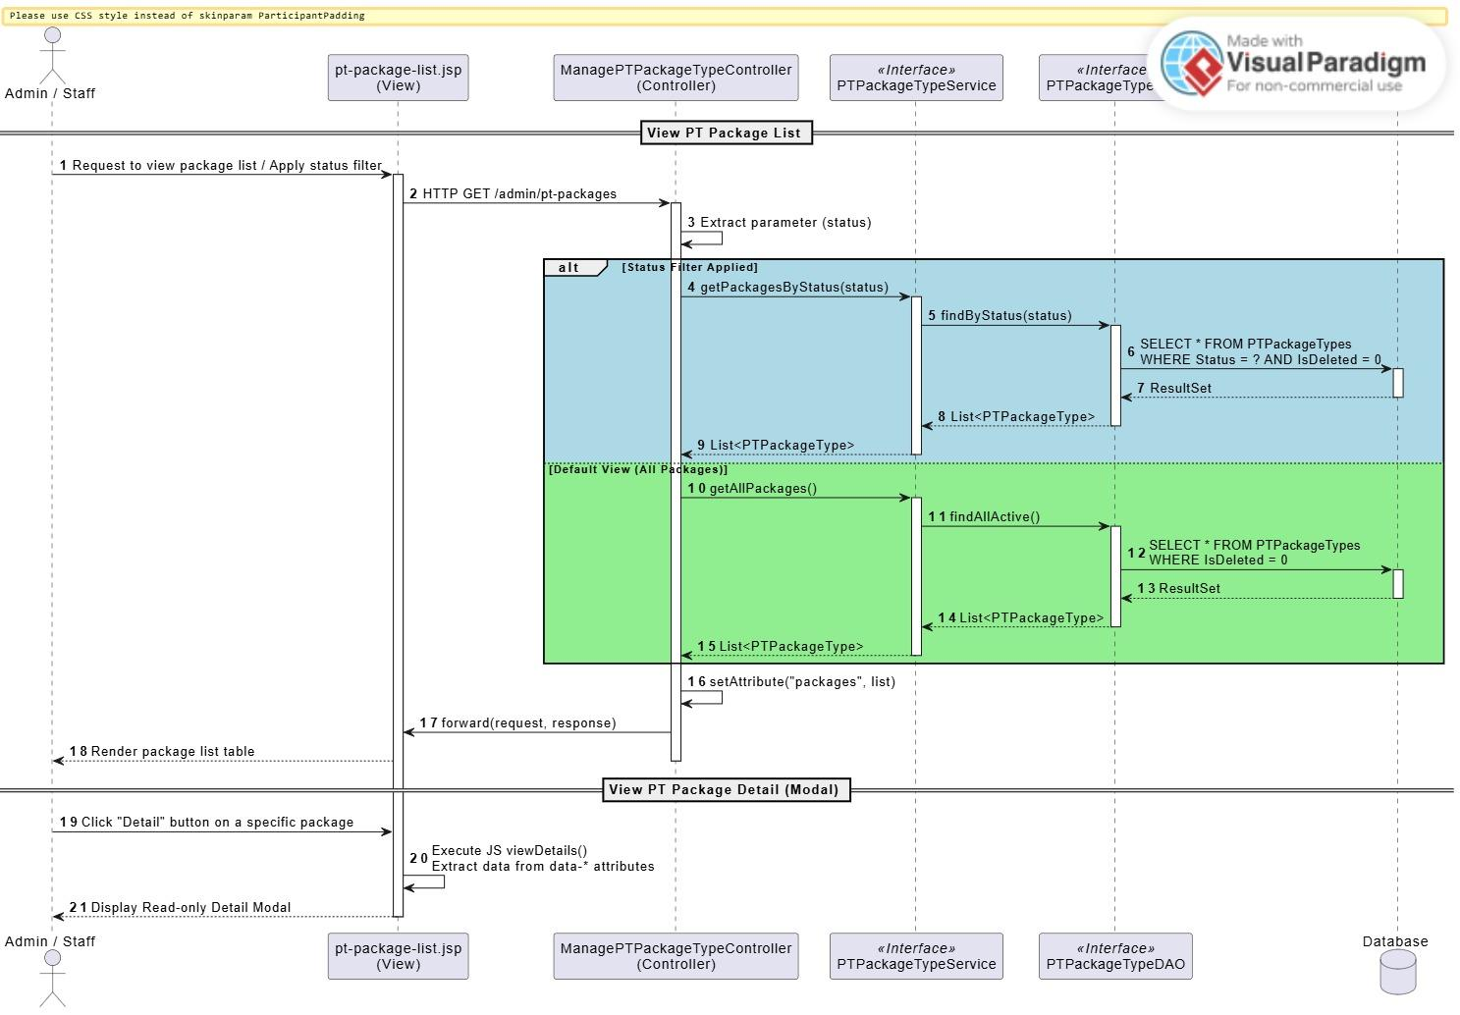
Description: This sequence diagram shows how Admin and Staff view the list and details of PT packages. The controller retrieves package data via the service and DAO layers, then forwards it to the view for display.

3.20.3 Create & Update PT Package Sequence Diagram
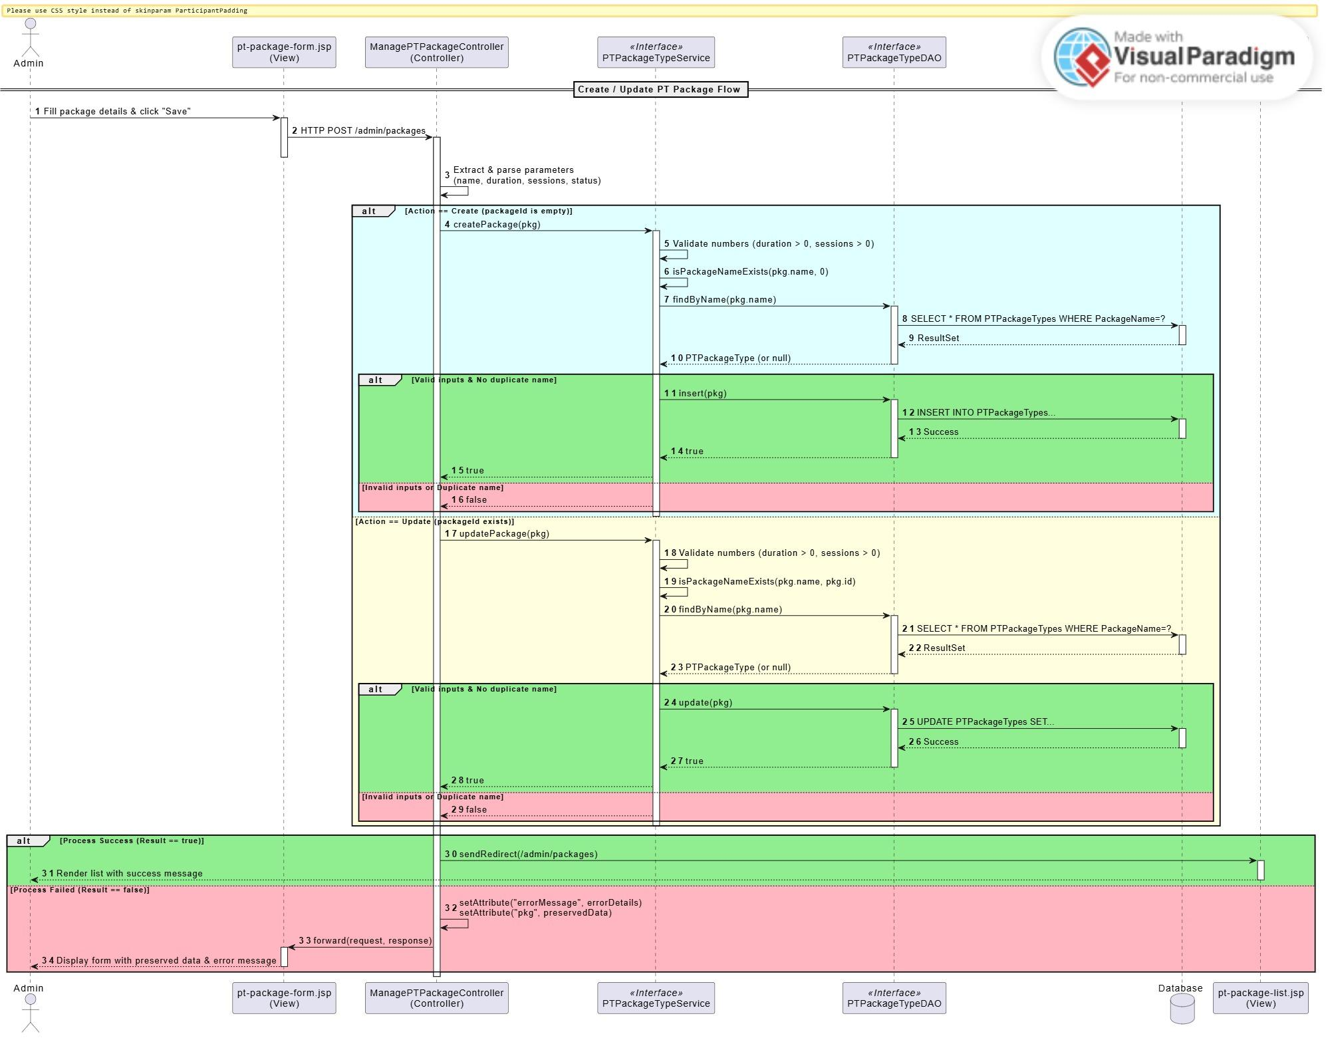
Description: This sequence diagram describes how an Admin creates a new PT package or updates an existing one. It includes data validation steps, such as checking for duplicate package names, before the service saves the data to the database using the Post-Redirect-Get pattern.

3.20.4 Delete / Toggle Status PT Package Sequence Diagram
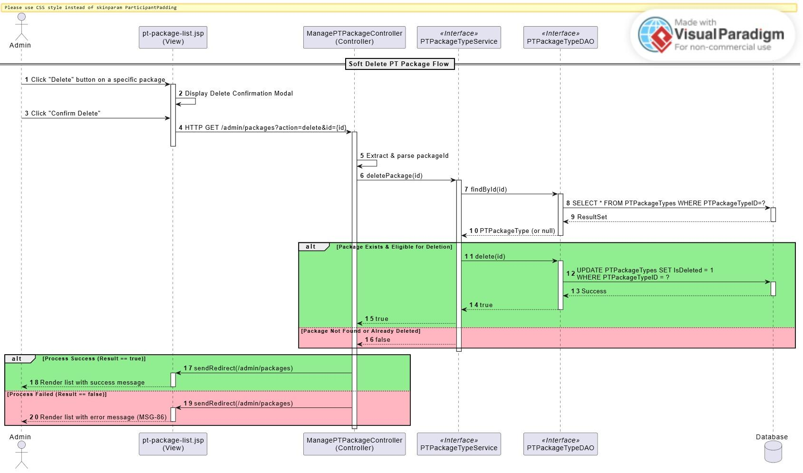
Description: This sequence diagram explains how an Admin soft-deletes or toggles the status (Active/Inactive) of a PT package. It includes a validation check to ensure the package exists before updating its status, preventing data loss for existing registrations.

3.20.5 Create / Update PT Package Swimlane Activity Diagram
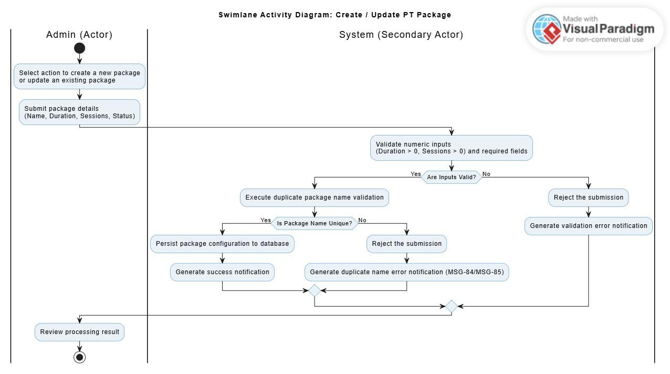
Description: This activity diagram maps the workflow of creating or updating a package from a business perspective. It emphasizes the system's double-layered validation rules (e.g., checking numeric inputs and verifying unique names) before confirming the action.

3.20.6 Delete / Deactivate PT Package Swimlane Activity Diagram
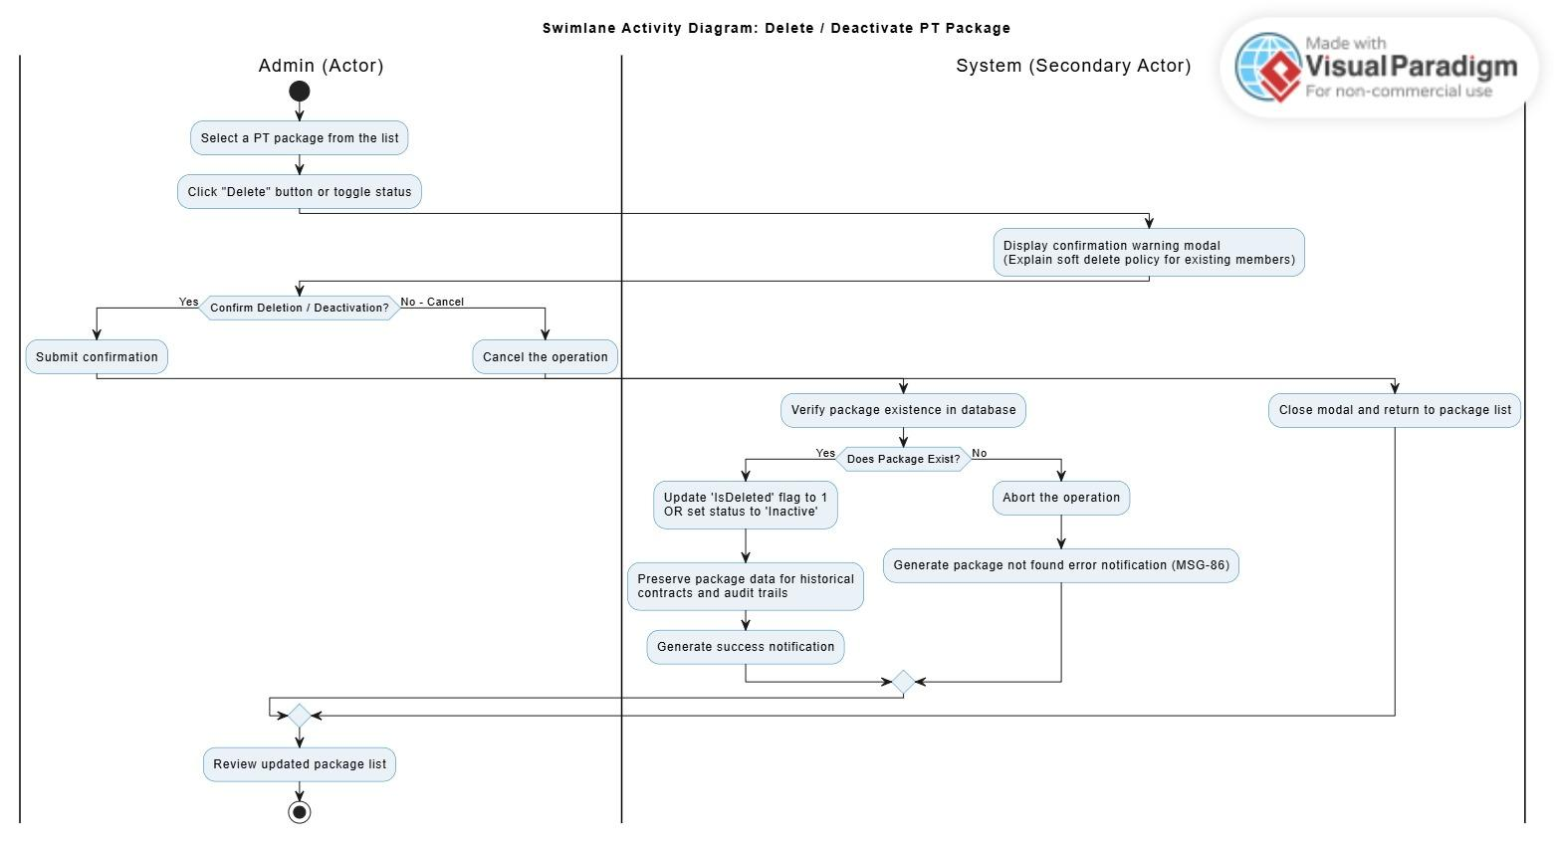
Description: This activity diagram shows the steps for soft-deleting or deactivating a package. It highlights the use of a confirmation warning modal to prevent accidental deletion and the system's logic to protect existing member contracts.

3.21 Manage Blog & Policies

3.21.1 Class diagram
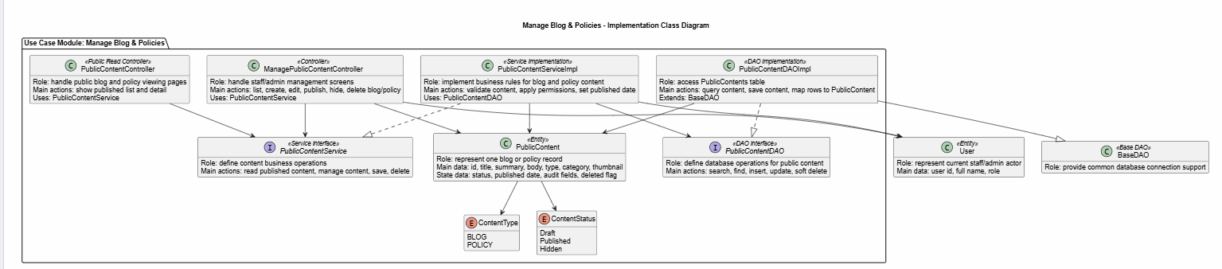
Description: This class diagram shows the main classes used to manage blogs and policies. The management controller handles staff/admin actions such as creating, editing, publishing, hiding, and deleting content. The public controller displays published blogs and policies to users. The service handles validation and business rules, while the DAO reads and updates content data in the database. The PublicContent class represents one blog or policy, with its type and status managed by ContentType and ContentStatus .

3.21.2 Create Blog & Policy Sequence Diagram
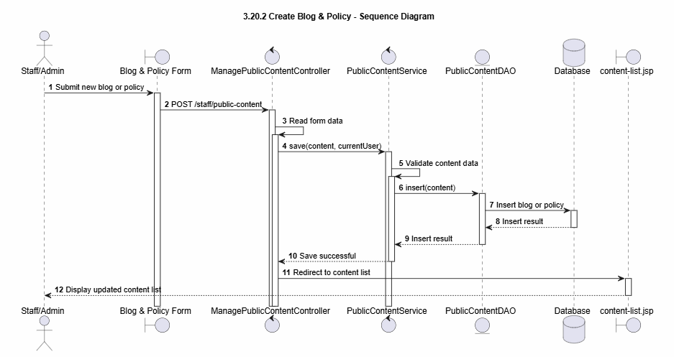
Description:This sequence diagram describes the process of creating a new blog or policy. Staff or Admin submits the content form. ManagePublicContentController receives the request and reads the form data. The controller sends the content information to PublicContentService. The service validates the content data and calls PublicContentDAO to insert the new blog or policy into the database. After the save action is successful, the system redirects the user to the content list page.

3.21.3 View Blog & Policy Sequence Diagram
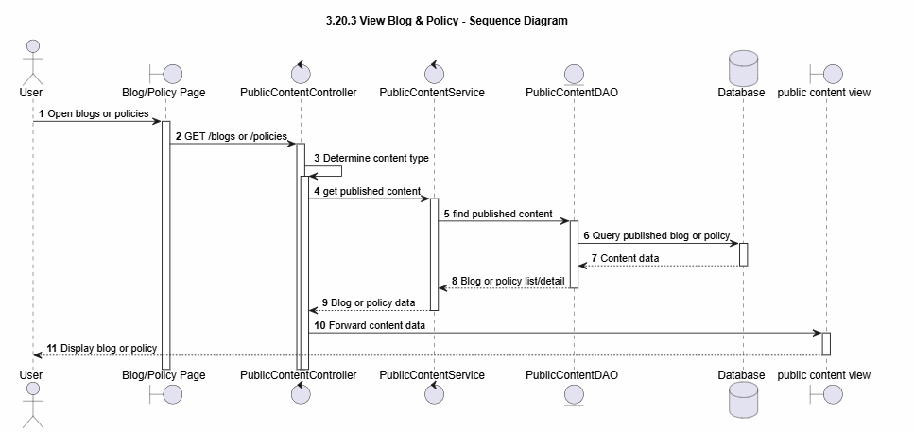
Description:This sequence diagram describes the process of viewing blogs or policies. The user opens the blog or policy page. PublicContentController receives the request and determines the content type. The controller calls PublicContentService to get published content. The service calls PublicContentDAO to query the database. After the content data is returned, the controller forwards it to the public view page. The user can then see the blog or policy content.

3.21.4 Update Blog & Policy Sequence Diagram
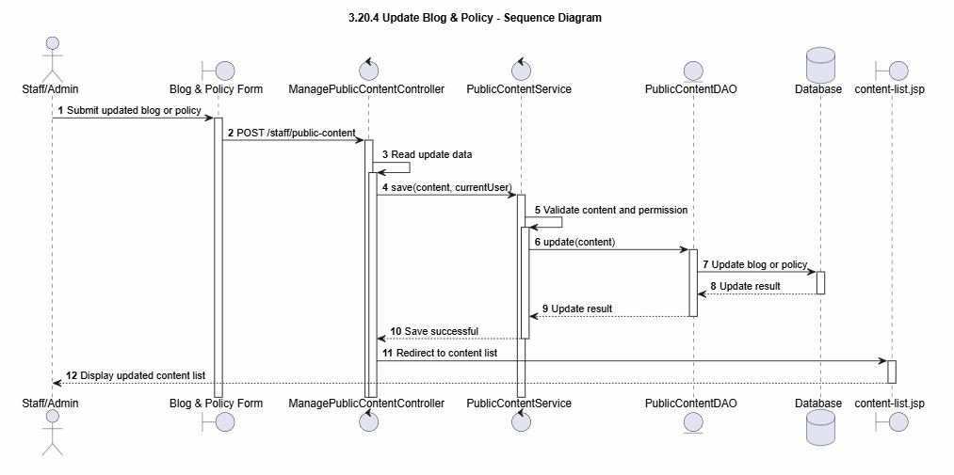
Description:This sequence diagram describes the process of updating a blog or policy. Staff or Admin submits updated content through the form. ManagePublicContentController receives the request and reads the update data. The controller sends the data to PublicContentService. The service validates the content and checks permission. Then the service calls PublicContentDAO to update the blog or policy in the database. After the update is successful, the system redirects the user to the content list page.

3.21.5 Delete Blog & Policy Sequence Diagram
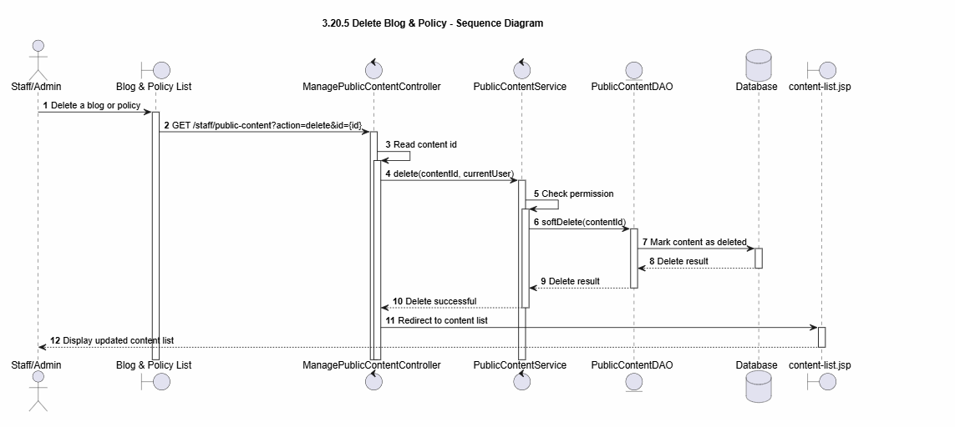
Description:This sequence diagram describes the process of deleting a blog or policy. Staff or Admin selects the delete action from the content list. ManagePublicContentController receives the request and reads the content id. The controller sends the id to PublicContentService. The service checks permission and calls PublicContentDAO to soft delete the content in the database. After the delete action is successful, the system redirects the user to the content list page.

3.22 View Membership Growth Report

3.22.1 Class diagram
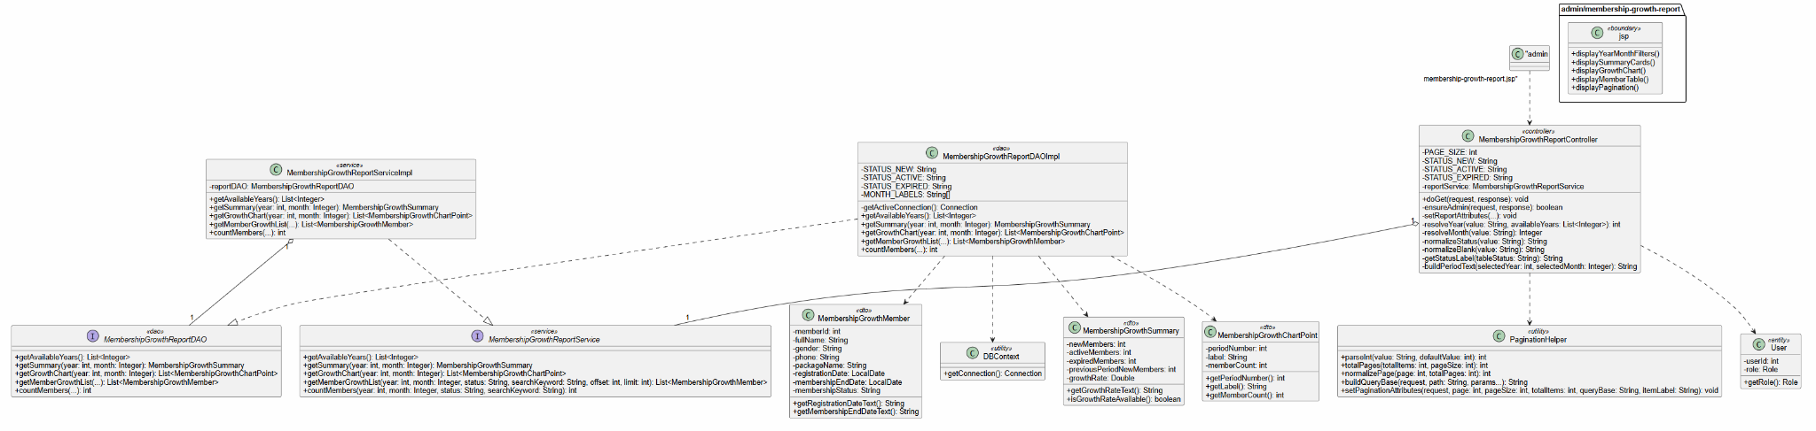
Description: Describes the classes used to generate and display the membership growth report. It includes Admin, report page, controller, service, repository, report criteria, report summary, growth chart data, and detailed member rows.

3.22.2 Sequence Diagram
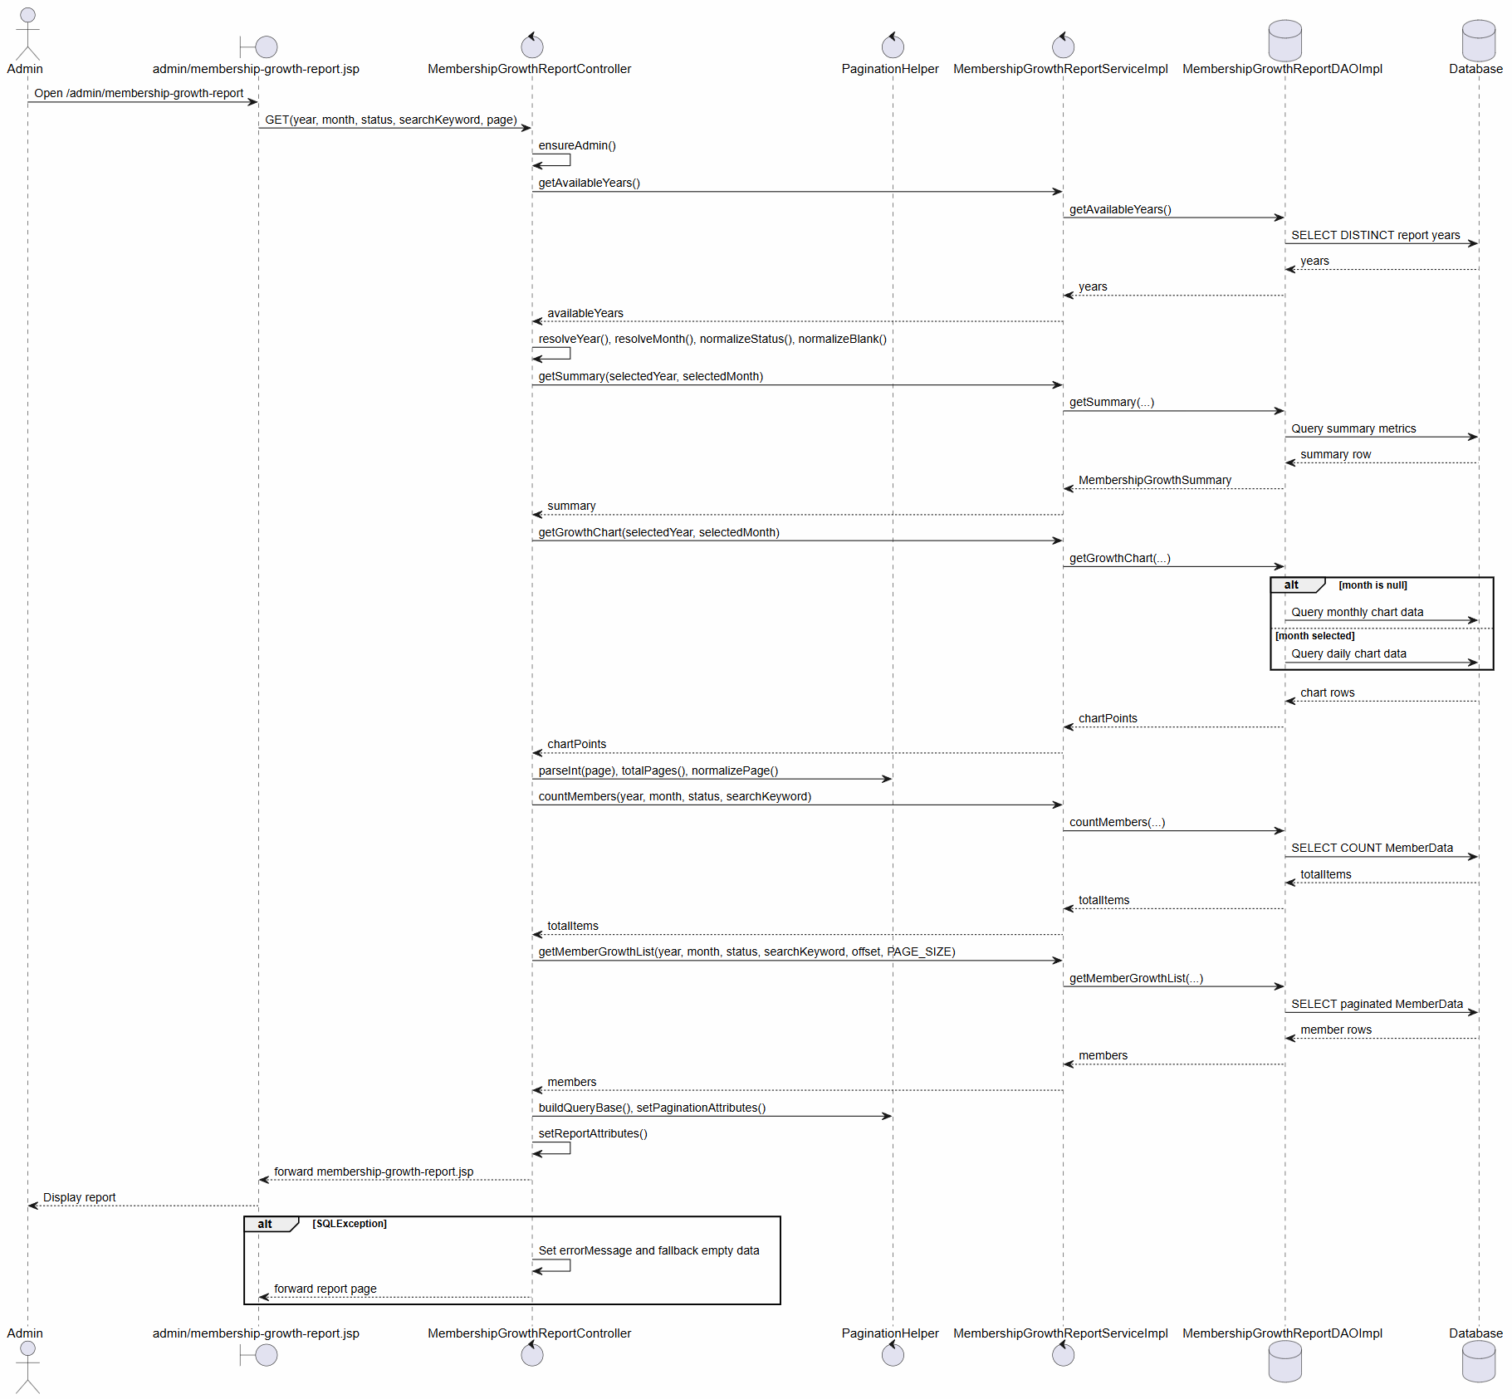
Description: Describes the flow where Admin opens the report page, selects filter criteria, requests the report, and the system validates criteria, retrieves summary data, chart data, and detailed member records. It also includes invalid filter and no-data flows.

3.22.3

3.23 Chat Bot

3.23.1 Class diagram
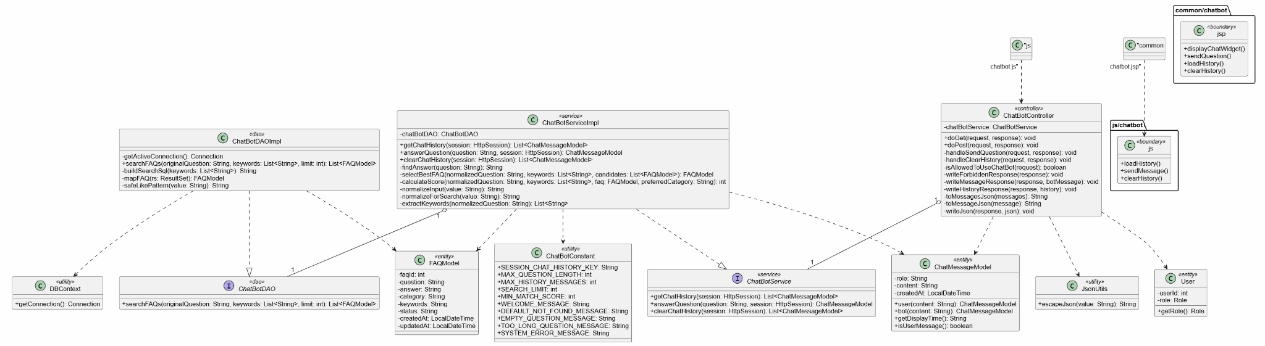
Description: Describes the classes involved in the chatbot feature, including Guest, Member, ChatBot widget, controller, service, FAQ repository, chat message, FAQ answer, and chat response.

3.23.2 Sequence Diagram
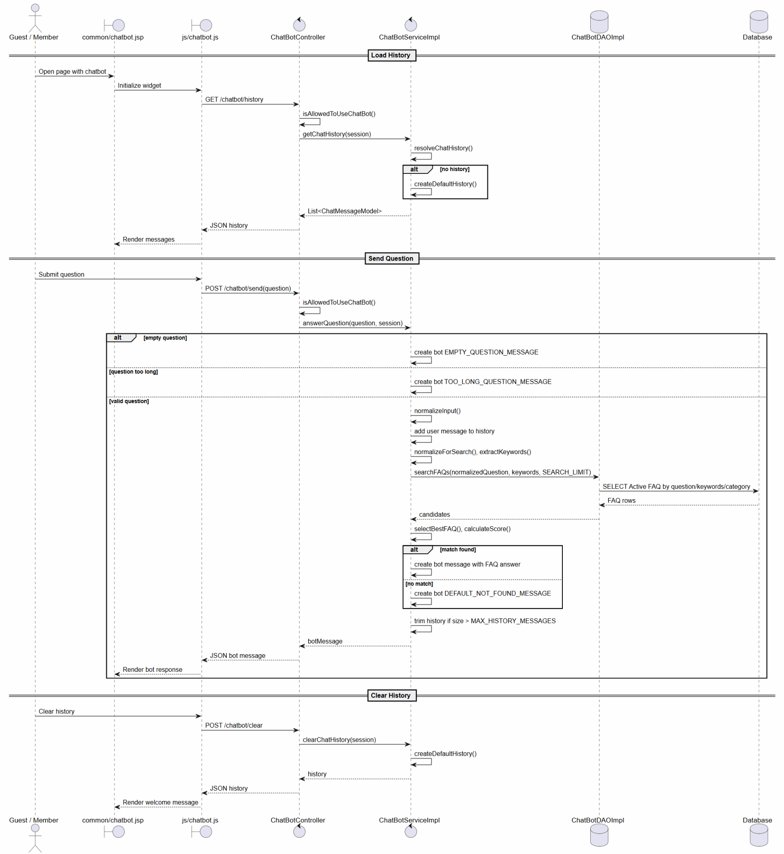
Description: Describes the flow where a Guest or Member opens the chatbot, enters a question, submits it, and the system searches for a matching FAQ answer. It also includes empty-question handling and the no-matching-answer flow.

3.23.3

3.24 Manage Staff & PT Check-ins

3.24.1 Class Diagram
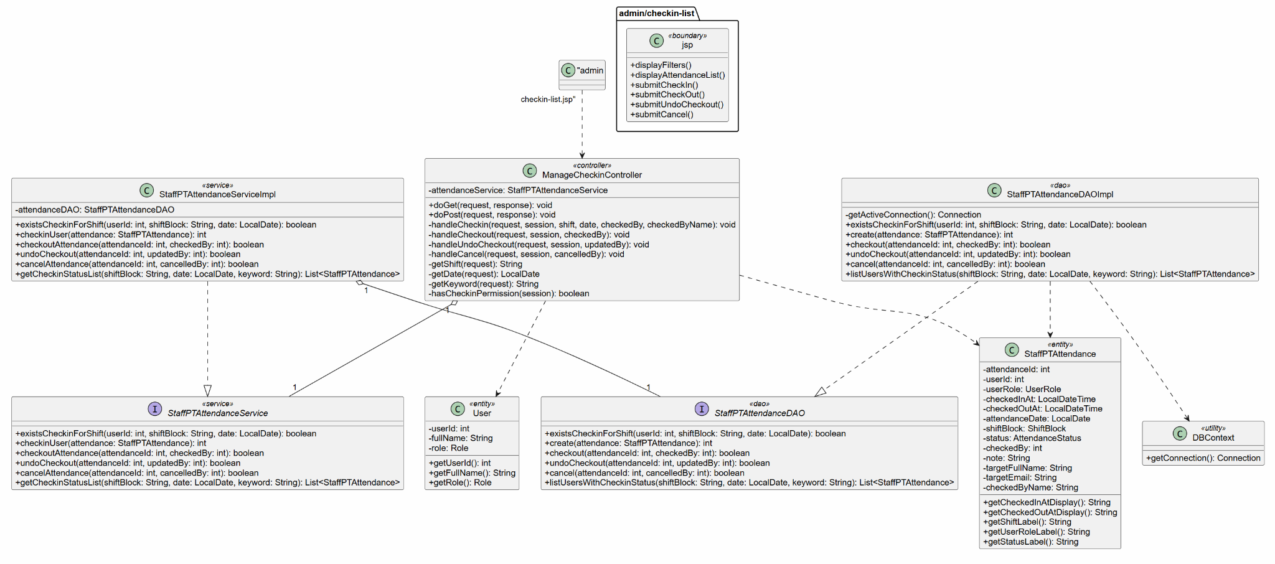

3.24.2 Sequence Diagram
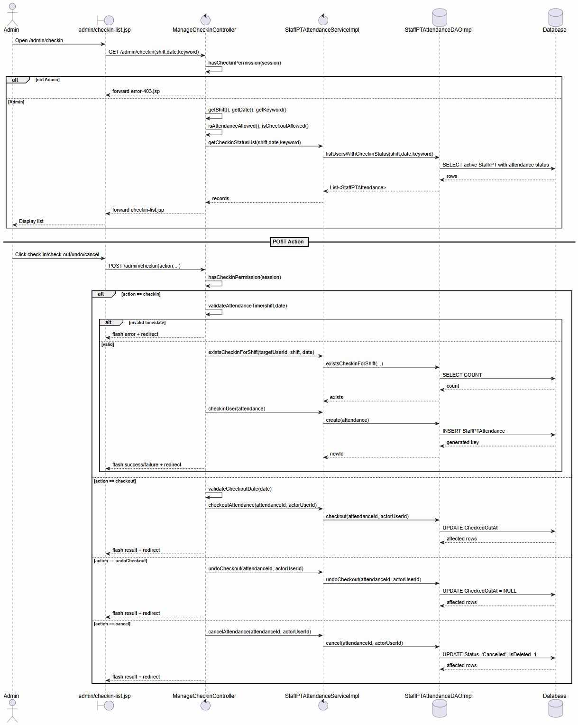

3.25 Manage Staff & PT Check-ins

3.25.1 Class Diagram
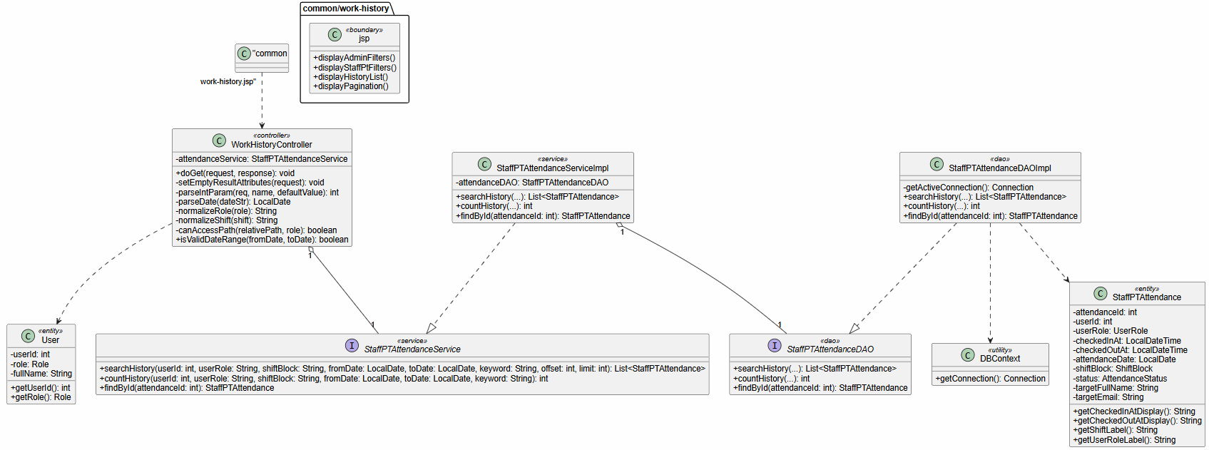

3.25.2 Sequence Diagram
